


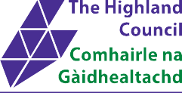
EDITION 16 July 2025
Highland’s Information Trail
Delivering Integrated Children’s Services in Highland

Introduction
This Highland Information Trail guides professionals to resources available to support and improve maternal and child health across Highland. It covers information from both a national and local perspective from pre pregnancy through to the age of five. A number of useful websites are also listed to further support families.

This resource combines the Public Health Scotland Early Years Pathway and is structured to complement the core programme of contacts as detailed in Pathways for Maternity Care, Keeping Childbirth Natural and Dynamic (KCND) and The National Health Visiting Pathway for Scotland ensuring integrated services and seamless transitions. It also supports The Best Start: A Five-Year Forward Plan for Maternity and Neonatal Care in Scotland by empowering parents to make choices based on high quality information. Additional support and contact is given if necessary following assessment.

Health Literacy
Health Literacy is about people having enough knowledge, understanding, skills and confidence to use health information, to be active partners in their care, and to navigate health and social care systems. One in five adults in Scotland has difficulty with reading/numeracy and learning acquisition, therefore it is important to ensure that any information leaflets given out are complimented with a full explanation and discussion of their contents. Check directly with the person how best to communicate information which may be better in DVD or picture formats, several materials are available in easy read versions. Ready Steady Toddler! is no longer available, as an alternative for parents with learning disabilities, resources are available to order from the HIRS library. These include You and Your Baby 0 – 1; and You and Your Little Child 1 – 5 (order one per client). The Health Literacy Place is a useful resource for developing your health literacy skills with useful tools and techniques such as Teach back, chunk and check, using simple language and pictures including a link to an e-learning module from NHS Education for Scotland Health Literacy e-learning on the Turas platform.

Health Improvement/Health Behaviour Change
Taking a motivational interviewing (MI) approach in supporting health behaviour change is more effective than simply giving advice, how we present information is of great importance. Local health behaviour change and MI training is provided by NHS Highland Health Improvement Team, their prospectus, training calendar and booking forms can be accessed here Learning & Development for Health Improvement 2025-2026

BadgerNet – Maternity
The BadgerNet Maternity system is an electronic maternity record (EMR) replacing the paper hospital record and the SWHMR. In place of the SWHMR, women are offered the option to consent to an online portal and application (Badger Notes) to view their maternity records and access leaflets over the internet through PC, tablet device or mobile phone. Please note that women who do not opt into this service, have no access to a personal smartphone/device or have limited or no English should continue to be provided with the hard copies. Resources available on women’s portal are annotated with the BadgerNet icon. 
Universal resources will be automatically assigned to the recommended reading list at the relevant gestation and targeted resources should be assigned by the midwife as appropriate. All women should be OFFERED the hard copy version of ‘Ready Steady Baby!’- standard order is 20 copies (email HIRs if more is required).

Health Improvement Resource Service (HIRS) hirs.mailbox@nhs.scot Website: http://healthyhighlanders.co.uk/HPAC Telephone: 01463 704 647,
The Health Information and Resources Service (HIRS) has a Library which offers a wide range of health-related materials for loan, free of charge to those working or living within the Highlands. Materials consist of: Leaflets, Posters, Training Packs, Games, Models & Equipment. Most Leaflets can be viewed online and downloaded from the website where clients need to register with HIRS at http://healthyhighlanders.co.uk/HPAC. NHSH, Rowans, Room 38 Flat 3, New Craigs, Leachkin Road, Inverness, IV38NP.

Information for Health Professionals

Ready Steady Baby! is a key resource for parents and provides most of the information that they will need before, during and after pregnancy. The different professionals who have contact with women throughout this time should make a point of referring to this resource. It covers pregnancy and 6-8 weeks post birth and has been designed to reduce the need for many different leaflets. A hard copy should be offered to all pregnant women. An easy read version of RSB has been developed by Public Health Scotland.
Off to a Good Start is a key resource for supporting breastfeeding.
Professionals who have contact with women at all stages should refer back to it and work through it with women.

Pre-pregnancy Care - All professionals who have contact with women and partners who may be contemplating pregnancy should advise them about safe medications, healthy diet, and lifestyle, e.g., physical activity, healthy weight, smoking, alcohol and substance use. This discussion should also include the importance of folic acid and vitamin D supplements.

Nutrition – Preconception & maternal healthy weight: Eating well in pregnancy guidance offers best practice in promoting healthy weight in the pre-pregnancy, pregnancy and postnatal period. It aims to reduce pregnancy risks linked to a high BMI by improving nutrition, fitness, and access to services.

Healthy Weight in Pregnancy
Eating Well in Pregnancy

Infant Feeding Policy- Maternity

Infant Feeding Policy- Health Visiting

Healthy Start Maternal Vitamins It is recommended that women take 400 micrograms supplement of folic acid for 3 months before conception and until 12 weeks pregnant and a daily supplement of Vitamin D 10 micrograms throughout pregnancy. Vitamins in pregnancy . All pregnant women in Highland are entitled to free Healthy Start Vitamins for the duration of their pregnancy.
They should be offered with a supporting conversation at:
- Booking- 2 bottles
- 22-week appointment- 2 bottles

Healthy Start Vitamins Breastfeeding mothers are provided free to all breastfeeding mothers up to 1 year. Thereafter breastfeeding women are encouraged to take a Vitamin D supplementation.

Healthy Start Children’s drops
Are provided free to all children under 12 months old and free to infants that are eligible for Best Start Foods/Grants from age 1 – 3

Please note that vitamin drops are only for breastfed children and formula feeding children that are taking less than 500ml of formula daily

Midwives and Health Visitors can order these via HIRS

Oral Health Care - Pregnancy offers an opportunity to remind women to register with a dentist. NHS dental treatment is free during pregnancy and until the baby is 1 year old.

Remind women:
- Maintain good oral hygiene by brushing twice daily with 1500 ppm fluoride toothpaste and flossing to prevent gum issues.
- Baby teeth start calcifying at 5 months in utero.
- Adult teeth begin calcifying just before or shortly after birth.

If women experience any problems registering with a dentist then the NHS Dental Help Line number should be given:
North Highland - 08001412362 or
Argyll & Bute CHP - 0845 833 2310.
For further information to help care for your child’s teeth, see www.child-smile.org.uk
Flu, pertussis & RSV - vaccinations must be discussed with women and relevant information leaflets provided.

Infant Food Insecurity Pathway
To combat rising infant food insecurity driven by the cost-of-living crisis, the Highland Food Insecurity Pathway Pilot. This will enable staff to urgently refer families for direct infant formula support through HALO, whilst offering referral to the Welfare Team welfare.support@highland.gov.uk
All staff with contact with women & families should routinely ask about money worries & offer a hard copy of ‘Worrying About Money’ leaflet & promote the Worrying about Money? Highland App

Best Start Grant Is a package of four payments to give money to lower income families during the key early years of a child’s life. These payments will not affect other benefits and are eligible to the mother of the child, her partner or someone who has a young mother dependent on them if they are on the following benefits. Universal Credit, Income support, income-based jobseekers’ allowance, income-related employment and support allowance, pension credit, housing benefit, child tax credit and working tax credit. Under 18’s or 18- & 19-year-olds who are still in full time education do not need to be on a qualifying benefit.

Best Start Foods replaced the healthy start voucher scheme in Scotland in 2019. It provides eligible women with a pre-paid card that can be used to buy healthy foods for children under 3. The card can be used in shops and online. The payments are:
- £21.60 every 4 weeks during pregnancy
- £43.20 every 4 weeks from your child being born up until they're a 1-year-old.
- £21.60 every 4 weeks between the ages of 1 and 3

Pregnancy and Baby Payment
- £767.50 for the first child, £383.75 for subsequent children, and an additional £383.75 for multiple births.
- To help cover costs such as prams or baby clothes, but parents can spend the money as they see fit.
- Can be claimed from 24 weeks of pregnancy until the baby is 6 months old.
- Evidence from Baby Box claim, Mat B1, or birth certificate.

Early Learning Payment of £319.80 is available for low-income eligible families when a child reaches the age of 2 or 3 years.
School age Payment of £319.80 around the time a child would usually start school. This does not replace the School Clothing Grant
Scottish Child Payment Weekly payment of £27.15 for every child to help towards the costs of supporting your family. Payment is every 4 weeks if application is successful.

Further information and how to apply here:
https://www.mygov.scot/best-start-grant/

Child Benefit Paid to one person, if you’re responsible for bringing up a child who is:
- under 16
- under 20 if they stay in approved education
Eldest or only child £26.05 per week
Additional Children £17.25 per week
Paid 4 weekly

Further information and how to apply here:
Child Benefit: Make a claim - GOV.UK (www.gov.uk)

Scotland’s Baby Box:
- Every baby in Scotland is entitled to a free baby box from the Scottish government.
- The box includes baby essentials for the first six months and can be used as a safe sleeping space.
- Midwives fill out a registration card at around 22 weeks during an antenatal appointment. The box is delivered at least four weeks before the due date to the address provided.
In unfortunate circumstances such as still birth delivery of a box may be cancelled via scotlandsbabybox@theapsgroup.com or 0800 030 8003 quoting the registration number on the leaflet. Additional registration cards are requested from the same above email address. More information (contents, etc) is available at http://www.parentclub.scot/baby-box

Benefits, Entitlements, and Work Support:
- Financial Health Check: Available to all households in Highland for advice on money and debt management.
- Pregnant Women: Can self-refer to local Citizens Advice Bureaux for independent advice on debt management, housing, employment rights, and more.
- Support for Vulnerable Families: Staff can refer families with appropriate consent.
- Highland Council Welfare Support Team: Provides advice on benefits and other entitlements.

The Welfare Support Team can be contacted on 0800 090 1004 or email welfare.support@highland.gov.uk
Contact details of local CAB offices can also be found here

SMP and MA pay guides can be accessed
Statutory Maternity Pay & Maternity Allowance

Staff can access training Health inequalities : money counts [supportive conversations] | Turas | Learn

You can watch this short clip asking about money worries
https://www.youtube.com/watch?v=ge2XedoG_T8&feature=youtu.be
Staff working in Argyll & Bute can access locality information from:
http://www.argyll- bute.gov.uk/social-care-and-health/welfare- rights
Words Up Baby is a resource being used in universally in Highland Council which highlights the importance of communication, promoting positive attachment with babies even before birth. The key messages are discussed with parents at appointments during pregnancy and after birth.
Before Birth leaflet is given at 22 weeks to accompany the antenatal conversations.
Baby talks handout is given at 4-8 weeks after birth.
Words Up Early Stages highlights 6 key messages essential to promoting early language development. Where there is a concern about a child's language development, this series of leaflets (available in A4 or A5 size) will help to support a discussion of ways to promote early language. Although they are aimed at parents of children from the toddler to P1 stage, no ages are specified on the leaflets, allowing them to be given at the right time for the child depending on their stage of development. The 4 leaflets are titled: 'First Words'; 'Words Together'; 'Talking Together' and 'Chatting Now' and are available from HIRS.

Play@home:
- Families in Scotland with children aged 0-5 receive baby, toddler, and pre-school books.
- Activities in the books support child development, attachment, and family communication.
- Professionals refer to these activities when discussing children’s physical, social, and emotional growth, as well as speech and language development.
- The books can also be used to discuss baby massage.
Bookbug offers free bags of books and goodies for children, distributed through health visitors, early years settings, and local libraries.
- Each child receives four bags: Baby Bag, Toddler Bag, Explorer Bag, and P1 Family Bag, with Gaelic versions available.
- Families can also join free, fun Bookbug sessions at various locations, where they enjoy rhymes, songs, and stories together. These sessions support positive attachments and the development of speech and language skills.

Family Nurse Partnership (FNP) deliver intensive home visiting to young women having their first baby.
- Young women 20 years old & under, 25 years old if care experienced.
- The main aims of the programme are to improve maternal health, child health and development and increase the family’s economic self-sufficiency.
- FNP is offered in some areas of Highland
- Areas that do not have access to FNP should consider Community Early Years Practitioners or other Third Sector Partners who offer support to young people.
- Further Information HERE

Translating and interpreting - Women and families who do not speak English as a first language may require interpretation or translation services to enable communication. It is the responsibility of staff to book the service if required. Face to face interpretation is available for spoken languages through Global Languages and telephone interpretation is available through Language Line. British Sign Language interpretation is also available for service users who are Deaf or hard of hearing as well as other communication support such as lip reading or note taking. For interpretation and translation guidance see
NHS staff: here
Highland Council Staff: here

Digital Inclusion A discussion should be had with all women and their families to check their ability to access digital resources and offer supporting health information accordingly either digitally or in paper format. Not being able to access resources digitally whether it be through lack of confidence, skills or poverty puts families at a huge disadvantage. The Connecting Scotland Website Connecting Scotland provides information and practical help for organisations supporting families to get digitally connected.

Family Information Services provide details on registered Early Learning and Childcare (ELC) services across Scotland. Information can be found on registered child minders, registered after school clubs, registered day care nurseries, registered ELC settings and non-registered parent and toddler groups.

Offices are open Mon – Fri 9am – 5pm.

Highland Tel: 01463 702 871 familyinformationservice@highland.gov.uk

Argyll & Bute Tel: 01369 70851
Families can access the link and click on their regional area for local information: www.families.scot

1140 hours of funded early learning and childcare is available for 2-year-olds who:

- 2-year-olds who are, or have been at any time since turning 2, looked after by the local authority, subject of a kinship care order or subject of a guardianship order. (LAC).
- Have a care experienced parent who has been in care under a UK Local Authority and is able to supply evidence of this or if not gives permission for Officers to verify their status. (Care Experienced)
- 2-year-olds living in households where their parent(s) meet the qualifying benefit criteria below - out of work benefits or income-related benefits with income below a certain threshold. (Benefit related)

- 2-year-old discretionary places- must be requested by named person or other professional and be submitted with a comprehensive, clear, and concise child’s plan. If the plan does not highlight the anticipated outcomes and benefits for the child, the application may be refused. (Discretionary).

Qualifying benefits:
- Income support
- Income based Job Seekers Allowance
- Any income related element of Employment and Support Allowance
- Child Tax Credit, but not in receipt of Working Tax Credit, and an income below £19,995
- Child Tax Credit and Working Tax Credit, and an income below £9,552.
- Support under Part VI of the immigration and Asylum Act 1999
- Universal Credits with an earned income below £796 per month
- Incapacity Benefit or Severe Disablement Allowance
- Pension Credit
- Care experienced parent who has been in care under a UK local authority

For further information
Enrol your child for early learning and childcare

Just Ask Enquiry Line
If you have questions about the development or wellbeing of a child or young person in Highland, you can call on Tuesdays or Thursdays from 1pm to 4pm. A health or educational professional will return your call within a few days. Call 0300 303 1365 for assistance. Further Information HERE

Highland Third Sector Interface
The Highland Third Sector Interface was formed in 2012 and officially launched on the 4th of March 2013. Their Mission is to ensure that the Third Sector in Highlands is strong, developing and a valued community and regional asset. As a Third Sector Interface they work together with eight partners to deliver, among other services, four specific themes of work as agreed with the Scottish Government:
•Volunteering development
•Social Enterprise development
•Supporting and developing a strong third sector
•Building the third sector relationship with community planning
They co-ordinate the regional work, specifically strategic involvement with the public and private sectors, while supporting locally delivered work of our Partners.
For more Information
info@highlandtsi.org.uk
01349 864289
Thorfin House, Bridgend Business Park, Dingwall, IV15 9SL
See their useful community directory HERE
Violence Against Women (VAW) VAW is a widespread issue that affects many of the women and children we work with. The Highland Violence Against Women Partnership has developed a range of resources to support staff, including:
- Guides on responding to VAW.
- Specific protocols for sexual violence, Female Genital Mutilation (FGM), and forced marriage.
- Documentation to support MARAC risk identification and referral.
- Information on support services
- A face-to-face multi-agency training programme
For the most up-to-date resources, please visit the Highland Violence Against Women Partnership website Ending Violence Against Women - HVAWP (scot.nhs.uk)
Some resources are also available through HIRS (search under subject 1GBV gender-based violence).
Hazel Inglis- Midwifery Development Officer

Hazel.inglis@highland.gov.uk

078727078453
Issue No 16 | Date of issue: July 2025 | Review date: November 2025

Gestation/Age resource should be issued/assigned to Badgernet Recommended Reading list | Information resource  Blue titles are web links to click on | Image | Given by | Produced by | Alternative languages/formats available
 | Information resource  Blue titles are web links to click on |  |  |  | Badgernet Patient Portal  Blue titles are web links to click on
 | Information resource  Blue titles are web links to click on |  | Universal and/or Targeted | Available From
Preconception &1st Booking visit (Assigned to BN @ 8-12 weeks) | Ready Steady Baby!  The online version revised in 2025 | 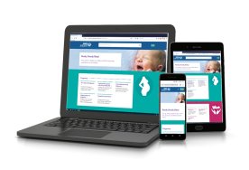 | Midwife/GP | Public Health Scotland | Online  Ready Steady Baby! (nhsinform.scot)  Translations & accessible formats  Ready Steady Baby! Translations - Publications - Public Health Scotland
 | Ready Steady Baby!  The online version revised in 2025 |  | Universal | Weblink only
  Preconception &1st Booking visit (Can be assigned to BN @ 8-12 weeks) | Healthy food and mood in pregnancy:  This leaflet gives information on a healthy diet and keeping active in pregnancy.  2023 Revised Edition | 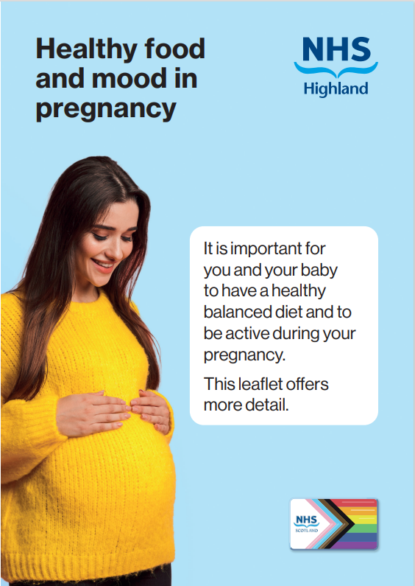 | Midwife/GP or Family Nurse | NHS Highland
 |  |  | Targeted | HIRS L1CPB/007/L
Preconception &1st Booking visit (can be assigned to BN @ 8-12 weeks  New for 2025 | Perinatal Mental Health Condition- Advice for women, birthing parents and their partners: This toolkit offers guidance on mental health before, during, and after pregnancy on a phone app. |  | Midwife/GP or Family Nurse | Health Improvement Scotland/ SIGN | Right Decisions: Health & Care on the App Store  Right Decisions: Health & Care – Apps on Google Play
 |  |  | Targeted | Phone app.
1st Booking Visit  (can be assigned to BN @ 8-12 weeks) | Ready Steady Baby- Easy Read Booklets  The booklets are split into 3 different sections.  - Booklets 1-7 are a guide to pregnancy  - 8-12 cover labour and birth  - 12-19 baby’s first 8 weeks  November 2023 version | 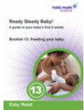  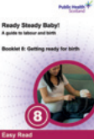  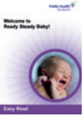  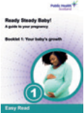 | Midwife/GP or Family Nurse | Public Health Scotland | PDFs can be downloaded here  Ready Steady Baby easy read - Publications - Public Health Scotland  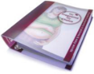  These replace my pregnancy my choice resource.
 |  |  | Targeted | HIRS L1BAB/069/L

1st Booking visit | Ready Steady baby  Encompasses pre-birth until baby is 8 weeks old.  All women should be offered a hard copy of this resource  Revised edition 2025 | 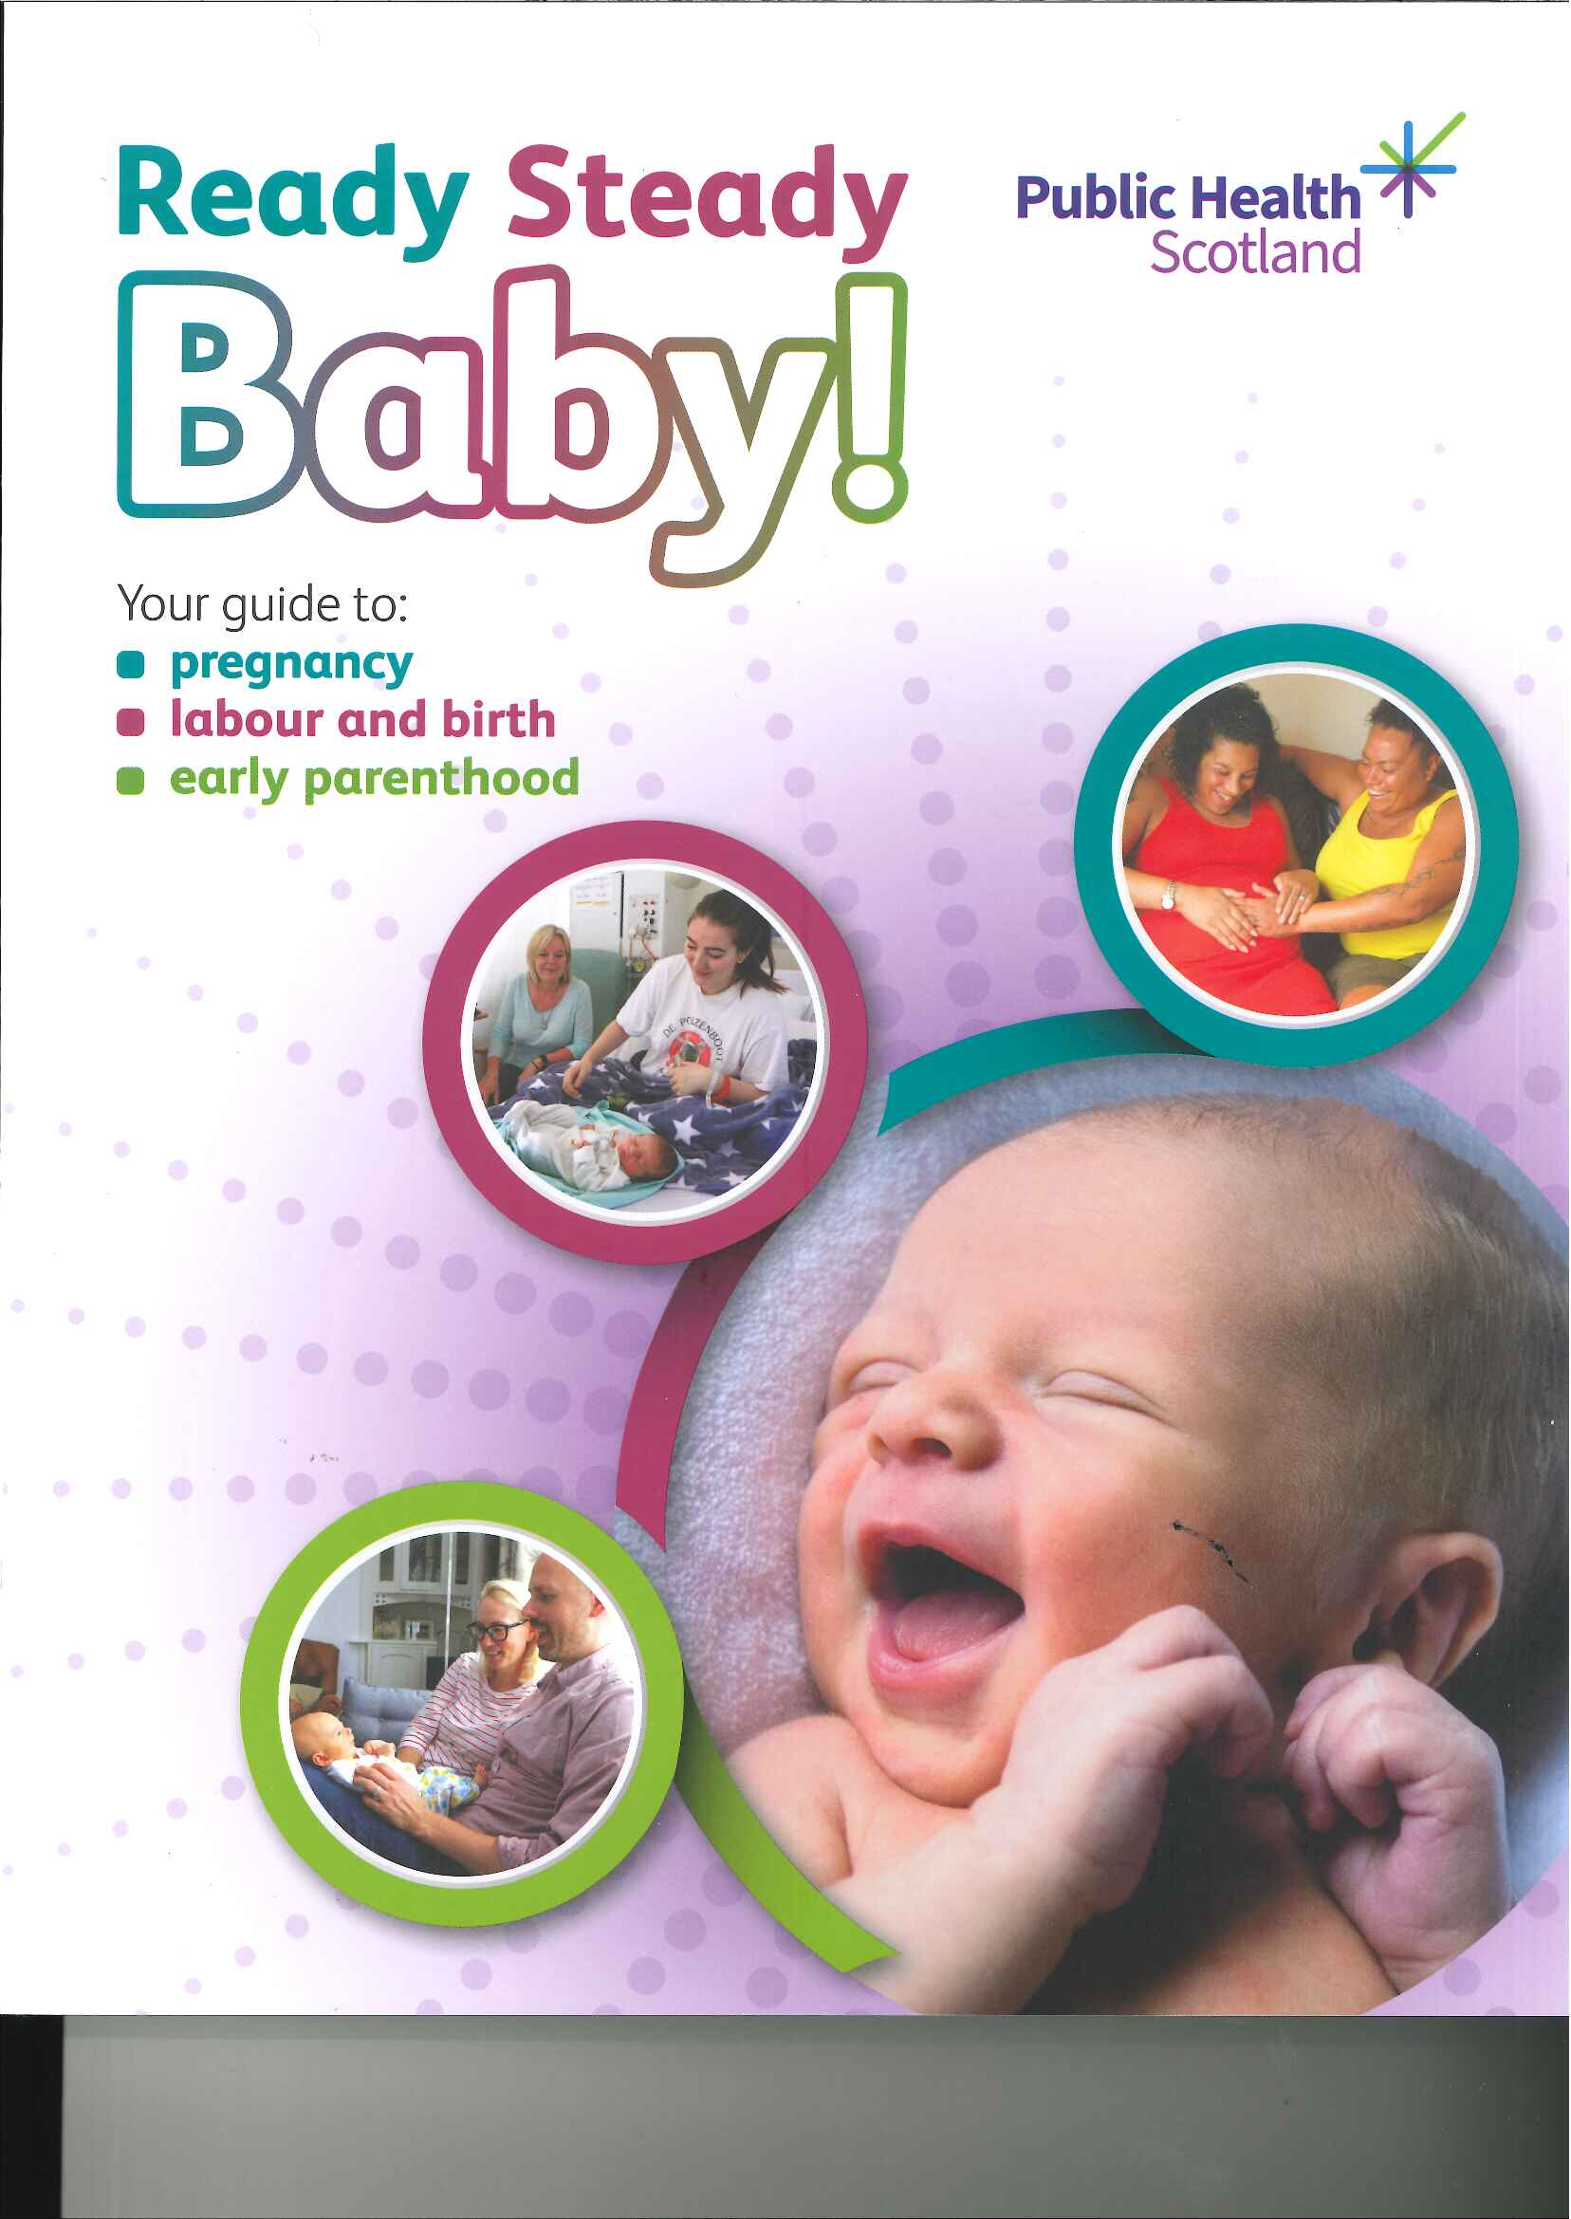 | Midwife or Family Nurse |  | Public Health Scotland | Available in Arabic, Polish and simplified Chinese (Mandarin) and Ukrainian  Ready Steady Baby Translations  Alternative formats (Braille, Large print, and audio versions) email  phs.otherformats@phs.scot
1st Booking visit |  |  | Universal |  | HIRS L1CPB/003/L
1st Booking Visit    Should be ordered and issued alongside the RSB | Ready Steady Baby Vaccines in Pregnancy  Explains why vaccines are offered during pregnancy covers covid-19, flu, and whooping cough  April 2025 | 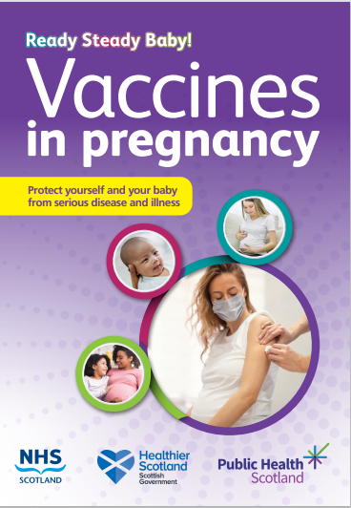 | Midwife, Family  Nurse, |  | Public Health Scotland | Available in Arabic, Polish, and simplified Chinese (Mandarin) and Ukrainian  Public Health Scotland-Vaccines in pregnancy leaflet  Alternative formats (Braille, Large print, and audio versions) email  phs.otherformats@phs.scot
 |  |  | Universal |  | HIRS L1IMM/037/L
1st Booking visit | Winter vaccines 2024: Flu and COVID-19  Information leaflet explaining about the winter flu & COVID-19 vaccines for pregnant women | 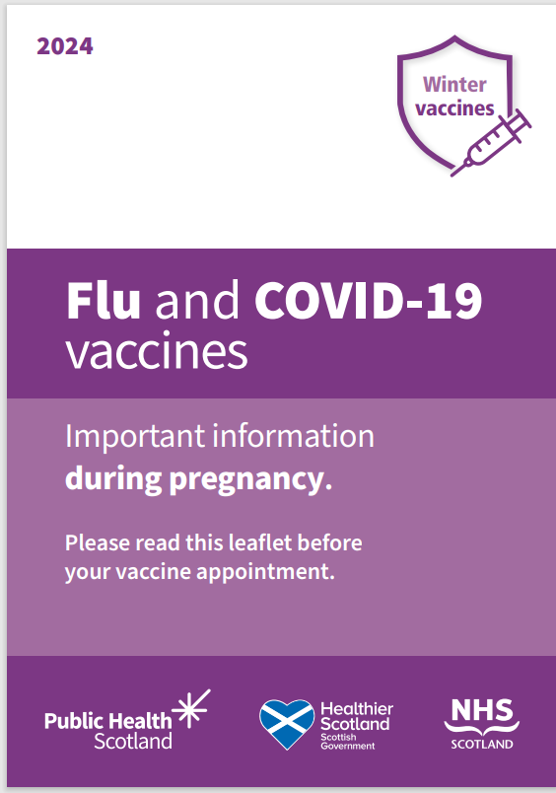 | Midwife, Family Nurse |  | Public Health Scotland | Translations and alternative formats (Braille, large print, audio versions and easy read) of this leaflet are available  phs.otherformats@phs.scot  0800 030 8013
 |  |  | Universal |  | HIRS L1IMM/042/L
1st Booking visit | Protect your baby against respiratory Syncytial Virus (RSV) This leaflet provides information on RSV vaccine which is offered during pregnancy to help protect babies against serious illness caused by RSV. | 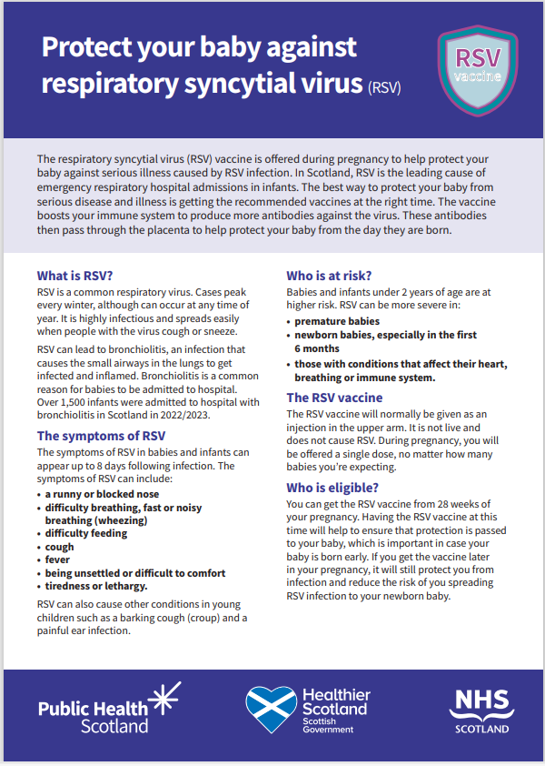 | Midwife, Family Nurse | Public Health Scotland |  | Translations and alternative formats (Braille, large print, audio versions and easy read) of this leaflet are available  Protect your baby against respiratory syncytial virus (RSV) - Publications - Public Health Scotland  phs.otherformats@phs.scot
 |  |  | Universal | HIRS L1IMM/045/L

1st Booking Visit | Cannabis Use During Pregnancy  A double-sided leaflet explaining the risks of cannabis use during pregnancy and where to get helps  New for 2022 | 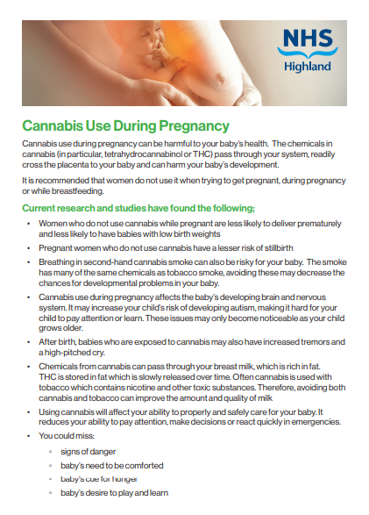 | Midwife, Family  Nurse, | NHS Highland | Available to download only. Printed copies by special request only  Cannabis Use During Pregnancy  Is currently being updated
 |  |  | Targeted | x1CPB/001/x
Preconception &1st Booking visit (Can be assigned to BN @ 8+12 weeks) | Group B Streptococcus (GBS) in pregnancy and newborn babies  This new leaflet can be given to pregnant women who request more information about GBS than is given in the RSB.  Reviewed 2022 | 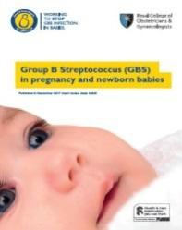 | Midwife or family Nurse | RCOG & Group B Strep Support Group (GBSS) | Can also be downloaded along with other useful leaflets from  Group B Streptococcus (GBS) in pregnancy and newborn babies  Sheets of GBS yellow Alert stickers and other resources can be ordered free from  Group B Strep Support Shop
 |  |  | Targeted | HIRS L1CPB/023/L
1st Booking visit (Will be assigned to BN @ 8+12 weeks) | My pregnancy and post-birth wellbeing plan  A helpful tool to assist women to plan how  to manage their emotions and keep mentally well during pregnancy and following the birth of their baby | 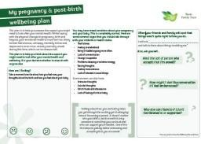 | Midwives or family nurse | Tommy’s | Available to download  My pregnancy and post-birth wellbeing plan
 |  |  | Universal | Download only  HIRS 1BAB/027/X
1st Booking visit (Will be assigned to BN @ 8+12 weeks) | Cervical Screening during Pregnancy a leaflet clarifying cervical screening recommendations during pregnancy  Revised edition May 2023 | 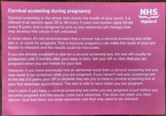 | Midwife or Family Nurse | NHS Highland  RCOG | Download only- NHS Highland intranet  Cervical Screening during Pregnancy  RCOG  Cervical smears and pregnancy patient information leaflet
 |  |  | Universal | HIRS L1BAB/031/X
1st Booking visit (Will be assigned to BN @ 8+12 weeks) | You're Pregnant! Scans and Tests  This booklet explains the screening and diagnostic tests you can have in pregnancy.  Revised edition 2024 | 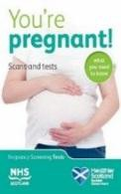 | Midwife or Family Nurse | Public Health Scotland | Available to download in Arabic, Farsi, Latvian, Polish, Punjabi, Romanian, Russian, simplified Chinese (Mandarin), Spanish, Turkish, Ukrainian, Urdu, and Vietnamese  Also, Easy read and large print format  You're Pregnant! Scans and Tests  Alternative formats (Braille and audio versions) email  phs.otherformats@phs.scot
 |  |  | Universal | HIRS L1CPB/002/L

1st Booking visit (will be assigned to BN @ following blood results) | Your pregnancy, your choice given to women who receive a higher-chance screening result for Down’s syndrome, or Edwards’ or Patau’s syndrome  Revised edition Nov. 2023 | 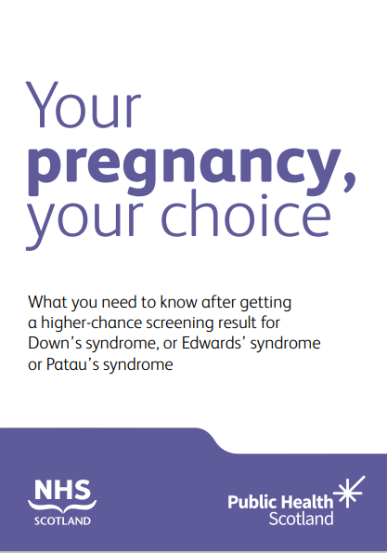 | Screening midwife | Public Health Scotland | Available to download in Arabic, Polish, and simplified Chinese (Mandarin) and Ukrainian  Also, in Easy Read format  Your pregnancy, your choice  Alternative formats (Large print, Braille, and audio versions) email phs.otherformats@phs.scot
 |  |  | Targeted | HIRS L1BAB/060/L
1st Booking visit (Will be assigned to BN @ 8+12 weeks) | Protect your baby from whooping cough  July 2024 edition | 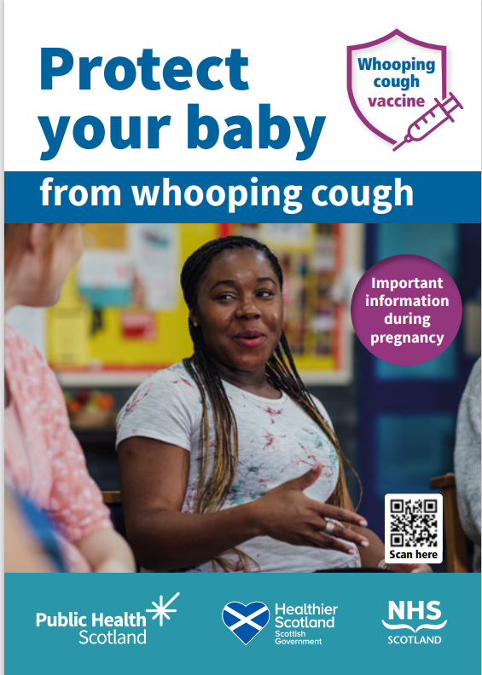 | Midwife or Family Nurse | Public Health Scotland | Available to download in Arabic, Polish, Russian, simplified Chinese (Mandarin), traditional Chinese (Cantonese) and Ukrainian  Also, in Easy Read & Large Print format  Protect your baby from whooping cough  Alternative formats (Large print, Braille, and audio versions) email phs.otherformats@phs.scot
 | Protect your baby from whooping cough  July 2024 edition |  | Universal | HIRS L1IMM/016/L
1st Booking visit  *Given as hard copy at booking | FW8 prescription exemption form | 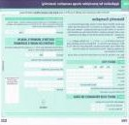 | GP/Midwife or Family Nurse | Banner Business | From August 2022, an exemption certificate is no longer issued. In Scotland, the FW8 form will be accepted as proof of pregnancy for dental treatment.  Application for Maternity Exemption Certificates | Scottish Dental
1st Booking visit  *Given as hard copy at booking | FW8 prescription exemption form |  | Universal | Banner Business
1st Booking visit (Will be assigned to BN @ 8+12 weeks) | Best Start Foods  Should be offered to all pregnant women at booking and will be taken up by those who are eligible.  The application for Best Start foods and pregnancy grant is the same and should only need filling in once. | 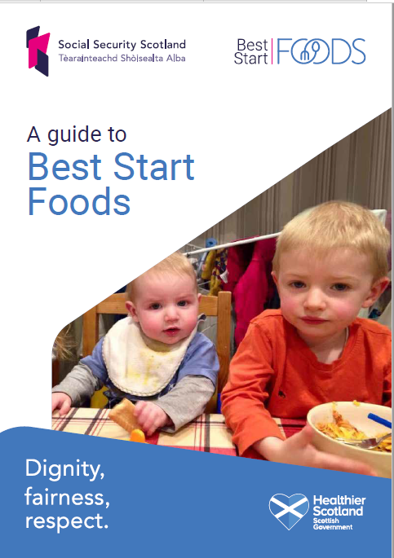 | Midwife or Family Nurse | Scottish Government | Clients can apply online Best Start Foods and Grant, on the telephone 0800 182 2222 or by filling out a paper form which can be downloaded here  Best Start Grant and Foods single application form  Available in alternative languages and formats by calling  0800 182 2222
 |  |  | Universal | Download only

1st Booking visit (Will be assigned to BN @ 8+12 weeks) | Vitamin D and you  This leaflet explains the benefits of getting enough vitamin D as part of a healthy diet.  Updated 2023 | 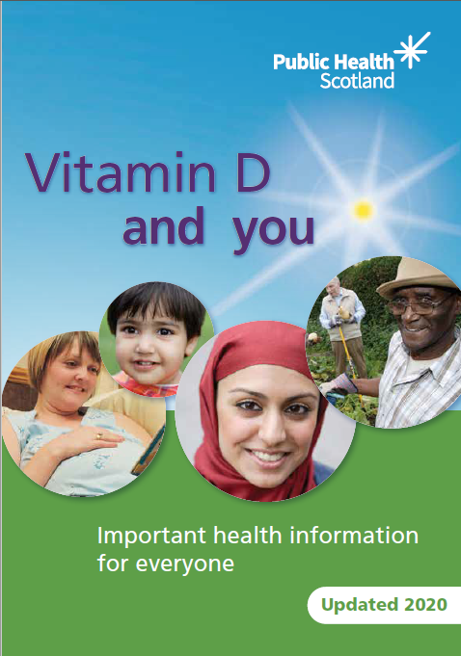 | Midwife or Family Nurse | Public Health Scotland | Available to download in multiple languages Also, in Easy Read format  Vitamin D and you  Information for professionals re new doses etc available here:  Alternative formats (Large print, braille, and audio versions) email phs.otherformats@phs.scot
 |  |  | Universal | HIRS L1FOO/002/L
1st Booking visit (Can be assigned to BN @ 8+12 weeks) | I Quit: stopping smoking when you're pregnant  This booklet is designed to help pregnant smokers, and their midwives work with local stop smoking services. | 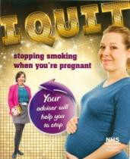 | Midwife or Family Nurse | Public Health Scotland | If pregnant smokers have any questions or need more information, they can be directed to the Specialist midwives for Smoking Cessation or call Smokeline free on 0800 84 84 84 to speak to an expert, or visit www.quityourway.scot
 |  |  | Targeted | HIRS L1DRS/050/L
1st Booking visit (Will be assigned to BN @ 8+12 weeks) | Carbon Monoxide, smoking and your baby to be given to ALL women who are smoking, recent  quitters or with a CO reading  of 4ppm or above | 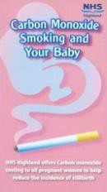 | Midwife, Family Nurse or Smoking Cessation Advisor | NHS Highland
 |  |  | Targeted | HIRS L1DRS/047/L
1st Booking visit (Will be assigned to BN @ 8+12 weeks)  Also, in Red book pack given by HV at primary visit whilst stocks last | Smoke free Homes and cars  Gives information to families on the benefits of smoke- free homes and cars  Download only | 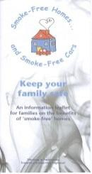 | Midwife, Family Nurse or Smoking Cessation Advisor | NHS Highland | Contains tear-off form to complete and return to sign up to the ’Smoke-Free Homes and Cars Challenge includes a FREEPOST pre-paid addressed envelope. A pack will then be posted out.  Download only  Smoke free Highland
 |  |  | Targeted | X1drs/051x new code

1st Booking visit (Can be assigned to BN @ 8+12 weeks) | Help keep your baby safe and healthy  Describes the risk of harm to a baby from drinking alcohol when pregnant.  Updated 2025 | 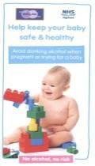 | Midwife, Family Nurse | HADP/NHS Highland | 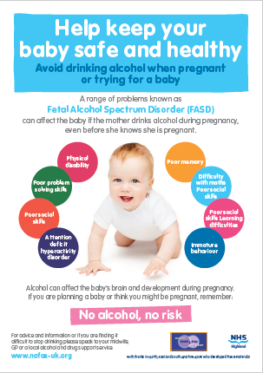  Promotes the message of ’No Alcohol When Pregnant, No Risk ’. Describes Fetal Alcohol Spectrum Disorder (FASD).  A4 Poster also available to order via  HIRS P1/CPB/002/P
 |  |  | Targeted | HIRS L1CPB/021/L
1st Booking visit (Can be assigned to BN @ 8+12 weeks) | Information for adult haemoglobinopathy carriers, sickle cell, beta thalassaemia For parent who are found to be carriers following booking bloods.  Version 2014 (reviewed 2024) | 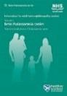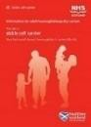 | Midwife, Family Nurse | Public Health Scotland | Download only from  Information for adult haemoglobinopathy carriers, sickle cell, beta thalassaemia  Available in Arabic, Polish, and simplified Chinese (Mandarin) and Urdu  Also, in Easy Read format  Alternative formats (Large print, Braille, and audio versions) email phs.otherformats@phs.scot
 |  |  | Targeted | Download only
1st Booking visit  *Given as hard copy  This handy leaflet contains contact details of local CAB offices and highland council helpline | Worrying about money All women should be asked if they have any money worries and referred to their local CAB office for a financial health check for specialist advice on benefits, debt, housing etc | 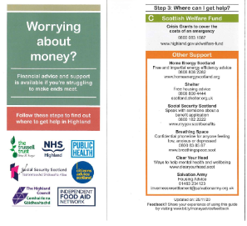 | Midwife or Family Nurse | NHS Highland Public Health Department | Contact details of local CAB offices can also be found here  Alternatively, the Council’s Welfare Support Team can be contacted on Tel: 0800 090 1004 or email welfare.support@highland.gov.uk  SMP and MA pay guides can be accessed  Statutory Maternity Pay & Maternity Allowance  see asking about money worries short clip  https://www.youtube.com/watch?v=ge2XedoG_T8&feature=youtu.be
 |  |  | Universal | HIRS LMONE/001/L
1st Booking visit  *Given as hard copy | Worrying about money  Promotional business card for the ‘Worrying About Money’ app  The app is free and allows individuals identify financial advice and support that is available locally in Highland. |  | Midwife or Family Nurse | Joint Publication NHS Highland/Highland Council | 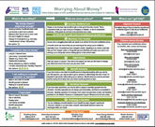  An A5 crib sheet is also available to download from HIRS detailing where to best signpost service users.  HERE  Polish version available to download only  HERE
1st Booking visit  *Given as hard copy |  |  | Universal | HIRS PC4MON/001/PC

1st Booking visit (Can be assigned to BN @ 8+12 weeks) | Steps to deal with stress Limited stock of CD available | 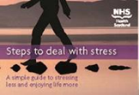 | Midwife or Family Nurse | Public Health Scotland | Available in Polish, traditional Chinese (Cantonese), Urdu, Audio (English) and in Easy Read format  Steps to deal with stress: A simple guide to stressing less and enjoying life more (healthscotland.com)  A relaxation CD is also available to order- HIRS L1MEN/032/L- once stock runs out it will be available as a download  What to do if you are struggling with stress
 | Steps to deal with stress Limited stock of CD available |  | Targeted | HIRS L1MEN/018/L
1st Booking visit (Will be assigned to BN @ 8+12 weeks) | The NHS Minor Ailment Service  8-page leaflet explaining this service, available to pregnant women and under 16 (under 19 in full time education)  2013 Version | 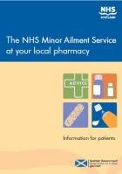 | Pharmacist, Midwife or Family Nurse | Scottish Government | Available to download only  The NHS Minor Ailment Service at your local pharmacy
 |  |  | Universal | Download only
1st Booking visit (Can be assigned to BN @ 8+12 weeks) | Protect your baby against tuberculosis (TB)  For non-routine immunisation – offered to babies who are more likely to come into contact with tuberculosis  December 2023 version |  | Midwife or Family Nurse | Public Health Scotland | Available in Arabic, Bengali, simplified Chinese (Mandarin), Polish, Ukrainian, Urdu  Also, in Audio (English) Easy Read- English, Dali & Pashto and in large print format  Protect your baby against tuberculosis (TB)  Alternative formats (Braille, and audio versions) email phs.otherformats@phs.scot
 |  |  | Targeted | HIRS L1IMM/015/L
1st Booking visit (Can be assigned to BN @ 8+12 weeks) | Protect your baby from hepatitis B  For non-routine immunisation – offered to babies who are more likely to come into contact with hepatitis  August 2024 version | 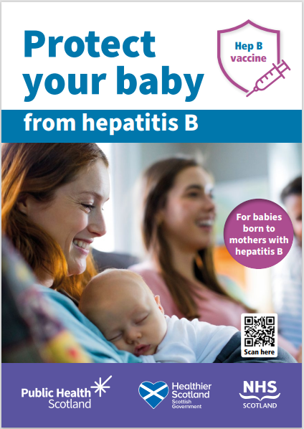 | Midwife or Family Nurse | Public Health Scotland | Available in traditional Chinese (Cantonese), Polish and Urdu  Also, in Audio (English) Easy read format  Protect your baby against hepatitis B  Alternative formats (Large print, braille, and audio versions) email phs.otherformats@phs.scot
 |  |  | Targeted | HIRS L1IMM/011/L

1st Booking visit (Can be assigned to BN @ 8+12 weeks) | Farming leaflet This leaflet advises women on the risks of contact with farm animals in pregnancy and how to avoid contracting chlamydiosis, toxoplasmosis, listeriosis and Q fever. | 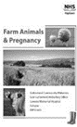 | Midwife or Family Nurse | NHS Highland | Available as pdf download only  Currently being updated
 |  |  | Targeted | Download Only | Available as pdf download only  Currently being updated
1st Booking visit (Will be assigned to BN @ 8+12 weeks) | Tommy’s When to call the midwife Infographic  This useful info graphic provides simple guidance on when to call the midwife particularly useful for prims, those with literacy or language barriers. | 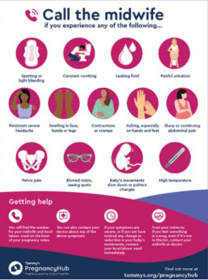 | Midwife or Family nurse | Tommy’s | Available to download only via link  When to call the midwife infographic  can be printed and given or/ forwarded for women to download to their phones or other devices
 |  |  | Universal | Download Only
1st Booking visit | Healthy Start Vitamins are offered free to all pregnant women throughout pregnancy, Midwives should issue two bottles at first contact and 2 at the 22-week contact | 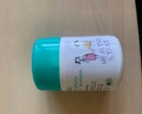 | Midwife or Family Nurse | Healthy Start | Contain vitamins D & C and folic acid, 56 tablets per pot should last approximately 2 months
1st Booking visit |  |  | Universal | HIRS VT1BAB/003/VT
1st Booking visit | Perinatal and Infant Mental Health Team information leaflet  The leaflet contains contact details, and describes what the team is for, and the services they can provide. | 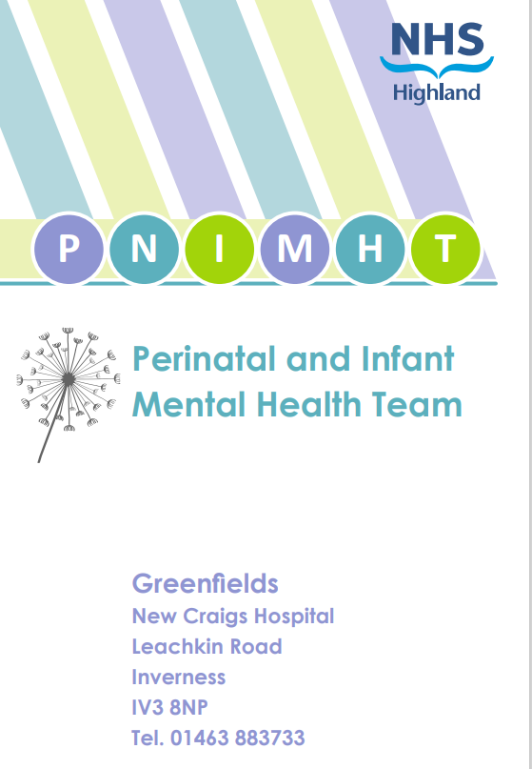 | Midwife | NHS Highland | This leaflet is for women who have been referred to the PNIMHT and will be sent to women who are offered an appointment.  Information leaflet can be downloaded from  PNIMHT leaflet-HIRs
 |  |  | Targeted | Download Only  1MEN/071/x
Prior to Dating Scan (will be assigned to BN at 8 - 12 weeks) | Leaflet explaining what to expect at the first booking scan | 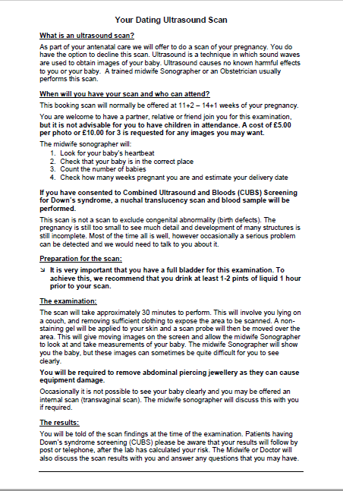 | Midwife | NHS Highland
 | Leaflet explaining what to expect at the first booking scan |  | Universal | Download only
1st Booking visit  *Given as hard copy | FNP  Promotional business card  Given to all pregnant young women 20 years old and under (25 years old if care experienced) at booking. Informing them that a Family Nurse will contact them | 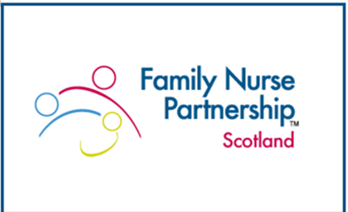 | Midwife | Highland Council/NHS Highland
 |  |  | Targeted | Order from FNP-

1st Booking visit (Will be assigned to BN @ 8-12 weeks  New for 2025 | FGM- a statement opposing female genital mutilation  This leaflet explains the legal position in Scotland on FGM. FGM is a serious criminal offence in Scotland and throughout the UK. It also provides information on support available. | 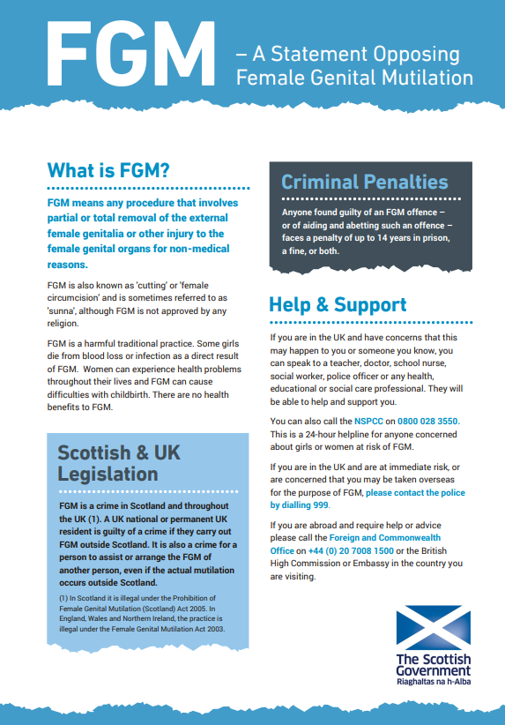 | Midwife | Scottish Government |  | Available to download in different languages  Scottish Government Female Genital Mutilation (FGM) statement: 2015 - gov.scot
 |  |  | Targeted | Download only
1st Booking visit (Will be assigned to BN @ 8+12 weeks)  New for 2025 | Birthplace decisions: information for pregnant women and partners on planning where to give birth  This leaflet can be used to support discussions with women & their partners, when deciding where to give birth  February 2025 | 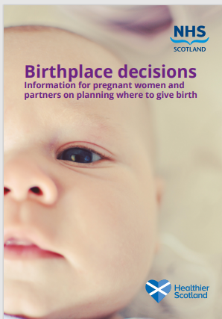 | Midwife |  | Scottish Government | Available to download in different languages  Birthplace decisions: information for pregnant women and partners on planning where to give birth - gov.scot
 |  |  | Universal |  | L1BAB104/L
1st ANC appointment  (will be assigned to BN 18-20 weeks)  New for 2025 | Information about Deinfibulation  This leaflet describes deinfibulation procedure for women affected by female genital mutilation | 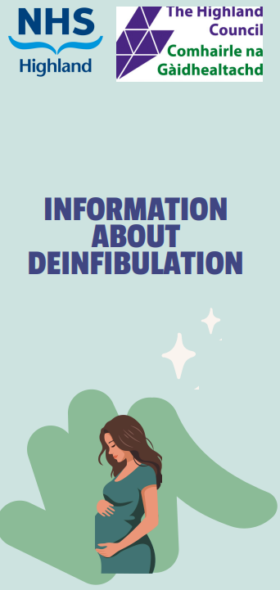 | Consultant Obstetrician | NHS Highland/Highland Council |  | Awaiting translations
 |  |  | Targeted | Download only |  | Awaiting translations

22–25 weeks pregnant | Before Birth – You can make a difference Words up Baby leaflet - 4 key messages to develop good communication and relationships before baby is born. | 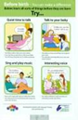 | Midwife | Highland Council | This resource was updated and is now double sided, it replaces the original “From the beginning leaflet”
 |  |  | Universal | HIRS L1BAB/035/L
22–25 weeks pregnant | Baby buddy APP from best beginnings full of useful advice and tips with video clips around mental health and breast feeding, great sections for fathers too. | 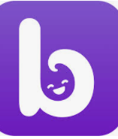 | Midwife or Family Nurse | Department for Work and Pensions | Available to download as an app  Baby Buddy app | Best Beginnings
22–25 weeks pregnant |  |  | Universal
22-25 Week visit (can be assigned to BN @ 22 weeks) | Get extra help to balance your budget: This -page leaflet details the 5 Best Start payments available to eligible women including Best Start Foods  New version 2025 |  | Midwife or Family Nurse | Social Security Scotland | For further information on eligibility and to apply https://www.mygov.scot/pregnancy-and-baby-payment/  Printable form for posting  Best Start Grant and Foods single application form
 |  |  | Targeted | HIRS L1CHI/009/L
22-25 Week visit (can be assigned to BN @ 22 weeks) | Building a Happy Baby: A Guide for Parents  This leaflet offers advice and information for parents on getting to know their baby and setting up the foundations for a close a loving relationship. | 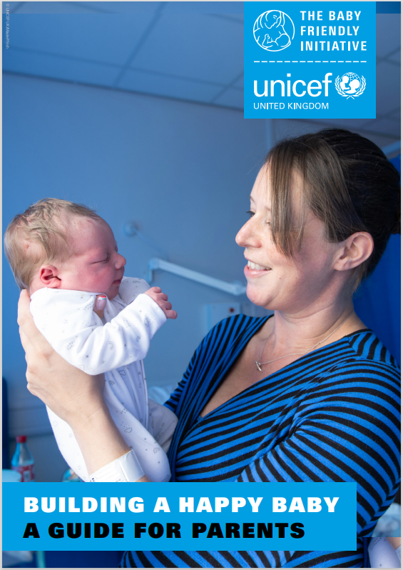 | Midwife | Unicef | A Available to download from HIRS  Building a Happy Baby: A Guide for Parents
 |  |  | Universal | 1BAB/033/X
22-25 Week visit (information leaflet will be assigned to BN @ 22 weeks but hard copy form will still need completed in hard copy) | Scotland’s Baby Box  Form to be completed by midwife at around 22 weeks and will be delivered to women around 36 wks.  More information (contents, etc) is available at  Baby box | Parent Club | 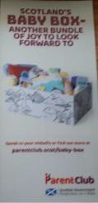 | Midwife or Family Nurse | Scottish Government | In unfortunate circumstances such as still birth, delivery of a box may be cancelled via 0800 030 8003 or by emailing scotlandsbabybox@theapsgroup.com quoting the registration number on the leaflet.
 |  |  | Universal | Registration cards can be ordered via email scotlandsbabybox@theapsgroup.com

22-25 Week visit (Will be assigned to BN @ 22 weeks)  Updated October 2024 | Feeling your Baby move is a sign they are well/Reporting reduced fetal movements. What should I expect? 2-sided leaflet consistent with national guidelines aiming to tackle misinformation, the flip side explains what care women should receive when they report RFM’s | 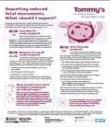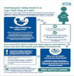 | Midwife or Family Nurse |  | Tommy’s | First page available in multiple languages and audio version (English) via link  Feeling your baby move is a sign they are well
 |  |  | Universal |  | HIRS 1CPB/024/L
22–25-week visit | MATB1 maternity certificate Allows women to claim SMP and Maternity Allowance Issued to all women from 20 Weeks pregnant | 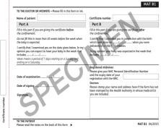 | Midwife or Family Nurse |  | Department for Work and Pensions | Order MatB1 certificates
22–25-week visit |  |  | Universal |  |  | Order MatB1 certificates
22-25 Week visit (Will be assigned to BN @ 22 weeks)  New for 2025 | Contraception after having a baby:  There are lots of choices of contraception after having a baby. This leaflet helps you make that decision. | 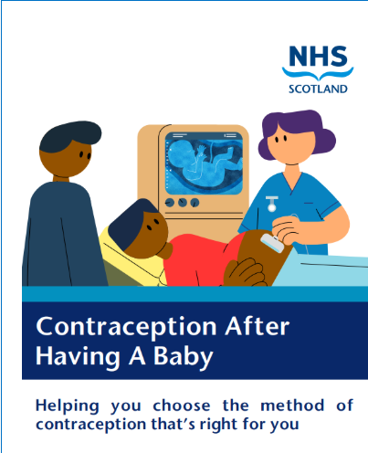 | Midwife or Family Nurse |  | Family planning association | Information can also be accessed here  Contraception, STI and Health Guides for Medical Professionals
 |  |  | Universal |  | HIRS L1Cpb/028/l
22-25 week visit  *Given as hard copy  New for 2025 | Receiving anti-D immunoglobulin in pregnancy This leaflet explains blood group D and antibodies. It also explains the importance of preventing haemolytic disease of the fetus & newborn (HDFN) | 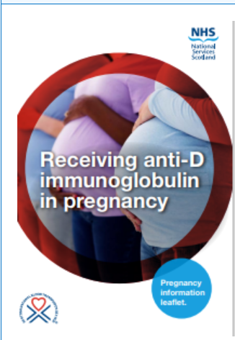 | Midwife | NHS Scotland/Scottish National Blood Transfusion
22-25 week visit  *Given as hard copy  New for 2025 |  |  | Targeted | HIRS L1BAB/100/L

28 Week visit (Will be assigned to BN @ 28 weeks) | Off to a good start: All you need to know about breastfeeding  June 2023 version  New 2025 version | 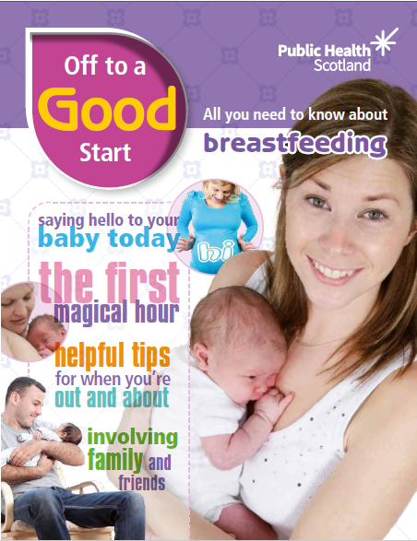 | Midwife or Family Nurse |  | Public Health Scotland | Available to download in Arabic, Polish and Ukrainian  Also available in easy read (Accessible) format  Off to a good start: All you need to know about breastfeeding  Alternative formats (Large print, braille, and audio versions) email phs.otherformats@phs.scot
 |  |  | Universal |  | HIRS L1BAB/004/L
28 weeks pregnant | From Bump to Breastfeeding  These videos clips are useful for all pregnant women, especially those considered to have literacy issues, or would benefit from an audio/visual format, alternative language, or have limited digital access. | 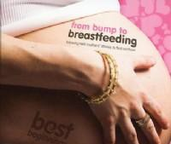 | Midwife or Family Nurse |  | Produced by Best Beginnings and distributed by Public Health Scotland | The full set of DVD video clips are available online at the Best Beginnings website: www.bestbeginnings.org.uk/from-bump-to- breastfeeding
28 weeks pregnant |  |  | Video Clips- Universal |  | Online
28 Week visit | SilverCloud  An online programme designed to relieve symptoms of worry and low mood in the perinatal period |  | GP | NHS Inform |  | SilverCloud is a website with courses to improve mental wellbeing by using CBT techniques  Get help with your mental health and wellbeing | NHS inform
28 Week visit |  |  | Targeted | Online- access code: NHS24
28 Week visit (Can be assigned to BN @ 28 weeks) | Pregnancy Related Pelvic Girdle Pain A leaflet for women experiencing pelvic girdle pain giving self-care advice  2023 Version | 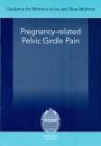 | Midwife | POGPH |  | Information helping pregnant women to manage symptoms of Pelvic Girdle Pain
28 Week visit (Can be assigned to BN @ 28 weeks) |  |  | Targeted | HIRS LCPB/006/L

28 Week visit (Can be assigned to BN @ 28 weeks) | My Caesarean Delivery Journey: the enhanced recovery approach  A leaflet for women who are having a planned Caesarean Section, outlining the care to expect before, during and after the birth. | 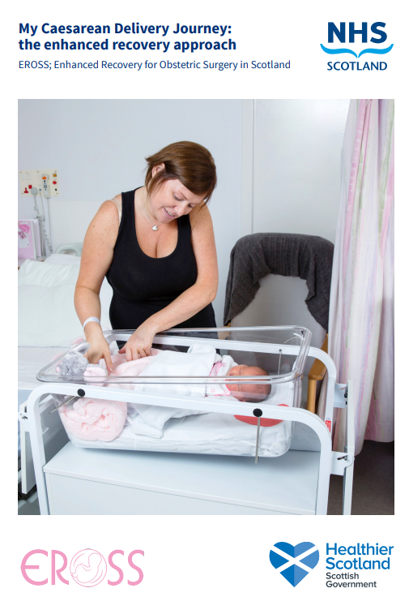 | ANC Staff | NHS Highland | Available at consultant ANC’s when elective surgery is booked.
 |  |  | Targeted
28 Week visit (Will be assigned to BN @ 28 weeks) | Your baby! Tests offered This booklet explains what condition your baby can be tested for and what the tests involve.  April 2025 | 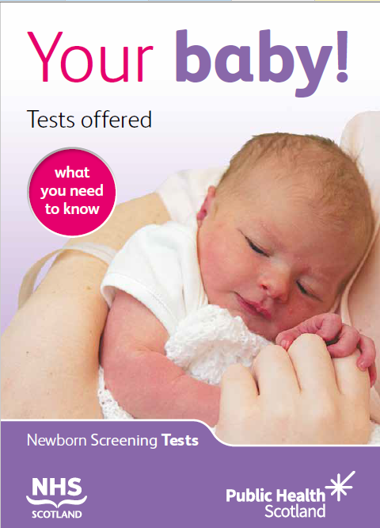 | Midwife or Family Nurse | Public Health Scotland | Available in Arabic, simplified Chinese (Mandarin), Polish and Urdu,  Also, in Easy Read and Audio (English)  Your baby! Tests offered  Alternative formats (Large print, braille, and audio versions) email phs.otherformats@phs.scot
 |  |  | Universal | HIRS L1CPB/004/L
HV  32–34 weeks | Money worries Leaflet  Pre-birth contact from HV | 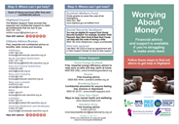 | Health Visitor or Family Nurse | Joint Publication NHS Highland/Highland Council | This leaflet should also be offered at booking but serves as a reminder that financial circumstances may have changed and should be discussed.
HV  32–34 weeks | Money worries Leaflet  Pre-birth contact from HV |  | Universal | HIRS LMONE/001/L

Post-birth prior to discharge from hospital or home birth (Will be assigned to BN @ 1day post birth ) | Formula feeding: How to feed your baby safely  To make an informed decision around infant  feeding and information on how to formula feed safely. Endorsed by UNICEF baby  friendly initiative.  September 2024 | 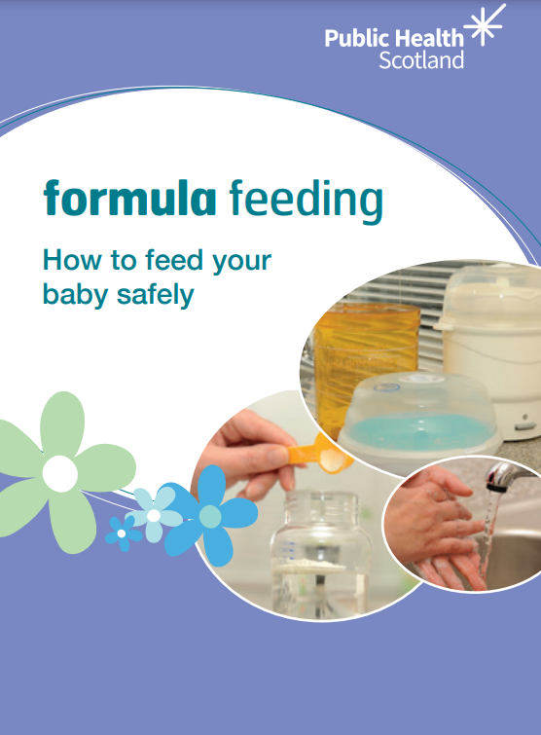 | Midwife or Family Nurse | Public Health Scotland | Available in Polish, Arabic, Polish, Romanian, Slovakian, Urdu and easy read (English)  Formula feeding: How to feed your baby safely  Now available to order form HIRS in an easy read format L1BAB/049/L
 |  |  | Universal | HIRS L1BAB/018/L  Easy read: L1BAB/049/L
Post-birth prior to discharge from hospital or home birth | Breastfeeding a baby with Down Syndrome  We hope this guide will provide you with all the information you need to enjoy a successful breastfeeding relationship with your baby. | 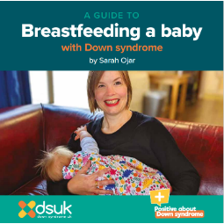 | Midwife or Family Nurse | Down Syndrome UK | Download from HIRS  Breastfeeding a baby with Down Syndrome
 |  |  | Targeted | Download only  HIRS L1BAB/034/X1 | Download from HIRS  Breastfeeding a baby with Down Syndrome
Post-birth prior to discharge from hospital or home birth (Will be assigned to BN @ 1day post birth) | Child Benefit Form | 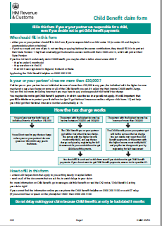 | Midwife or Family Nurse | HMRC | Child Benefit Claim Form Pack (Form CH2) is aimed at anyone responsible for a child. If you are unable to claim online, form available to download:  Claim Child Benefit if you cannot claim online - GOV.UK (www.gov.uk)
 | Child Benefit Form |  | Universal | HIRS L1BAB/028/L
Post-birth prior to discharge from hospital or home birth (can be assigned to BN @ 1day post birth) | Who can register a birth in Scotland  Website outlining the legal implications of birth registration and signposting to further help |  | Midwife or Family nurse | Scottish Government | For further Information  Joint Birth Registration
 |  |  | Targeted | Website only | For further Information  Joint Birth Registration
Post-birth prior to discharge from hospital or home birth (Will be assigned to BN @ 1day post birth) | Caring for your baby at night A5-sized colour booklet giving information on one of the biggest challenges for new parents - getting used to the changes that a baby will bring to their night-time routine  November 2022 version | 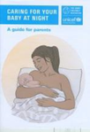 | Midwife or Family Nurse | Unicef | Parents leaflet can also be downloaded as pdf  Caring for your baby at night and when sleeping (unicef.org.uk)
 |  |  | Universal | HIRS L1BAB/025/L
Post-birth prior to Post-birth prior to discharge from hospital or home birth (can be assigned to BN @ 1day post birth)  Updated September 2024 | Safer sleep for babies: guide for parents and carers  provides parents and carers with evidence-based guidance for reducing the risks of SIDS and safe sleeping practice for babies  September 2024 | 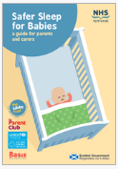 | Midwife or Family Nurse | Scottish Government | Available to download in multiple languages  Safer sleep for babies: guide for parents and carers  Alternative format (BSL and audio version)  Safer Sleep for Babies Quick Reference Card  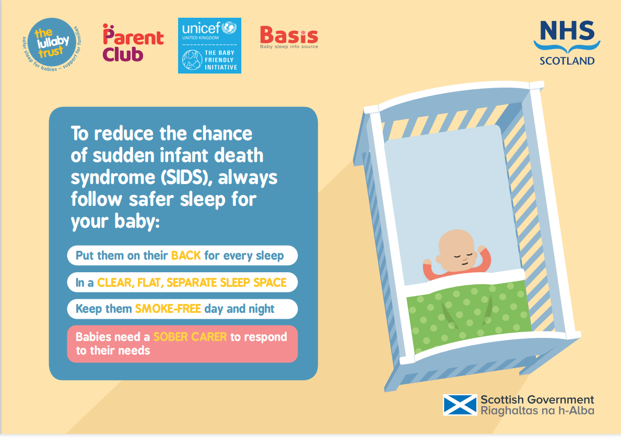
 |  |  | Universal | Full leaflet:  HIRS 1BAB/073/L  Quick guide:  HIRS1BAB/075/L  A Professional’s guidance is available to order  HIRS1BAB/074/L
Post-birth prior to discharge from hospital or home birth (can be assigned to BN @ 1day post birth) | Postnatal Breastfeeding Booklet  Gives local information or support available  Updated 2025 | 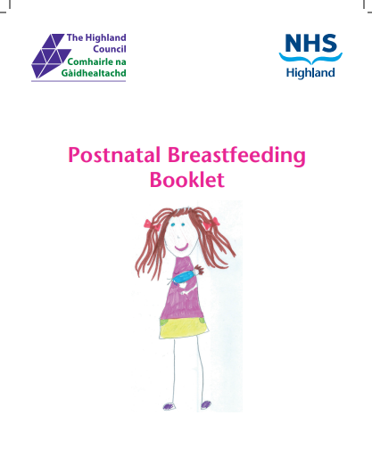 | Midwives/IFSW/FNP/HV | NHS Highland
 |  |  | Universal | HIRS L1BAB/068/L

Post-birth prior to discharge from hospital or home birth (will be assigned to BN @ 1day post birth  New for 2025 | Contraception after having a baby:  There are lots of choices of contraception after having a baby. This leaflet helps you make that decision. |  | Midwife or Family Nurse | FPA | Information can also be accessed here  Contraception, STI and Health Guides for Medical Professionals
 |  |  | Universal
Post-birth prior to discharge from hospital or home birth | Antidepressants and Breast feeding  This leaflet explains about antidepressants and breastfeeding. | 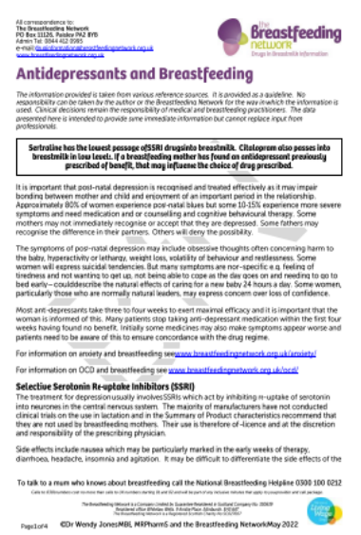 | Midwives/IFSW/FNP/HV | The Breastfeeding Network | Download only from HIRs  Antidepressants and Breastfeeding
 |  |  | Targeted | Download only  HIRS x1BAB/036/x1 | Download only from HIRs  Antidepressants and Breastfeeding
Post-birth prior to discharge from hospital or home birth (assigned to BN @ 1day post birth) | Some women start smoking after the birth of their baby. This leaflet helps new mothers stay away from cigarettes | 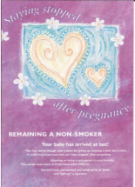 | Midwife or Family Nurse | GASP
 |  |  | Targeted | HIRS L1DRS/053/L

Post Birth Prior to discharge from hospital | Breastfeeding mums vitamin D only product  1 tub to be given out by midwives prior to discharge from hospital |  | Midwives |  | Pro Health Solutions | This tub contains 120 tablets and will last for approximately 4 months, HV will distribute thereafter if mum continues to breast feed
Post Birth Prior to discharge from hospital |  |  | Targeted |  | HIRS VT1BAB/002/VT
Post Birth Prior to discharge from hospital | Vitamin drops per guidance  1 bottle to be given out by midwives prior to discharge from hospital | 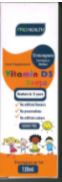 | Midwives |  | Pro health solutions | HV will distribute thereafter if mum continues to breast feed potentially changing at end of 2025
Post Birth Prior to discharge from hospital |  |  | Targeted |  | HIRS VT1BAB/002/VT
Post Birth Prior to discharge from hospital | Vitamin D and you  This leaflet explains the benefits of getting enough vitamin D as part of a healthy diet.  Updated 2023 |  | Midwives |  | Public Health Scotland | Available to download in multiple languages Also, in Easy Read format  Vitamin D and you  Information for professionals re new doses etc available here:  Alternative formats (Large print, braille, and audio versions) email phs.otherformats@phs.scot
 |  |  | Universal |  | HIRS L1FOO/002/L
Post Birth prior to discharge from hospital | Mastitis and Breastfeeding  This leaflet explains about mastitis; signs of mastitis, self-help measures, support available | 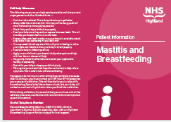 | Midwives/IFSW/FNP/HV |  | NHS Highland
 |  |  | Targeted |  | HIRS L1BAB/076/l1
Post Birth Prior to discharge from hospital | Feeling depressed and breastfeeding  This leaflet explains about feeling depressed and breastfeeding. It is important to ask for help. | 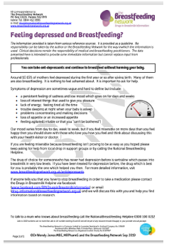 | Midwives/IFSW/FNP/HV |  | The Breast Feeding Network | Download only from HIRS  Feeling depressed and breastfeeding
 |  |  | Targeted |  | HIRS x1BAB/035/X | Download only from HIRS  Feeling depressed and breastfeeding
Post Birth Prior to discharge from hospital  New for 2025 | ICON-Infant Crying: How to cope  This leaflet explains that infant crying is a normal, often peaking between 6 to 8 weeks, and provides reassurance to parents that it is designed to get their attention and will eventually stop. | 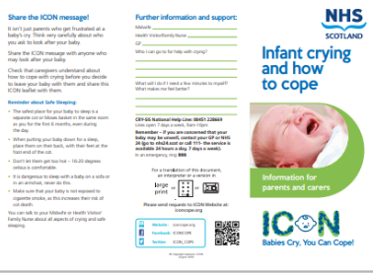 | Midwives/IFSW/FNP/HV |  | NHS Highland | Easy read versions of both leaflets and downloadable resources available HERE
Post Birth Prior to discharge from hospital  New for 2025 |  |  | Universal |  | HIRS L1BAB/102/L  HIRS L1BAB/103/L (Babies born prematurely)
Post Birth Prior to discharge from hospital  New for 2025 | Newborn pulse oximetry Screening test for babies born within NHS Highland | 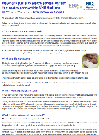 | Midwives | NHS Highland
Post Birth Prior to discharge from hospital  New for 2025 |  |  | Universal

CMW up to transfer of care  HV/FNP  At any point up to 12 months  New for 2025 | Worrying about money  All staff with contact with women & families should routinely ask about money worries & offer a hard copy of ‘Worrying About Money’ leaflet & promote the Worrying about Money? Highland App |  | Midwife/IFSW/ Health Visitor or Family Nurse |  | Joint Publication NHS Highland/Highland Council | To combat rising infant food insecurity driven by the cost-of-living crisis, the Highland Food Insecurity Pathway Pilot.  This will enable staff to urgently refer families for direct infant formula support through HALO, whilst offering referral to the Welfare Team welfare.support@highland.gov.uk
 |  |  | Universal |  | HIRS LMONE/001/L
HV Primary visit 10–14 days | Red Book  (Personal Handheld Child Health Record) | 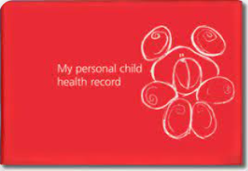 | Health Visitor or Family Nurse
HV Primary visit 10–14 days | Red Book  (Personal Handheld Child Health Record) |  | Universal |  | Initiated when birth notified
HV Primary visit 10–14 days | What to expect after immunisation: babies and children up to 5 years old  (To be issued to parents and carers after each immunisation)  New 2025 version | 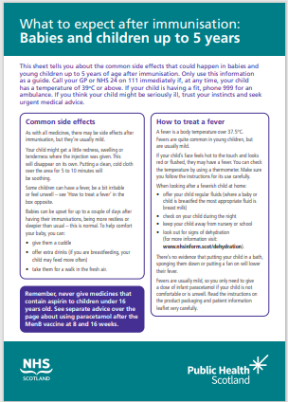 | Health Visitor or Family Nurse | Public Health Scotland |  | Available to download in multiple languages Also, in Easy Read and large print format  What to expect after immunisation: babies and children up to 5 years old  Alternative formats (Large print, braille, and audio versions) email phs.otherformats@phs.scot
HV Primary visit 10–14 days |  |  | Universal | HIRS L1IMM/001/L
HV Primary visit 10–14 days  In red book pack  New schedule commencing 1st July 2025 | Protect your child against serious disease  Provides information on the routine immunisations offered  May 2025 Version | 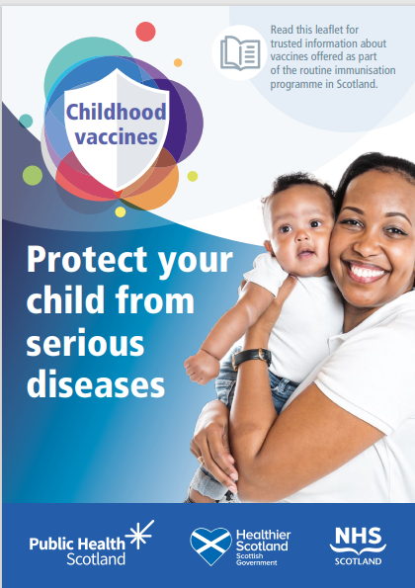 | Health Visitor or Family Nurse | Public Health Scotland |  | Available to download in multiple languages Also, in Easy Read and large print format  Protect your child against serious diseases - Publications - Public Health Scotland  This publication is also available in BSL and audio on NHS Inform
 |  |  | Universal | HIRS L1IMM/006/L
HV Primary visit 10–14 days | Handle with Care: How to keep your baby safe  Available to download, this leaflet is aimed at parents and explains why you should never shake a baby, how babies like to be held, how to cope with crying and  places to go for help. | 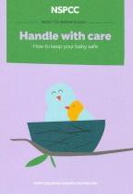 | Health Visitor or Family Nurse | NSPCC |  | Download only available from:  Handle with care: How to keep your baby safe
HV Primary visit 10–14 days |  |  | Targeted | Download only

HV Primary visit 10–14 days  Updated Sept. 2024 | Safer Sleep for babies provides parents and carers with evidence-based guidance for reducing the risks of SIDS and safe sleeping practice for babies |  | Health Visitor or Family Nurse | Scottish government | The full leaflet will be issued by Midwives post birth…offer this quick guide as a reminder  Safer Sleep for Babies Quick Reference Card .
HV Primary visit 10–14 days  Updated Sept. 2024 |  |  | Universal | Quick guide: HIRS1BAB/075/L
HV Primary visit 10–14 days | Physical activity for early years (birth- 5 years)  This Infographic outlines activity recommendations for 0-5 from the CMO’s report Start active, Stay active  2019 Version | 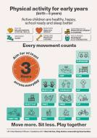 | Health Visitor or Family Nurse | Scottish Government | Available to download only  Physical activity for early years (birth- 5 years)
HV Primary visit 10–14 days |  |  | Universal | Download only
HV Primary visit 10–14 days | Baby Talk – I learn when I’m playing. Words up Baby leaflet - 4 key messages to develop good communication and relationships once baby is born. | 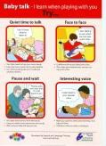 | Health Visitor or Family Nurse | The Highland Council | Available in Polish and Gaelic  Also available in poster A4 format under code via HIRS  HIRS P1BAB/011/P
HV Primary visit 10–14 days |  |  | Universal | L1/BAB/046/L
HV Primary visit 10–14 days | Meningitis Baby Watch Postcard giving information on Meningitis and Septicaemia symptoms  2017 version | 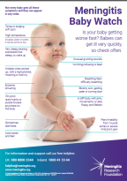 | Health visitor or Family Nurse | Meningitis Research Foundation | Download via  Meningitis Baby Watch Poster  Also, PDF available to download in Romanian  Meningitis professional Resources
HV Primary visit 10–14 days |  |  | Universal | HIRS PC1BAB/014/PC
HV Primary visit 10–14 days | Vitamin D and you  This leaflet explains the benefits of getting enough vitamin D as part of a healthy diet.  Updated 2023 |  | Health visitor or  Family Nurse | Public Health Scotland | Available to download in multiple languages Also, in Easy Read format  Vitamin D and you  Information for professionals re new doses etc available here:  Alternative formats (Large print, braille, and audio versions) email phs.otherformats@phs.scot
HV Primary visit 10–14 days |  |  | Universal | HIRS L1FOO/002/L
HV 3–5 weeks | Bookbug Baby Bag | 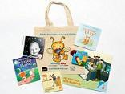 | Health Visitor or Family Nurse | Scottish Book Trust | Available in Gaelic from Local Bookbug Coordinator  Bookbug information available to download in various languages  Scottish Book Trust
 |  |  |  | Order from book bug coordinator

 | HV 3-5 weeks |  | play@home baby book  Introduces play activities and ideas which will contribute to each stage of the child’s development and promote parents and carers as the children’s first and most important teachers. |  | 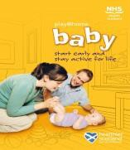 |  | Health Visitor or Family Nurse |  | Public Health Scotland |  | Alternative formats (Large print, braille, and audio versions) email phs.otherformats@phs.scot
 |  |  |  |  |  |  | Universal |  | HIRS L1/BAB/058/L
HV 6–8 weeks |  | Childsmile Practice  This leaflet is only available online.  Childsmile: Looking after your teeth poster |  | 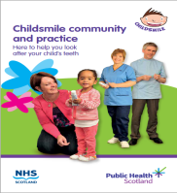  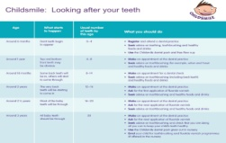 |  | Health Visitor or Family Nurse COHT |  | Public Health Scotland |  | Available to download in multiple languages  Also in audio format  Resources for Parent/Carers – Childsmile (nhs.scot)
 |  |  |  |  |  | Universal |  | Childsmile website
HV 6–8 weeks |  | First Teeth, Healthy Teeth  This resource is for Health Visitors, Family Nurses, or dental health professionals to use as a reference. It is not available for distribution to  Parents  2025 version |  | 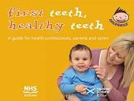 |  | Health Visitor or Family Nurse |  | Public Health Scotland |  | Available to download in English  Resources for Professionals – Childsmile (nhs.scot)
 |  |  |  |  |  | Universal |  | Childsmile Oral Health Teams
HV 6–8 weeks |  | Drinks for babies and young children  Also, option to give at various stages  1/2025 version |  | 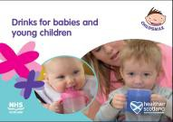 |  | Health Visitor, Family Nurse or COHT |  | Public Health Scotland on kind permission of Oldham Community Services |  | Available to download in multiple languages  Also, in audio format, BSL  Resources for Parent/Carers – Childsmile (nhs.scot)  Food & Eating | Parent Club
 |  |  |  |  |  | Universal |  | Childsmile Oral Health Teams (COHT) 1338
HV 3/4 months |  | Snack ideas for children  Ideas to help you provide a variety of healthy safe snacks for both you and your children to enjoy at home and at school or play  09/2024 Version |  | 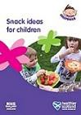 |  | Health Visitor, Family Nurse or COHT |  | Public Health Scotland |  | Available to download in multiple languages  Also, in audio format  Resources for Parent/Carers – Childsmile (nhs.scot)  Food & Eating | Parent Club
 |  |  |  |  |  | Universal |  | Childsmile Oral Health Teams (COHT) 1181

HV 3/4 months | Fun First Foods  (Discuss delaying until around 6 months)  2023 version |  | Health Visitor or Family Nurse | Public Health Scotland | Available to download in multiple languages Also, in Easy Read & audio format  Resources for Parent/Carers – Childsmile (nhs.scot)  Food & Eating | Parent Club
HV 3/4 months |  |  | Universal | Online  HIRS L1BAB/015/L
HV 3/4 months | Vitamin D3 tablets for Breast feeding mums  All Mums to be offered these free vit d3 tablets throughout their breast-feeding journey  Updated 2022 | 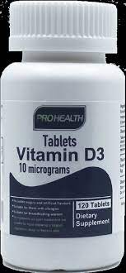 | Health Visitor or Family Nurse | Pro health solutions | This tub contains 120 tablets and will last for approximately 4 months  .  Midwives will issue the first pot prior to discharge from hospital
HV 3/4 months |  |  | Targeted | HIRS VT1BAB/001/VT
HV 3/4 months | Vitamin drops per guidance:  1 bottle at 4 months – HV/FN  2 bottles at 8 months – HV/FN  3 bottles at 13/15 months- HV/FN  2 bottles at 27/30 months – HV |  | Health Visitor or Family Nurse | Pro health solutions | Every child under 3 is now entitled to free vitamin D drops  Babies who are fed more than 500mls formula per day do not need any vitamin drops as formula contains vitamin D.  Each bottle contains 120 doses which will last for 4 months
HV 3/4 months |  |  | Universal | HIRS VT1BAB/002/VT
HV 3/6 months | Free Flow Drinking Cup  Universally to all babies | 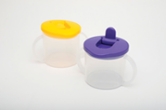 | Health Visitor or Family Nurse or COHT | Childsmile | Contact Childsmile Oral Health improvement teams to order all resources based on areas:  - nhsh.midandwesthighlandohiteam@nhs.scot Mid & West  - nhsh.northhighlandohiteam@nhs.scot North Highland  - nhsh.southhighlandohiteam@nhs.scot South Highland
HV 3/6 months | Free Flow Drinking Cup  Universally to all babies |  | Universal | Childsmile Oral Health Teams (COHT)
HV 3/6 months  HV 13/15 months  HV 27/30 months | Oral Hygiene Pack  Universally to all children | 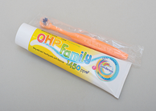 | Health Visitor or Family Nurse or COHT | Childsmile | Contact Childsmile Oral Health Improvement teams to order all resources based on areas:  - nhsh.midandwesthighlandohiteam@nhs.scot Mid & West  - nhsh.northhighlandohiteam@nhs.scot North Highland  - nhsh.southhighlandohiteam@nhs.scot South Highland
HV 3/6 months  HV 13/15 months  HV 27/30 months | Oral Hygiene Pack  Universally to all children |  | Universal | Childsmile Oral Health Teams (COHT)

HV 13–15 months | Enrol your child for early learning and childcare  What about 2-year-olds?  The Scottish Government offers funded childcare places for eligible 2-year-old children | 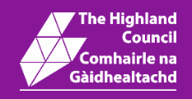 | Health Visitor or Family Nurse | Highland Council | If parents receive certain benefits they could be entitled to free childcare. In addition, children aged two or over who are looked after, subject to kinship care or a guardianship order are eligible for a funded place.  2-Year-Old Funding Application Form
HV 13–15 months |  |  | Targeted | Download only
HV 13–15 months | Bookbug Toddler Bag (for age 1 – 2) | 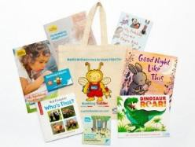 | Library or Local Bookbug coordinator | Scottish Book Trust | Available in Gaelic from Local Bookbug Coordinator  Bookbug information available to download in various languages  Scottish Book Trust
HV 13–15 months | Bookbug Toddler Bag (for age 1 – 2) |  | Universal | Scottish Book Trust
HV 13–15 months | Play@home toddler book  introduces play activities and ideas which will contribute to each stage of the child’s development and promote parents and carers as the children’s first and most important teachers. | 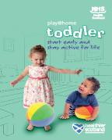 | Health Visitor or Family Nurse | Public Health Scotland | Available in simplified Chinese (Mandarin), and Polish  Alternative formats (Large print, braille, and audio versions) email phs.otherformats@phs.scot
HV 13–15 months |  |  | Universal | 1BAB/061/L
HV 13–15 months | First Words – now I’m saying words too. Key messages to encourage language development simply stated | 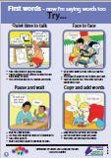 | Health Visitor or Family nurse | Highland Council | Available also in Polish and Gaelic via HIRS
HV 13–15 months |  |  | Universal | HIRS 1BAB/048/L | Available also in Polish and Gaelic via HIRS

HV 27-30 Months | Best Start Grant early Years Payment  The early learning payment of £319.80 to help with the costs of early learning between 2 and 3 ½ years | 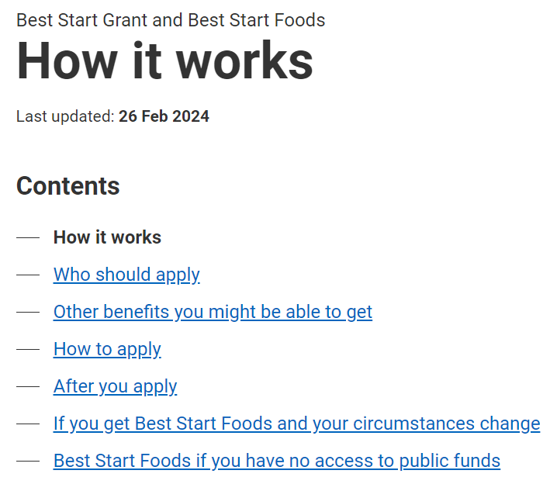 | Health Visitor or Family Nurse | Scottish Government | Best Start Grant and Best Start Foods - mygov.scot
HV 27-30 Months |  |  | Targeted | Apply online | Best Start Grant and Best Start Foods - mygov.scot
HV 27-30 Months | Head lice and nits  Website gives helpful advice about head lice, treatment, and prevention. Includes details of wet combing & dry detection combing |  | Health Visitor or Family Nurse | Public Health Scotland | For more information  NHS inform- head lice and nits
HV 27-30 Months |  |  | Targeted | Website | For more information  NHS inform- head lice and nits
HV 27-30 Months | Words together – let’s keep talking. Key messages to encourage language development simply stated | 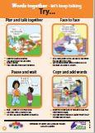 | Health Visitor | Highland Council | Available in polish and Gaelic via hirs
HV 27-30 Months |  |  | Targeted | HIRS 1CHI/OO5/L | Available in polish and Gaelic via hirs
HV 27-30 Months | Flu vaccine- for children 2-5 (and not yet at school)  For age 2 – 5 and not yet in school  2024 Version | 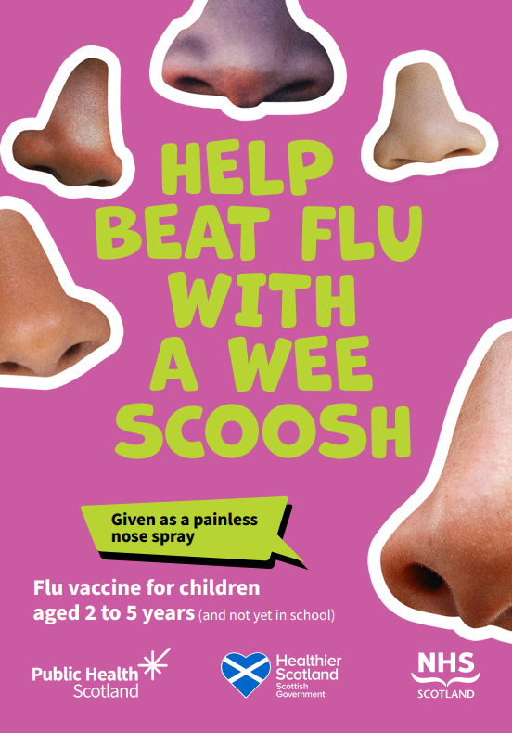 | May be posted or given via EL&CC or GP’s | Public Health Scotland | For more information  Child Flu Vaccines  Alternative formats (Large print, braille, translation support and audio versions) email phs.otherformats@phs.scot

HV 30 months – 3 years | Bookbug Explorer Bag | 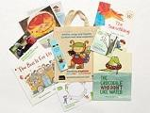 | Usually given via from Nursery, Library or local bookbug coordinator | Scottish Book Trust | Available in Gaelic from Local Bookbug Coordinator  Bookbug information available to download in various languages  Scottish Book Trust
HV 30 months – 3 years | Bookbug Explorer Bag |  | Universal | Order from local book bug coordinator
HV 30 months – 3 years | Play@Home pre-school book introduces play activities and ideas which will contribute to each stage of the child’s development and promote parents and carers as the children’s first and most important teachers. | 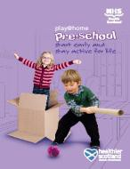 | EL&CC & Library Services | Public Health Scotland | Public Health Scotland Email nhs.HealthScotland-PlayAtHome@nhs.scot for more information  Play@home  available from your Local Area contact  Learning- Public Health Scotland
HV 30 months – 3 years |  |  | Universal | 1CHI/008/L
4.5-5years | Scottish child payment and best start grant This leaflet contains information on a new payment of £27.15 weekly paid every four weeks for each eligible child under six. | 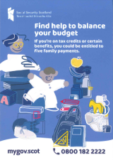 | Health Visitor or FNP | Social Security Scotland
4.5-5years |  |  | Universal | HIRS L1CHI/009/L
4.5 – 5 years ¹ | Bookbug P1 Family bag | 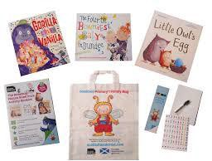 | Usually given via from Nursery, | Scottish Book Trust | Available in Gaelic from Local Bookbug Coordinator  Bookbug information available to download in various languages  Scottish Book Trust
4.5 – 5 years ¹ | Bookbug P1 Family bag |  | Universal | Library, local bookbug coordinator or schools

Remind parents and carers that all children are entitled to free eye tests from optician

 | Bereavement Resources
 | Wellbeing after miscarriage  This free online programme & phone app which includes mental health support from specialist counsellor | 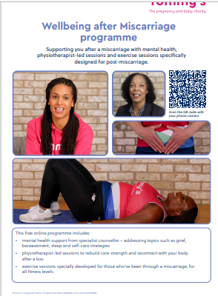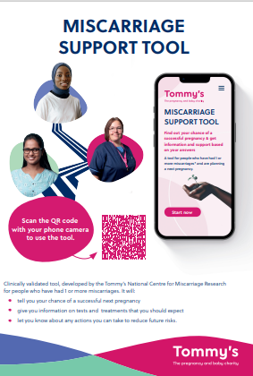 | Midwife/Nurse | Tommy’s | Available to download  Wellbeing after miscarriage
 |  |  | Targeted | Downloadable resources/Phone App | Available to download  Wellbeing after miscarriage
 | I think I might be having a miscarriage  This leaflet has information about symptoms of a miscarriage, where to get help and what might happen next. | 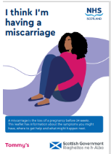 | Midwife/Nurse | Tommy’s/ Scottish Government | Available to order from  Health Improvement Resource Service Ordering System  Available in other languages
 |  |  | Targeted | L1CPB/027/L
 | After a miscarriage  This leaflet has information on recovery following a miscarriage, finding support and thinking about another pregnancy. | 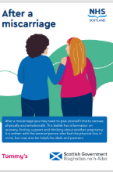 | Midwife/Nurse | Tommy’s/ Scottish Government | Available to order from  Health Improvement Resource Service Ordering System  Available in other languages
 |  |  | Targeted | L1CPB/027/L
 | Miscarriage: Dads and Partners  This leaflet has information if you are the partner of someone who has had a miscarriage. It has suggestions for how you can help, and information and support for you. | 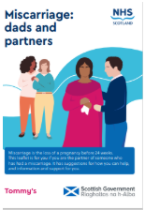 | Midwife/Nurse | Tommy’s/ Scottish Government | Available to order from  Health Improvement Resource Service Ordering System  Available in other languages
 |  |  | Targeted | L1CPB/027/L
 | General HIOH’s Leaflet  This leaflet explains the support and services offered by HIOH’s (befriending, counselling and support groups etc..) and how families can access them. Can be given to families in the memory bag but we always send separately so they don’t get crushed in the bags | 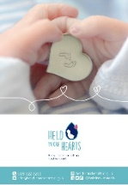 | Midwife/FNP | Held in our Heart’s (HIOH’s) | Held In Our Hearts - Providing baby loss counselling and support
 |  |  | Targeted | HIRS 1BAB/072/L
 | HIOH & ARC - Leaflet for parents who have had to make the difficult choice to end their pregnancy.  Written in conjunction with families who have been in this position, with suggestions they feel might help | 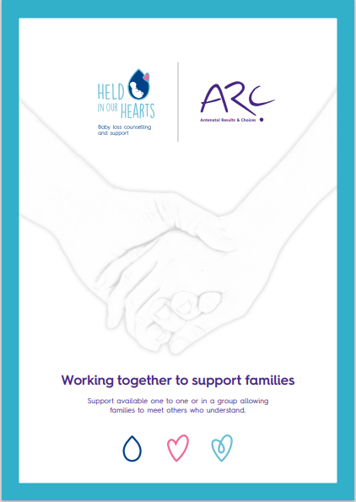 | Screening Midwives | Held in our Hearts & ARC (Antenatal results and Choices) | ARC – antenatal results and choices - Held In Our Hearts
 |  |  | Targeted | HIRS 1BAB/070/L | ARC – antenatal results and choices - Held In Our Hearts
 | Here for you  For those families who know their baby has died in utero and are sent home with pessaries. Families can contact a peer supporter during this time to help prepare for what lies ahead and speak to someone with lived experience of baby loss | 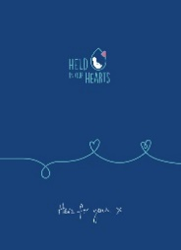 | Screening Midwives/ Hospital consultant | Held in our Hearts | Here for you- Digital Version
 |  |  | Targeted | HIRS L 1BAB/071/L | Here for you- Digital Version

 | Memory bags  These bags contain: ceramic candle, Heart in their Hand keyring, photograph album and birth recognition card, forget me not seeds and leaflet with information on support. | 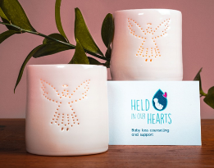 | Midwife/FNP |  | Held In Our Hearts
 |  |  | Targeted |  | HIRS BAG1BAB/030/BAG
 | Post-mortem Video.  Produced in conjunction with pathologist Dr Evans and Held In Our Hearts bereaved parents. To be shown before discussion on Postmortem. | 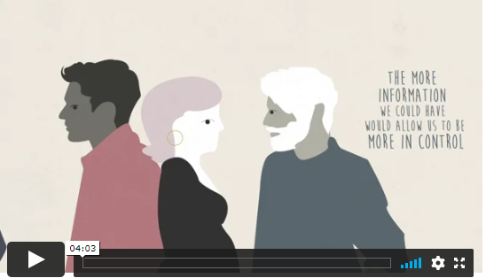 |  |  | Available on Held In Our Hearts website. Also installed on tablets provided for bereavement support. | Parent to Parent Post-mortem Film - Held In Our Hearts  All voices and discussions are from bereaved families who have lived experience of loss and having to decide whether to have a PM. Supports informed choice.
 |  |  | Targeted
 | Certification of pregnancy and baby loss prior to 24 weeks New Scottish Government and NHS Scotland leaflet for health professionals and parents, providing information on the memorial Book and certification of pregnancy and baby loss prior to 24 weeks. | 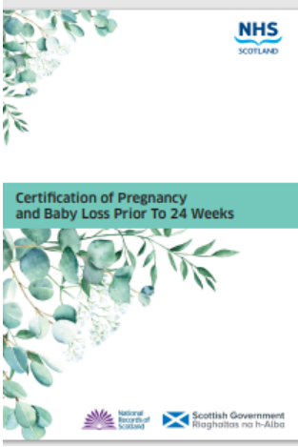 | Midwife/Nurse | Scottish Government/NHS Scotland
 |  |  | Targeted | L1BAB/099/L

Useful websites for parents
Parenting cont.
Care and Learning Alliance (CALA) E-Learning Zone www.calaelearning.co.uk/our-courses
One Parent Families Scotland www.opfs.org.uk
Parenting Across Scotland www.parentingacrossscotland.org
Sleep Scotland www.sleepscotland.org
Bumps To Bairns https://bumps2bairns.com/
Fathers Network Fathers Network Scotland – building a father-friendly world
Substance use
Smoking - Quit Your Way Scotland (Tel: 0800 84 84 84) www.quityourway.scot
Smoke Free Highland www.smokefreehighland.co.uk
Scottish Families Affected by Alcohol & Drugs (Helpline: 08080 10 10 11) www.sfad.org.uk
The Highland Substance Awareness Toolkit - an online library that provides information in relation to drugs and alcohol in Highland. www.h-sat.co.uk
Highland Overdose Prevention & Engagement- HOPE: Highland Overdose on the App Store The HOPE App – Apps on Google Play

Income Max
Jobcentre Plus Advisor website www.jobcentreplusadvisor.co.uk

Money Helper: Becoming a parent
Becoming a parent | MoneyHelper

Maternity rights https://www.maternityaction.org.uk/

Best Start Grants
Best Start Grant and Best Start Foods - mygov.scot

Feeding/Nutrition/Activity/Dental
The Breastfeeding Network (Helpline: 0300 100 0210) www.breastfeedingnetwork.org.uk

Unicef – Baby Friendly Initiative www.babyfriendly.org.uk

La Leche League - Breastfeeding support (Helpline: 0845 120 2918) www.laleche.org.uk

Information resources for advice on breastfeeding and medicines Information resources for advice on medicines and breastfeeding – SPS - Specialist Pharmacy Service – The first stop for professional medicines advice

Child Smile www.child-smile.org.uk

Vegetarian Society www.vegsoc.org

Scottish Governments website for maternal and infant nutrition
Feeding Your Baby | Parent Club
Safety
RoSPA- sling advice
Baby slings - RoSPA
Road Safety Scotland – Go Safe with Ziggy Home - Road Safety Scotland

Child Accident Prevention Trust
www.capt.org.uk

Scotland’s Service Directory - NHS Scotland directory of services
Scotland's Service Directory | NHS inform
Child Protection
Highland Child Protection Committee one stop shop web page, includes training calendar, resources, best practice guidance etc.
www.hcpc.scot
Centre for excellence for looked after children in Scotland www.celcis.org/

Relationships
The Spark – Counselling & Relationship support (Helpline: 0808 802 2088) www.thespark.org.uk

Counselling mediation and relationship support
www.relationships-scotland.org.uk

Highland violence against women partnership website
www.hvawp.scot.nhs.uk
Immunisations
Immunisation Scotland
Vaccination schedule - Immunisations in Scotland | NHS inform

Mental Health
Healthier Scotland - Take Life On, One Step at a Time samh.org.uk/get-involved/our-campaigns/one-step-at-a-time
Mind – Depression Alliance
www.mind.org.uk/about-us/what-we-do/depression-alliance/
Self-help resources for Mums living with depression Home - Smile Group
Association for post-natal illness https://apni.org/
Birth Trauma Association www.birthtraumaassociation.org.uk/
Information on pregnancy planning for women who have bipolar affective disorder and post-partum psychosis
www.bipolaruk.org/information-on-postpartum-psychosis

Information on OCD during the perinatal period OCD-UK | A national OCD charity, run by, and for people with lived experience of OCD (ocduk.org)

Info on anxiety and depression includes info for dads
Charity Awards | Bluebell Care Trust

Information on specific medications during pregnancy and associated risks,
Includes patient friendly portal www.medicinesinpregnancy.org/

Play/Literacy
Scottish Book Trust – Bookbug www.scottishbooktrust.com/bookbug
Play Talk Read PlayTalkRead | Play Project | Fun Sensory Bus (smartplaynetwork.org)
Speech/Language/Communication website 'Through the Eyes of a Child' videos Through the Eyes of a Child Films (speechandlanguage.org.uk)
Highland SLT Facebook link
Highland Children and Young People's Allied Health Professionals - AHP | Facebook

Bereavement
Held in our hearts provides memory making resources, peer support and counselling for bereaved parents and family who have lost a baby at any stage in the Highlands. 1:1 and group support offered.
https://heldinourhearts.org.uk/

MISS are a miscarriage support service offering peer support based in Aberdeen but cover the highlands also
https://miss-support.org.uk/

Miscarriage Association The Miscarriage Association: Pregnancy Loss Information & Support
Sands a UK charity supporting anyone affected by the death of a baby www.sands.org.uk/

SiMBA (Simpson’s Memorial Box and trees of tranquility Charity) www.simbacharity.org.uk
Scottish Cot Death Trust offers services for bereaved parents
www.scottishcotdeathtrust.org

Crocus group non-denominational support group for bereaved children, includes portal for referrals
Crocus Highland | Highland Hospice

Financial support for bereaved parents from social security Scotland HERE
Child Bereavement Charity Child Bereavement UK

Screening
Antenatal Results Choices (ARC) www.arc-uk.org
Contact A Family- for families with disabled children www.cafamily.org.uk
Down’s Syndrome Association www.downs-syndrome.org.uk
Down’s Syndrome Scotland www.dsscotland.org.uk

Bliss offer support for families & training/resources for professionals for premature or sick babies
https://www.bliss.org.uk/

Violence against women
Scottish Women’s Aid http://womensaid.scot/
Rape Crisis Scotland www.rapecrisisscotland.org.uk/

Women’s Support Project HOME | WSP (womenssupportproject.org.uk)

Highland Violence Against Women Partnership www.hvawp.scot.nhs.uk/

RASASH Rape and Sexual Abuse Service Highland
Home | Rape & Sexual Abuse Service Highland (rasash.org.uk)

Commercial websites
Netmums www.netmums.com
Baby Centre www.babycentre.co.uk
The Nappy Network www.nappynetwork.org.uk

Pregnancy and beyond
Ready Steady Baby www.nhsinform.scot/readysteadybaby
Best Beginnings Baby Buddy www.bestbeginnings.org.uk
Resources for families and professionals
https://www.tommys.org
The Royal College of Obstetricians and Gynaecologists (RCOG) - produces patient information leaflets
www.rcog.org.uk
NCT (National Childbirth Trust) www.nct.org.uk/pregnancy
Public Health Scotland Public Health Scotland
Scottish Governments website covering pregnancy to 4+ Years www.parentclub.scot

Additional support
CHIP+ - Children in the Highlands Information Point CHIP+ Children in Highland Information Point
Contact - for families with disabled children www.contact.org.uk
Parentline Scotland (Helpline: 08000 28 22 33) Children 1st Parentline - Parenting Help, Advice & Support | Children 1st
National charity for those affected by childhood lower limb conditions Health Professionals - Charity Work | Steps Charity (stepsworldwide.org)
Commercial websites
Highland Sexual Health 01463 888300 information, Advice on sexual health and contraception including live chat and clinic times across highland.
https://www.highlandsexualhealth.co.uk/

