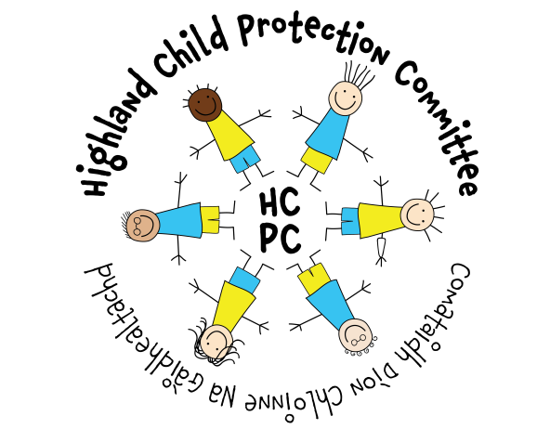

HIGHLAND CHILD PROTECTION COMMITTEE
IMPROVEMENT PLAN
2021 – 2023

Contents | Page
- Introduction  - Preface by Chief Officers  - Foreword by Chair, Highland Child Protection Committee | 3  4
- Child Protection Planning in Highland  - Reporting Structure  - Strategic Planning  - Constituent Members of Highland CPC | 5  6  6
- CPC Priorities 2021-2023  - Key Priorities  - Principles of Protection  - Outcomes and Indicators | 7  8  9
- Improvement Plan 2021-2023 | 10
- Additional Information  - Abbreviations  - Glossary of Terms | 23  24

Preface by Chief Officers

The Highland Chief Officer Group is pleased to endorse Highland Child Protection Committee’s Improvement Plan and priorities for 2021 – 2023. This reflects our direction to the CPC and our views based on the available various briefings and formal reports made available to us.

As Chief Officers we give a continued commitment and support to the work of the Committee, but acknowledge the particular challenges facing us all within the context of an ever changing child protection landscape, increasing demands and expectations of agencies alongside current financial restraint and uncertainties.

The Chief Officer’s would also like to extend our thanks to staff and managers who deliver frontline services for children and families, and commend their professionalism, sensitivity and diligence in meeting the demands and responsibilities facing them within the restraints highlighted.

Foreword on behalf of the Highland Child Protection Committee

As Chair of Highland Child Protection Committee, I am pleased to present our Improvement Plan 2021–2023. This is a revision of the 2019-2022 plan is based on current and emerging local and national priorities, as well as a focus on ensuring support for children, families and services during and following the COVID-19 pandemic. The revision of the Plan also seeks to align with the development of Highland’s Integrated Children’s Service Plan 2021. We seek to achieve better preventative and protective measures for vulnerable children and better outcomes for those we aim to protect in the future. In support of its successful delivery we aim to continue to capture increasing levels of information on the outcomes being achieved for our most vulnerable children.
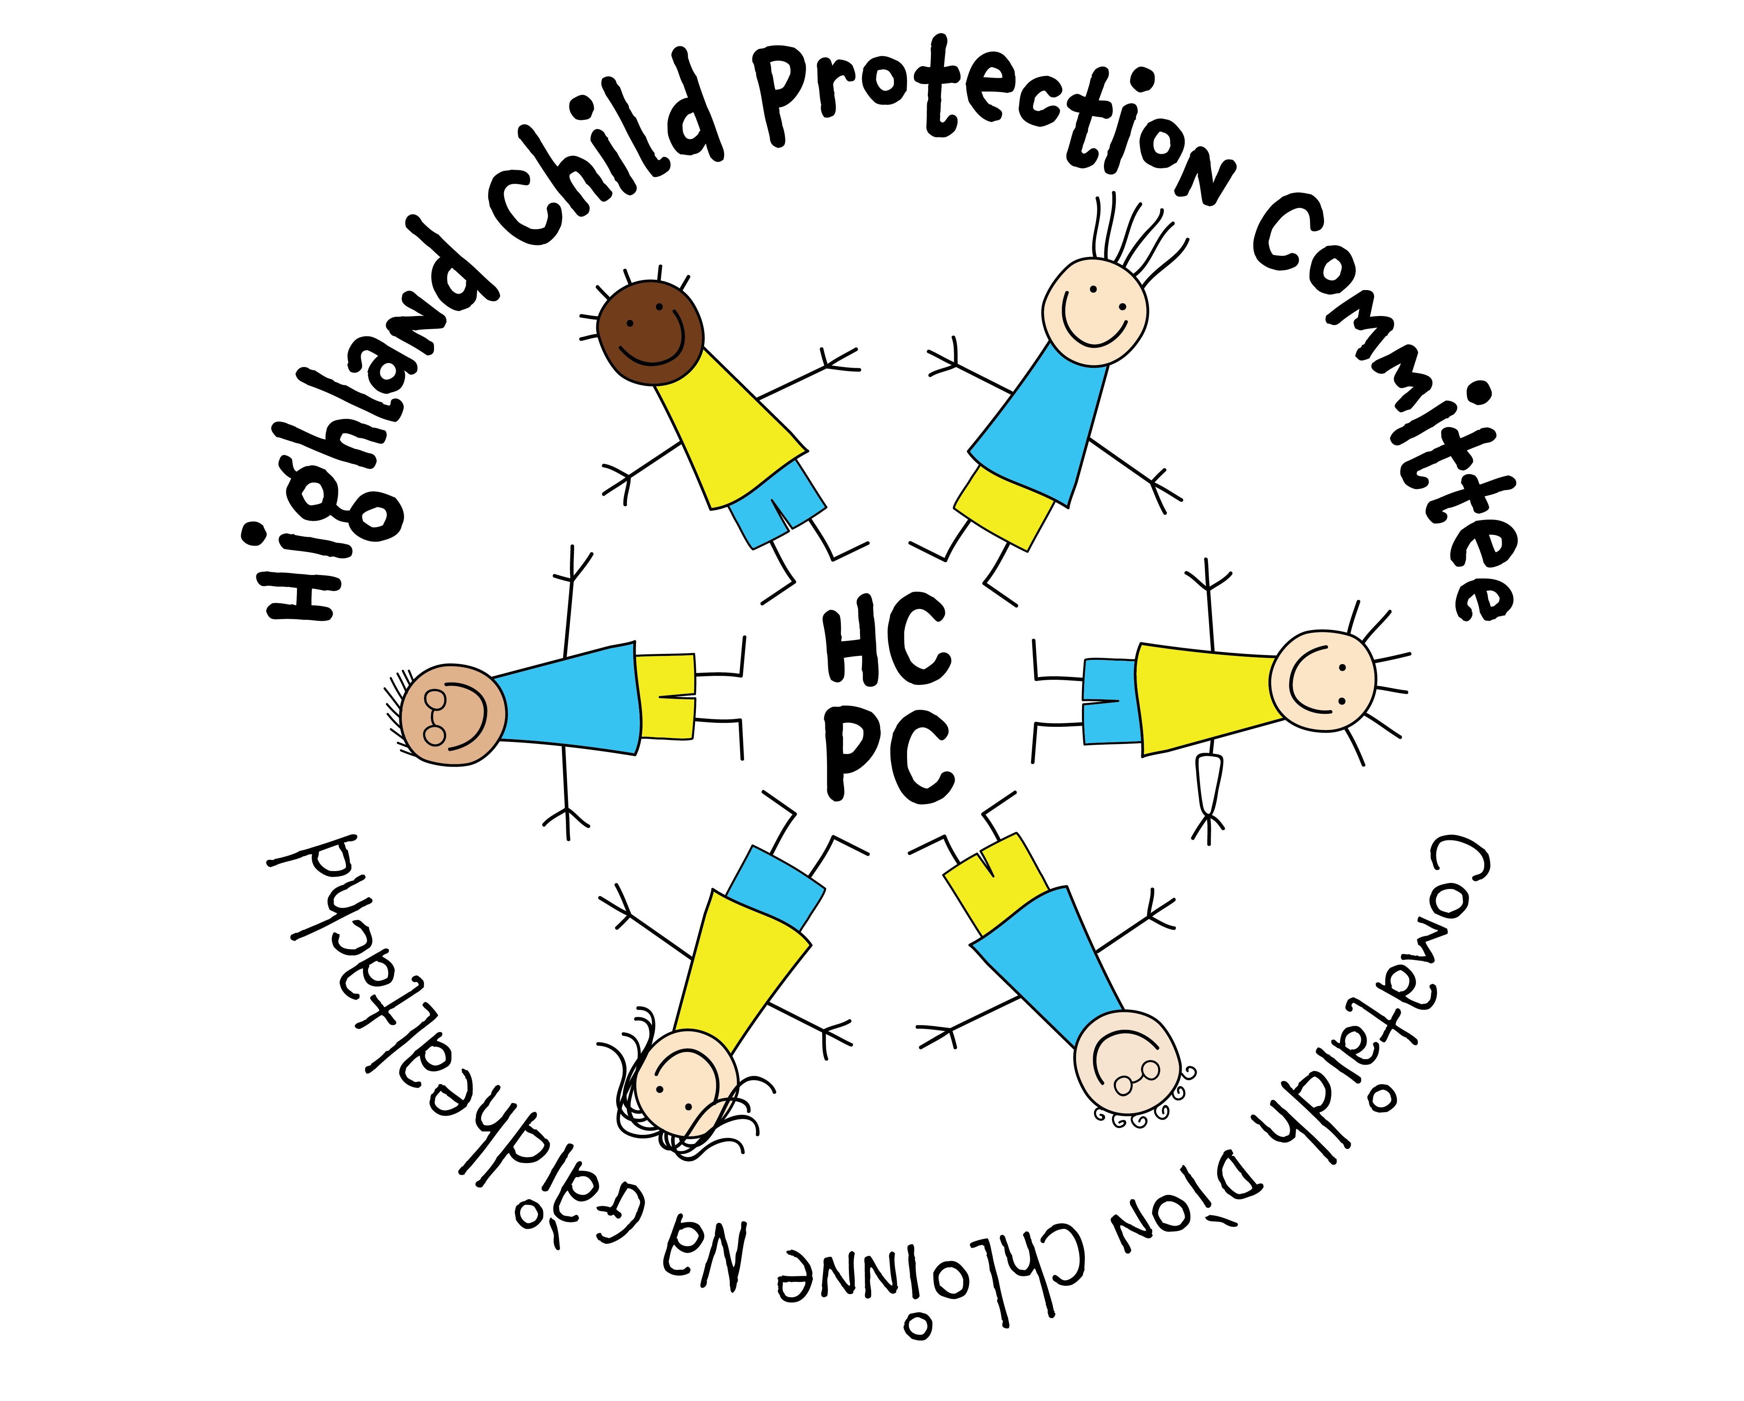
The proposed measurement of these outcomes has been carefully considered and demonstrates the application of SMART criteria:
- Specific – target a specific area for improvement
- Measurable – quantify or at least suggest an indicator of progress.
- Achievable – be able to specify who will do it.
- Realistic – state what results can realistically be achieved, with available resources
- Time-limited — specify when the result(s) can be achieved.

A period of review and reflection has enabled the CPC to move forward to a position where we can now be more proactive and ambitious, developing and providing a range of tools and training to assist services in delivering effective support and interventions for children and families. With a robust Quality Assurance plan in place we can also identify and measure improvement across Highland.

Mhairi Grant, Independent Chair. Highland Child Protection Committee
Reporting Structure – Highland Child Protection Committee

Child Protection Committee Membership 2019

Strategic Planning – Child Protection Committee

Summary of Key Priorities for 2019-2022
Priorities 2021-2023

PRINCIPLES OF PROTECTION – CPC THEMES FOR GOOD PRACTICE IN CHILD PROTECTION

STRONG LEADERSHIP
TIMELY INTERVENTIONS
BUILDING EFFECTIVE RELATIONSHIPS
KEEPING CHILDREN & YOUNG PEOPLE AT THE CENTRE
INFORMATION SHARING
EFFECTIVE ASSESSMENT AND PLANNING
7

Highland Child Protection Committee - Improvement Plan Outcomes
The outcomes outlined within the CPC Improvement Plan have been developed in line with the Scottish Government’s National Performance Framework. In particular, the plan focusses on the vision for children and young people:

‘We grow up loved, safe and respected so that we realise our full potential’

Highland Child Protection continues to commit to the principles of Getting It Right for Every Child. Improvement outcomes relate to the impact of services on the well-being of children and young people using the SHANARRI indicators. The Plan focuses on their experiences and the extent to which their lives and life opportunities will be enhanced to ensure they are:

- Safe
- Healthy
- Achieving
- Nurtured
- Active
- Respected and Responsible
- Included

In delivering the outcomes set out within the Improvement Plan, the Child Protection Committee will continue to take account of the views of children, young people and families across Highland.

Function of the Child Protection Committee
Highland CPC Improvement Plan 2021-2023
Improvement Priority: CPC should evidence clear leadership, delivery of high quality learning and development opportunities and scrutiny of child protection practice across Highland
CPC Theme(s): A culture of effective leadership, management, support and supervision is embedded in child protection work across Highland and in the principles of Highland Child Protection Committee (QI 3.1, 7.2, 9.1)
Needs assessment
The Care Inspectorate Review of Inspections 2012-2017 identified leadership as a key measure of child protection practice within local areas. The Public Protection Chief Officer Group was established in 2018 to consider child protection alongside public protection themes within Violence Against Women, Criminal Justice, MAPPA and Adult Support and Protection. The CPC is responsible for the scrutiny of child protection practice in Highland and required to consider child protection data, quality of practice across the partnership and the provision of effective learning and development opportunities for practitioners and managers working with children, young people and families. CPC is required to report to Chief Officers on a quarterly basis as well as keeping them informed of findings from Significant or Initial Case Reviews regarding individual children.
Protecting Children and Young People: Child Protection Committee and Chief Officer Responsibilities sets out the functions of CPCs required by the Scottish Government. For the CPC to report progress to the Public Protection Chief Officer Group, there are a number of functions which require fulfilled. This section of the Improvement Plan aims to set out those functions with key Actions to ensure Highland CPC meets Scottish Government requirements. It is crucial that CPC members understand the functions of the CPC and their role. Key agencies and specific roles within those agencies have additional responsibilities. CPCs must use the learning from ICRs/SCRs to promote good practice, improve practice and contribute to improved outcomes for children and young people across Scotland and this will be further informed by the National Learning Review Guidance due in Spring 2021. The national guidance for CPC and Chief Officers also highlights that the alignment with integrated children’s services processes and wider planning structures is essential and it is intended that the CPC Improvement Plan is embedded within Highland’s Integrated Children’s Service Plan from 2021.
Actions | Lead | Timescale | Measures/Evaluation | BRAG
Review CPC and Sub-Committee Membership to ensure representation at the appropriate level(s) from all services as outlined in the National guidance for CPCs and Chief Officers | CPC Chair | April 2021 | Membership reviewed and updated  Terms of reference updated and disseminated to all members  Induction pack revised and disseminated to all members  Register of attendance at CPC to be established and presented to Public Protection Chief Officer Group
Review and update Improvement Plan to reflect current and emerging priorities and in response to COVID-19 pandemic | CPC Chair  CPC Lead Officer | April 2021 | Improvement Plan updated and presented to CPC and Public Protection Chief Officer Group
Ensure quality assurance processes are in place to assess quality of interagency child protection practice | Quality Assurance Sub-Committee | April 2021 | Audit cycle developed and presented to CPC  Audit reports produced and presented to CPC  Findings disseminated across services  Risk Register developed
Minimum data set established with quarterly reporting to CPC and Public Protection Chief Officer Group | Quality Assurance Sub-Committee | March 2021 | Minimum data set in place  Quarterly reports to CPC and Chief Officer Group  Data set informs audit cycle
Develop mechanisms for data collection in relation to Child Concern Forms | Executive Chief Officer (Health and Social Care)  CPC Lead Officer | July 2021 | Review current processes for collation of Child Concern data  Present Findings and Recommendations to CPC and Public Protection Chief Officer Group
Induction training for all CPC members to understand the functions of the CPC and roles within it | CPC Chair  CPC Lead Officer | April 2021 | Induction training delivered
Develop proposal for Training and Communications Officer | CPC Chair  CPC Lead Officer | April 2021 | Proposal developed and presented to Public Protection Chief Officer Group  Post developed and recruited
Review and update Highland Child Protection Guidance in line with updated National Guidance | CPC Chair  CPC Lead Officer | July 2021 | Highland Child Protection procedures developed  Roll out of training and awareness raising in relation to updated procedures
Implementation of National Learning Review Guidance locally | CPC Chair  CPC Lead Officer | Sept 2021 | Local Learning Review protocol developed and presented to CPC  Multi-agency learning review events to be delivered to help services understand the Learning Review process in Highland
Standard Operating Procedure to be developed in relation to monitoring and review of ICR/SCR findings and subsequent actions | CPC Chair  CPC Lead Officer | April 2021 | ICR/SCR Action Plan updates and quarterly reporting to CPC
Review of Inter Agency policies and procedures to ensure they are current and accurate | CPC Chair  CPC Lead Officer | Dec 2021 | Existing policies and guidelines to be reviewed and updated as required  Policies and protocols to be established where there are current or emerging issues  Policies presented to CPC, approved and uploaded to www.hcpc.scot  Policies disseminated across agencies
Annual Report produced | CPC Chair  CPC Lead Officer | May 2021 | Annual report produced and presented to CPC and Public Protection Chief Officer Group
Chief Officers will receive regular written feedback about key child protection issues affecting children & young people, staff, agencies and communities in Highland | CPC Chair | March 2021 | Quarterly Reports to Public Protection Chief Officer Group
Learning and Development Improvement Plan reviewed and updated | CPC Lead Officer | June 2022 | Learning and Development Improvement Plan presented to CPC (June 2021)  Delivery of Learning and Development Plan
Consider the impact of COVID-19 on children, families and services in relation to child protection | CPC Chair to establish SLWG | June 2021 | Data available  Findings from local and national consultations with children, young people and services to be collated  Review of Child Concerns received during pandemic  Improvement Plan to be updated with any additional recommendations  Findings shared with other Partnerships and Services as appropriate  Recovery Plan developed

Improvement Priority: Practitioners are encouraged and supported to build effective relationships with parents/carers in child protection practice
CPC Theme(s): Relationships with parents/carers are effective, constructive and central to improving wellbeing and minimising risk of harm (QI 1.1, 2.1, 2.2, 5.4)
UNCRC Article 5 requires that Governments must respect the rights and responsibilities of parents and carers to provide guidance and direction to their child as they grow up, so that they fully enjoy their rights. This must be done in a way that recognises the child’s increasing capacity to make their own choices. In Child Protection practice it can be challenging to maintain effective relationships with parents/carers under stressful circumstances. However, UNCRC Article 18 (parental responsibilities and state assistance) also states that ‘Governments must support parents by creating support services for children and giving parents the help they need to raise their children’. Family relationships are also strongly emphasised in The Promise highlighting ‘Where children are safe in their families and feel loved they must stay, and families must be given support together to nurture that love and overcome the difficulties which get in the way’. CPC must support practitioners in building strong relationships with parents and carers to work in partnership to protect children and young people wherever possible. Significant Case Reviews have also highlighted the importance of developing effective relationships with parents/carers with the ability to support and/or challenge parents/carers particularly in cases where parental behaviour contributes to the risk of harm. Article 19 (protection from violence, abuse and neglect) states that Governments must do all they can to ensure that children are protected from all forms of violence, abuse, neglect and bad treatment by their parents or anyone else who looks after them. The Analysis of Case Reviews report 2018 found that practitioners need to be able to identify and respond to signs of non/disguised compliance and practice with respectful uncertainty. This can be achieved and acted upon effectively where constructive relationships with parents/carers are developed. Practitioners also need to take cognisance of the age, ethnicity and history of parents/carers in order to develop plans which are realistic, achievable and effective. Trauma informed approaches are key in developing this work further.
Actions | Lead | Timescale | Measures/Evaluation | BRAG
Develop prompt cards for staff based on principles of protection themes – aide memoires | CPC Lead Officer | Sept 2021 | No. of cards disseminated  Staff feedback re: effectiveness
Work with the Corporate Parenting Board in developing plans to deliver on ‘The Promise’ | Head of Improvement and Performance (Highland Council)  CPC Lead Officer | June 2021 | Improvement Plans are shared between CPC and Corporate Parenting Board to ensure consistency of approaches  CPC representation on Corporate Parenting Board  Corporate Parenting Board representation on CPC
Review and monitor use of Graded Care Profile to promote strengths-based approaches and partnership working with families | Quality Assurance Sub-Committee/Learning and Development Sub-Committee | Aug 2021 | Delivery of training and refresher sessions  Monitoring process developed  Evaluation tools to be developed to gain feedback from practitioners and families on use of GCP  Quarterly reporting to QA Sub-Committee
Identify methods for consulting with parents and carers about their experiences of child protection processes | Quality Assurance Sub-Committee | Nov 2021 | Establish current systems in place for consulting with parents and carers  Report with Findings and Recommendations for CPC
Audit child’s plans and supervision records to evidence parent/carer views are sought and recorded effectively | Quality Assurance Sub-Committee | Nov 2021 | To be included in Audit Cycle  Audit Report presented to CPC
Work with Trauma Champions to ensure practitioners understand the impact of trauma on children, young people and families and can respond appropriately | CPC Lead Officer | Dec 2021 | Make links with service Trauma champions  Promote the Trauma Training framework  No. of people undertaking training
Develop and disseminate 7-minute briefing paper on respectful uncertainty to help staff challenge presenting behaviour and identify over optimism in practice | Quality Assurance Sub-Committee | April 2021 | No. of briefing session delivered  Feedback forms received

Improvement Priority: Practitioners, managers and communities are supported to identify, share and respond to concerns about children promptly and effectively
CPC Theme(s): Effective and timely intervention minimises the risks to children and young people (QI 5.1, 5.2, 5.3)
Needs assessment
UNCRC Article 9 (separation from parents) states that Children must not be separated from their parents against their will unless it is in their best interests (for example, if a parent is hurting or neglecting a child). Children whose parents have separated have the right to stay in contact with both parents, unless this could cause them harm. UNCRC Article 20 (children unable to live with their family) also states that if a child cannot be looked after by their immediate family, the government must give them special protection and assistance. This includes making sure the child is provided with alternative care that is continuous and respects the child’s culture, language and religion. Child Protection work is often complex with practitioners and managers having to make decisions with limited time and information available.
The 2018 Analysis of Case Reviews report highlighted the necessity for effective and timely intervention to minimise risks to children. Significant Case Reviews have demonstrated that ‘drift’ particularly in cases of neglect and parental substance misuse can have severe consequences for children and young people. Likewise, in Reviews people within the local community have been aware of the risks posed to the child but were unwilling and/or unable to report these. Work undertaken with High Life Highland to increase staff knowledge and confidence in relation to child protection issues has resulted in better working relationships with Police Scotland and local Social Work teams with more appropriate sharing of concerns about children using High Life facilities and services. The CPC would want to use this model to engage with Community Partnerships and local communities to encourage and support people who may have concerns about children and young people.
Actions | Lead | Timescale | Measures/Evaluation | BRAG
Community Engagement Strategy and Plan to be developed to raise awareness of child protection in local communities and encourage communities to report concerns | Head of Development, HLH, High Life Highland with SLWG | December 2021 | Strategy and Plan developed with SMART targets
Updated Initial Referral Discussion (IRD) process to be reviewed in line with National Child Protection Guidance (2021) | Quality Assurance Sub-Committee | June 2020 | IRD standard operating procedure reviewed and updated as appropriate  Audit of IRDs to be undertaken in 2021
Develop a suite of recommended resources for use with young people in relation to Exploitation | Exploitation Sub-Committee | Nov 2021 | List of resources produced and made available through www.hcpc.scot
Develop and deliver training Exploitation for residential staff, front line practitioners and community groups (including night time economy) | Exploitation Sub-Committee | Nov 2021 | Exploitation Improvement Plan  No. of people receiving training  Feedback from participants
Work in partnership with Alcohol and Drugs Partnership to ensure funded projects within children’s services meet the needs of children, young people, families, communities and services as commissioned | Children Affected by Drugs and Alcohol Sub-Committee | June 2021 | CADA Improvement Plan developed and approved by CPC  Governance clearly communicated to funded projects  Quarterly reporting to CADA Sub-Committee
Review and update Care and Risk Management processes | CPC and Youth Justice Sub-Committee | June 2021 | Review CARM protocol  Deliver training and awareness raising for practitioners in relation to CARM  Develop process for Learning Reviews in relation to CARM cases  CARM data to be reported to CPC quarterly
Work with Corporate Parenting Board to improve young people’s experiences of Meetings based on their needs | Lead Officer with SLWG | Sept 2021 | Working Group established  Co-production with care experienced people to implement better meeting options including: space, methods, how the meeting is set up, refreshments, running of the meeting

Improvement Priority: CPC will promote effective information sharing with children, young people and families, within agencies and across the partnership
CPC Theme(s): Relevant information is shared appropriately, clear lines of responsibility for action are understood across partners and communication is effective in minimising potential risks (QI 1.1, 5.1, 5.2, 6.1)
Needs assessment
The majority of case reviews highlight flaws or gaps in information sharing within and between agencies. In Highland’s Analysis of Case Reviews 2018, Dr Vincent acknowledged strengths in relation to appropriate information sharing across Highland, particularly in relation to child protection concerns. However, the length of time taken to share information was highlighted, along with a reluctance to retain some ownership of the concerns once shared, and a lack of feedback and further discussion between agencies. The need for integrated chronologies which clearly identify significant life events is also highlighted within the ‘Analysis of Case Reviews’ report and the Care Inspectorate’s ‘Review of Findings Joint Inspection services for children and young people 2012-17’. The Promise also highlights the need to ensure information is shared to avoid children, young people and families having to tell their stories time and time again to a number of different agencies and professionals. Young people and adults have told us that they don’t want to have to continually repeat their story, they want to make sense of their history and they want to be able to access the information held about them. Children and young people need to have ownership of their personal information. Information sharing systems need to be arranged to account for this ownership, the right for confidentiality and the need for relevant information sharing at key points in the lives of children and young people.
Actions | Lead | Timescale | Measures/Evaluation | BRAG
Information Sharing section of Child Protection Guidance to be reviewed and updated | CPC Chair  CPC Lead Officer | June 2021 | Information Sharing procedure developed and disseminated to staff within the wider Child Protection procedures
Disseminate information about chronologies e-module and monitor feedback | Keeping Children Safe Sub-Committee | March 2020 | No. of participants undertaking e-module  Quality of chronologies – audit to be undertaken in 2021/22
Work with Corporate Parenting Board to Identify mechanisms which ensure the sharing of relevant information across services and support planning, decision making and interventions and prevent unnecessary trauma caused by retelling historical information | Corporate Parenting Board | Dec 2021 | Pro-forma for care experienced people developed with young people “how will their story be told” and recorded?  Research simple tools on “How will their story be told” that is of benefit to Care experienced people and professionals  Small working group to look at: positive recording, how to share a record.  Develop process for sharing within services
CPC Website to be reviewed and developed further to ensure accessibility of procedures and guidelines, information on current and emerging issues and clear signposting for reporting concerns about children and young people | CPC Lead Officer/Chairs of Sub-Committees | Sept 2021 | Website updated  No. of subscribers  Website data – pages visited, number of views
Deliver training in relation to Trafficking and the National Referral Mechanism to ensure timely sharing of concerns | Learning & Development Sub-Committee | Dec 2021 | Learning and development Improvement Plan  No. of staff attending training
Update local trafficking protocol to ensure practitioners and managers are clear how to share information in relation to trafficking concerns | Exploitation Sub-Committee | Sept 2021 | Protocol updated and available on www.hcpc.scot

Improvement Priority: Practitioners are supported to develop effective child protection plans
CPC Theme(s): Child protection plans are effective in achieving outcomes to meet needs and minimise risk of harm, and all available resources, techniques and tools are used to best effect (QI 1.1, 2.1, 5.1)
Needs assessment
UNCRC Article 6 (life, survival and development) states that every child has the right to life and Governments must do all they can to ensure that children survive and develop to their full potential. UNCRC Article 27 (adequate standard of living) also states that every child has the right to a standard of living that is good enough to meet their physical and social needs and support their development. In keeping with the ethos of the Highland Practice Model agencies and practitioners must work together with families to ensure that children receive the right help at the right time in order to promote the best possible outcomes.
Care Inspectorate’s ‘Review of Findings Joint Inspection services for children and young people 2012-17’ discusses the need for improvements in early intervention and in particular, recognising early signs of neglect. The review also discusses the complexity of issues involving the behaviours of adults such as parental substance misuse and domestic abuse, along with cases of neglect where risks are cumulative. The CPC Dataset evidences that Neglect, Domestic Abuse and Substance Misuse remain the three highest risk indicators in child protection registrations across Highland. Child protection plans are required to have clear goals, outcomes and actions in order to reduce or minimise risk of harm and practitioners require support to develop effective plans which can lead to improved outcomes for children. In order to assist with assessment and planning processes, Highland CPC have developed a number of tools and invested in the Graded Care Profile to help practitioners measure care given to children and young people. These now need to be embedded in practice across Highland, underpinned by a trauma informed approach and with clear mechanisms for reviewing the effectiveness of practice.
Actions | Lead | Timescale | Measures/Evaluation | BRAG
Quality Assurance Sub-Committee will review a proportion of Child’s Plans to determine if they are evidenced based and provide a clear analysis of areas of strengths, risk, need and concern, including cumulative concerns and the potential impact they may have on the child. | Quality Assurance Sub-Committee | March 2022 | Included in Audit Cycle  Multi‐agency file audit and single agency file audits evidence good or improving practice
Assessment and Analysis/Child Protection Planning Processes modules to be developed | Learning & Development Sub-Committee | April 2021 | Training materials developed  Pilot courses with L&D Sub-Committee and wider reference group  Courses delivered via MS Teams  No. of staff attending training
Substance Misuse Practitioner Toolkit to be reviewed and updated | Children Affected by Drugs and Alcohol Sub-Committee | Dec 2021 | Feedback from practitioners
Work with Violence Against Women Partnership to develop Safe and Together Proposal | Quality Assurance Sub-Committee with Violence Against Women Partnership | March 2021 | Equally Safe funding proposal submitted
Delivery of training in relation to contextual safeguarding to help practitioners develop plans specific to individual circumstances (e.g. young people at risk of exploitation) | Learning and Development Sub-Committee | Dec 2021 | Training sourced and delivered  No. of participants  Impact on practice evaluated

Abbreviations
CALA Care and Learning Alliance
CAPSM Children affected by Parental Substance Misuse
CPC Child Protection Committee
CSE Child Sexual Exploitation
FHC For Highland’s Children
GCP2 Graded Care Profile 2
ICR Initial Case Review
MAPPA Multi Agency Public Protection Arrangements
QA Quality Assurance
SCR Significant Case Review
SMART Specific Measurable Achievable Realistic Timescales
SLWG Short Life Working Group to take forward a specific piece of work
UHI University of Highlands and Islands
UNCRC United Nations Convention on the Rights of the Child

Glossary of Terms
Sub-Committee Group directed by the Committee to implement actions on behalf of the Child Protection Committee. Sub-Committees are required to report progress to Child Protection Committee on a quarterly basis
Graded Care Profile 2 Graded Care Profile 2 (GCP2) helps professionals measure the quality of care being given to a child. It's an assessment tool that helps them to spot anything that's putting that child at risk of harm from neglect
7 Minute Briefing A method of delivering messages in a short period of time
Chronology A list of significant events in a child’s life in order of their occurrence
Chief Officers Group The Public Protection Chief Officer Group comprises of the chief officers and senior managers for each of the key partner agencies in Child Protection and Public Protection. This includes representatives from Highland Council, NHS Highland and Police Scotland
Child Protection Committee Every Local Authority must have a Child Protection Committee. Child Protection Committees are locally based, inter-agency strategic partnerships responsible for the design, development, publication, distribution, dissemination, implementation and evaluation of child protection policy and practice across the public, private and wider third sectors in their local area
Keeping Children Safe Keeping Children Safe is a collective group of Third Sector providers with an interest in Child Protection. Chaired by the Care and Learning Alliance the group supports practitioners and managers working in the third sector and community groups
Safe and Together A programme for working with families where there are concerns about domestic abuse. It is a strengths bases approach working in partnership with the victim of abuse to reduce risk to themselves and any children. It also promotes work with perpetrators of domestic abuse.
Safe, Strong & Free The Safe Strong and Free Project (Ssf) is a Primary Abuse Prevention Programme. It is a Highland charity which aims to reduce the vulnerability of young children to abuse and assault
Viewpoint An interactive tool for gathering and collating the views of children and young people

