Gender based violence - Guidance for frontline staff

Advice for making telephone conversations that are safe; do not increase risk; provide opportunity to make sure women and children are safe at home.

Launched today is an excellent new video resource for Health & Social Care staff to support women at risk of gender based violence. The content is relevant to any frontline practitioner.

The stay at home messaging which is a large part of our fight against COVID 19 will pose a challenge in particular for women at risk of gender based violence (GBV) including domestic abuse.
- 1 in 4 women may experience domestic abuse & this may increase during COVID pandemic. Covid-19 is not the root cause of gender based violence
- The opportunity for this crime to take place increases & opportunity for women to seek help or remove themselves from abuse situation may be limited.
- Face to face consultations have reduced nevertheless staffs across Health and Social care are well placed to identify and support women and girls at risk of GBV.
- Staff in Health & Social care may have less experience of identifying abuse during phone consultations as opposed to face to face.
This resource was developed by Dr Sue Brechin a Consultant in Sexual & Reproductive Health , NHS Fife and a Scottish Quality & Safety Fellow in consultation with Scottish Women’s Aid, GBV leads and Public Health Scotland to support staff support women during lockdown.
Click on the icon below or copy and paste this link to your browser (it seems Google works best)
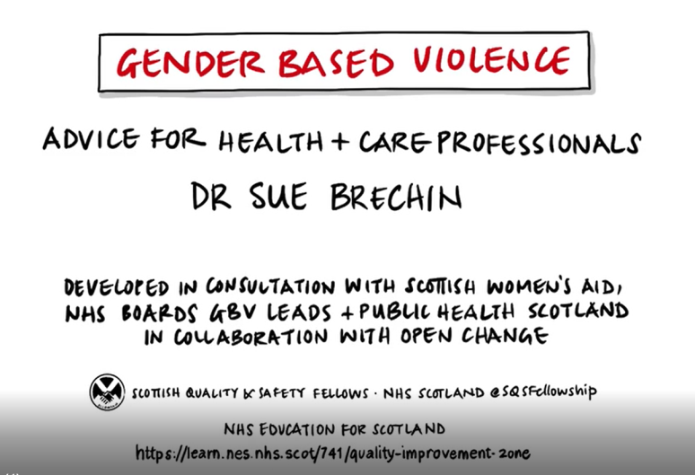
https://vimeo.com/408344058/4454d27aaf

Local Support Service Contacts – N.B. all services are open for support and advice
Inverness Women’s Aid 01463 220719 or email info@invernesswa.co.uk
Ross-shire Women’s Aid 01349 863568 or email info@rosswa.co.uk
Lochaber Women’s Aid 01397 705734 or email lwa@lochaberwomensaid.org
Caithness and Sutherland Women’s Aid 0345 408 0151 or email info@caswa.org.uk
Rape and Sexual Abuse Service Highland 03330 066909 or email info@rasash.org.uk
Highland Violence Against Women and Girls Support Service Booklet – click this link
National Domestic Abuse Helpline 0800 027 1234

