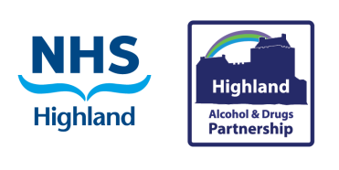
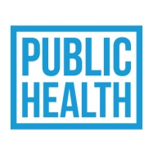
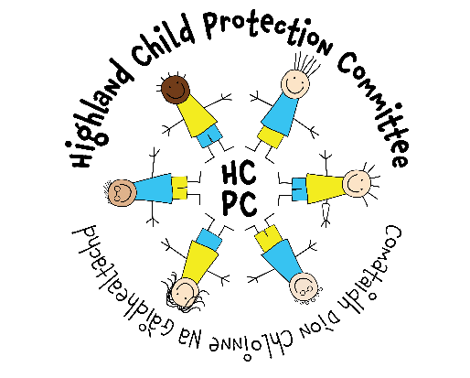
Alcohol Information Signposting

We find ourselves in a challenging time. Sometimes, people turn to alcohol in stressful times. However, we know that alcohol is not an effective stress relief, and can makes things worse.
Sometimes adults might not realise the impact alcohol has on young people or others in the home.
If you are an adult, and choose to drink alcohol, remember to try and keep to the ‘low-risk’ recommendations: More information at the Count 14 website
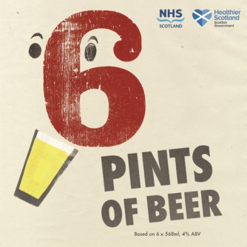 or 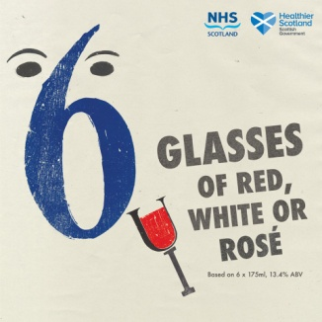 or 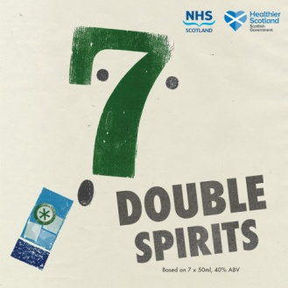
The following websites and phone support resources can be really helpful for families to get good information about alcohol:
- Alcohol Change UK is a leading UK alcohol charity. Includes links like:
  - I think my parents drink too much
  - Parents who drink too much
- Scottish Families Affected by Alcohol and Drugs supports anyone who is concerned about someone else's alcohol or drug use.
- A.D.A.M Another’s drinking affects me A web site for young people who are concerned or affected by another person's drinking
- Know the Score Scotland’s Drugs Information Gateway
- Crew a harm reduction charity based in Scotland
- Highland Substance Awareness Toolkit online resource for young people, parents and carers, and professionals
- Highland Alcohol and Drugs Partnership information relating to the Highland area, with signposts for getting help, local information, and other useful links
- Children’s Parliament investigates: an alcohol-free childhood – Video
- Drinkline. 0800 7 314 314. Concerned about your drinking? Call Drinkline now for advice and support (8am-11pm, 7 days)
- Drug and Alcohol Board Game developed by young people for young people, with support from Action for Children.
- Childline Alcohol page or call 0800 1111
- We Are With You Get free, confidential support with alcohol, drugs or mental health in one of our local services or online

