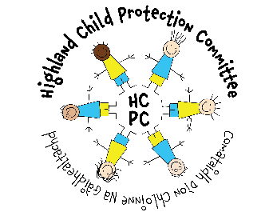
COVID-19 - Statement from Highland Child Protection Committee
Highland Child Protection Committee recognises that COVID-19 may have a huge impact on children, young people and families across our communities. The majority of children and young people will get through this time with love and ongoing support from family members, health and education services, and online platforms. However, for others, this will be an extremely difficult and stressful time. Whilst across the country we have seen a worrying increase in calls to Childline and Domestic Abuse agencies, it is encouraging to see that people are reaching out for help when they need it. Our website www.hcpc.scot has lots of information, links and resources for children and families, professionals and wider community.
Services are still available and children, young people, families and communities should not be afraid to seek help when needed. This includes where children or young people need medical help for issues other than COVID-19 - GP surgeries and hospitals are still able to provide treatment in a safe and supportive way.
Domestic abuse, drug and alcohol use, mental health issues, financial worries and general worry about coronavirus can all impact on the wellbeing and safety of children, young people and families. Some children and young people will be directly affected by the COVID-19 pandemic, others may sadly be experiencing abuse and neglect at home.
If you are experiencing abuse or neglect, or know someone in the community who is, please seek help. Speak to a Health professional, Education or Early Years staff, Social Work or the Police. Local services including Women’s Aid, Action for Children, Barnardos and the Rape and Sexual Assault Helpline (RASASH) are also able to provide confidential support. Whilst the message remains the same - stay home – this should be a place of safety for all. If you think a child is at risk of harm, if you need help, or you know someone else who needs help or support, please visit www.hcpc.scot for all the numbers you need. Our Lead Officer, Donna Munro will be happy to help point you in the right direction if you’re not sure who to contact. Please call 07584 268884 during office hours for further assistance. For Out of Hours Social Work support please call 08457 697284. In an emergency, phone 999.
The Child Protection Committee has a COVID-19 plan in place to support child protection activity across Highland during this period. We appreciate the huge amount of work going on across our partner agencies at this time and are grateful for the commitment and dedication shown by staff and managers across Highland. We will continue to provide support for services as necessary throughout COVID-19.
Child Protection is everyone’s responsibility. Now, more than ever, we rely on our communities to help us make sure our children and young people are safe. Please help us help others. If you see something, say something. Stay Safe.

Highland Child Protection Committee and Public Protection Chief Officer Group

