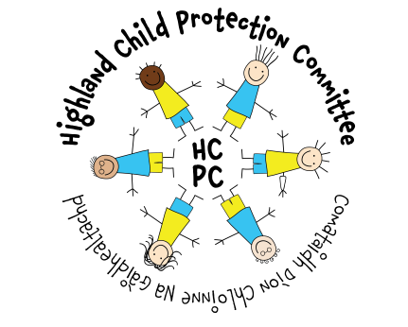
Policy on Perplexing Presentations and Fabricated or Induced Illness in Children

Warning – Document uncontrolled when printed

Policy Reference: | Date of Issue: October 2018
Prepared by: Dr Stephanie Govenden, Pam Tosh | Date of Review: October 2020
Lead Reviewer: DCI Vince McLaughlin | Version: 1.1
Ratified by: Child Protection Committee | Date ratified:
Planning for fairness: Yes/No | Date EQIA:

Distribution:  - GPs & GP sub group  - All Paediatric and Community Paediatric Staff  - Child Protection Advisors (Health & Education)  - Integrated Family Teams, Highland Council  - Lead Nurse (Health) for Child Protection  - CAMHS | - Principal Social work Officer, Highland Council  - Principal Officer for Allied Health Professionals  - Child Protection Committee Chair  - Health Visitors  - School Nurses  - Principal Nursing Officer, Highland Council

Introduction
This document provides local guidance to staff on the recommended process for managing concerns when a child presents with medically unexplained symptoms or there is an unusual pattern to the presentation that is concerning to professionals working with the family. This is termed a ‘perplexing presentation’ and can include fabricated or induced illness.
Fabricated or induced illness falls under the wider umbrella term of emotional abuse, also called harmful parent-child interactions. If you want to find out more about the spectrum of (un)intentional harmful parent-child interactions you can access local training through the Highland Child Protection Committee website: www.hcpc.scot

Background
This guideline had been produced in consultation with staff and is based on:
- Child protection companion, RCPCH 2013
- National guidance for child protection in Scotland 2014
- Fabricated or Induced Illness by Carers (FII): A Practical Guide for Paediatricians RCPCH 2012
- Child protection training seminar with Dr Danya Glaser (2018)
- Highland Child Protection Committee’s 6 key themes:
Presenting Features of Perplexing Presentations
These include:
- Reported symptoms not present & signs not observed by others, or independently of the child’s main carer (usually their mother).
- Reported symptoms & signs not explained by child’s medical condition, if they have one. Parents may also move from one issue to another, many of them are often vague and unclear.
- Physical examination & results of investigations do not explain reported symptoms or signs
- Inexplicably poor response to medication, treatment or procedures.
- Repeated presentation to different doctors due to parents failing to be reassured by negative test results .
- Professionals feel a parent is more animated or gets enjoyment derived from the telling of the child’s health story.
- Parent(s) request more investigations, assessment, and continuation of (unwarranted) treatment or new treatment.
- Impairment of child’s daily life beyond any known disorder.
- Where the child is able to express themselves, a parent talking on behalf of their child with no sense of the child’s experience of symptoms/impact on their life.
Practice point:
If one of the signs above is present, the treating doctor should look for others.

In these cases, there may be a number of underlying reasons for the presentation, including genuine concern and worry for the child. In fabricated or induced illness the parent, who is most often the child’s mother, has an underlying need for child to be recognised as ill (when not ill) or as more ill than the child is.
The need may stem from many diverse reasons including: anxiety; to confirm a (false) belief; to be recognised as a heroic or suffering parent; to gain attention; to deflect blame; to maintain a closeness to the child; as an expression of hostility to the doctor or for financial gain (DLA, litigation) or even hostility towards the child.
Specifically in cases of fabricated or induced illness, the process can be described as follows:
Induces illness or interferes with investigations, or significantly restricts child.

Child may have a specific illness.
Older children may report and believe in their own illness.
Examples include:
- Deliberately inducing symptoms by administering medication or other substances (this includes non-accidental poisoning), or by intentional suffocation or starvation.
- Interfering with treatments by over-dosing, not administering medication, or interfering with medical equipment such as infusion lines, gastrostomy or nasogatric tubes etc.
- Claiming the child has symptoms which are unverifiable unless observed directly, such as pain, frequent passing of urine, vomiting, or fits, resulting in unnecessary investigations and treatments.
- Exaggerating symptoms, again resulting in unnecessary investigations and treatments.
- Falsifying test results and observation charts.
- Obtaining specialist treatments or equipment for children which are not required i.e. wheelchair.
- Alleging unfounded psychological illness/ difficulties in a child.
- Placing significant restrictions on a child,(i.e. dietary due to unproven allergies) that lead to harm to the child, or trying to keep them in an infantile state that impairs normal child development.
Practice point
There is no direct correlation between the underlying motivation of the parent and the severity of harm experienced by the child. It is this harm that constitutes abuse or maltreatment.
Practice point
It is not always possible to predict which parents will progress from talking to inducing illness. In the small proportion of parents who move to illness induction, child mortality is estimated to be 5-8%.

The Child’s Experience
The child’s daily life in these situations can be severely limited. Their experience of medical and/or psychological care can include repeated examinations/ assessments, unnecessary, painful procedures and even unneeded operations. A child could be silently trapped in the falsification of illness or diagnosis around them.
In terms of their education and social activities, children may experience isolation from peers, limited or interrupted school attendance and education, and limited normal daily life activities. They may have been put into a sick role and be made to use aids, such as wheelchairs that they do not need, or be made to follow a severely restricted diet due to unproven food allergies/ intolerance.
The behaviour of their parent can cause a child to feel anxiety or confusion about their state of their physical and emotional health or take a false view of themselves as sick and vulnerable. Some children may collude with their parent so as not to go against them or to gain acceptance from them earning a special role within the family. They may themselves report the symptoms, and this is described as ‘medically unexplained symptoms.’
Practice point
We must consider the lived experience of the child to understand the effects on them of the behaviour of their parent.

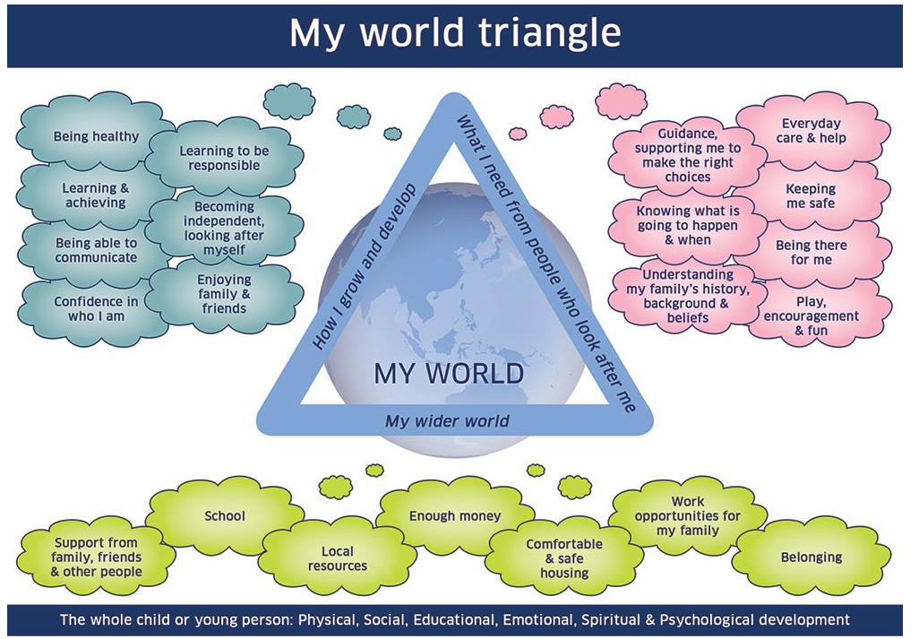
The use of the ‘My world triangle’ is a way of highlighting the area that a child is impacted by the behaviour or difficulties of their parent.
Practice point
When presenting such cases to panel consider describing a typical day for a child so the listener fully understands how their life is limited. Be factual and clear.

Practice point
When considering’ risk’ ask: Risk of what? Risk to whom? And from whom?
Multi-Agency Pathway for Perplexing Presentations
Concerns raised by medical, nursing or mental health staff but NO evidence of:
Illness induction, falsification of documents, or falsification of results

To evidence concerns a physical and/or mental health assessment must be prepared to show how behaviour is impacting directly on the child.
Gather and analyse information demonstrating how this is directly impacting on the child; consider a supporting chronology and consider if sibling chronologies are also needed.
Discuss concerns with Named or Lead Doctor for Child Protection and child protection nurse advisors.
Consider need for admission to complete your medical and psychosocial assessment – use direct observations (see appendix A)

- Consultant paediatrician/ CAMHS consultant or principal psychologist calls professional meeting of health staff to understand concerns and aim to reach a consensus view.
- The meeting must conclude with a communication plan and agreement over who is the responsible consultant/ or lead professional within CAMHS and an agreed rehabilitation plan, including CAMHS/ paediatric liaison staff.
- The Named doctor or Lead doctor or Lead nurse for child protection should attend or a Child Protection Advisor and a member of the CAMHS staff.
- Parents may be aware of this meeting as a way of understanding/ identifying the support or care their child may need and as a means of clarifying different professional opinions

Child’s responsible paediatrician should ask for additional information from education – school attendance, school performance or other concerns. Any support or early help school may have implemented to help the family. This can happen before the meeting above.

Responsible consultant must ensure that all professionals already involved with family are aware of the outcome of the health meeting and have given their views and will communicate the outcome to the other professionals working with the family.

Meeting between parent/carers and medical staff of no known cause for symptoms or severity (Appendix E)
Must include two paediatricians or a paediatrician and one other professional.
Make a plan for rehabilitation of the child back to normal functioning (helping the family form an acceptable narrative to explain recovery to others - hence the need for CAMHS involvement), including a return to school, withdrawal of unnecessary medical equipment or aids, and stopping unwarranted medication. This may include support from CAMHS and allied health professionals.

Parents do not accept and disengage or request new medical team.
Consider if there is a risk of immediate or significant harm to the child - if so:
- Discuss concerns with lead doctor.
- Refer to social care (speak and follow up in writing with child concern form).
- Agree what is communicated to parents and who is responsible for this.
Parents accept plan.
Identify who will be lead professional with responsibility for ensuring compliance with plan.

Multi-Agency Pathway for Perplexing Presentations
Concern WITH EVIDENCE of:
Illness induction, or falsification of documents, or results i.e. clear deception by a parent.

Make referral to social work with request for IRD/strategy meeting. Speak with social worker and complete a child concern form. You must escalate concerns if you feel a child is in immediate danger.
Agree/ discuss concerns with other health colleagues, including Lead Nurse or Lead Doctor for child protection. Communicate concerns to parents and plan for social work referral.

Consider holding a health professionals meeting to get a consensus view of health issues – do not allow this to delay referral to social work if you are concerned for a child’s safety.

Consider the information needed for IRD
- From health: an assessment of the child’s current functioning +/- health chronology.
- From education: an assessment of the child’s current functioning in terms of access to education and opportunities for social functioning.
- From social care/ police: understanding of any family involvement to date.

Multi-agency meeting to discuss concerns & agree plan.
This is attended by:
- Responsible paediatrician/ CAMHS clinician
- Police
- Child Protection nurse Advisor
- Social worker
- Education rep if child is known to them
- Child’s Named Person
- Others at request of police or social care

Illness induction if:
- Clear deception by the mother (main carer)
- Parents disagree & dispute independent /clinical observations
  - Request more investigations
  - Seek further medical opinion (when >1 already obtained)
  - Decline rehabilitation plan & child not functioning e.g. not attending school fully
- Rehabilitation not proceeding (not lack of resources)
Refer to child protection services because child’s functioning is being avoidably impaired by parent(s)

Consider risk to child of:
- Immediate harm
- Need for compulsory measures
- Need for measures to protect child/ separate child from parent.
Agree what will be communicated to parents and which 2 professionals will lead this i.e. social worker and paediatrician (Appendix F).
If evidence of crime – police lead.

Appendix A: CHILDREN’S UNIT ADMISSION PROTOCOL
Senior charge nurse or ward manager must be made aware of the admission and reason for admission.
If you are planning an admission, it is advised that you make the wider multi-disciplinary team aware before the admission to gain agreement on the observation protocols and avoid professional splitting by including CAMHS consultation. Splitting is commonplace in these cases unless there is space for staff to safely reflect on conflicting feelings which arise. In these cases, it is not unusual for a parent to ally with certain members of the team and disparage others making staff who are placed in the ‘good camp’ advocate for the misunderstood parent and those in the ‘bad camp’ feel rejected and useless at their job and avoidant of the family.
For example, if you agree a child will be monitored at meal times or in the bathroom and the parent informs nursing staff that the dieticians said this was not required – it will avoid disputes if all staff and parents are clear beforehand what is needed.
1. The protocol for admission must be agreed with parents with the child’s lead consultant before the admission.
2. It is the decision of the nurse in charge of the unit, based on the needs of all the inpatients if the child will go into a bay or cubicle.
3. The parents may not specify which nurse(s) takes observations or attends to the child’s care. This is the decision of the nurse in charge of the ward based on clinical needs of the ward patients.
4. The parents may not use their own measuring equipment from home i.e. weigh scales
5. Nursing staff will record factual, direct observations.
6. Communication will be led by the child’s responsible paediatrician and any questions or comments by parents will be directed to that paediatrician.
7. The paediatrician will work closely with the nursing staff also supporting the family, such as community nurses, epilepsy nurse, diabetic team etc. to ensure everyone has been able to express their concerns.
Parents can be kept updated – if any staff member considers there to be a risk to the child from the parents then they must escalate their concerns and discuss with the child protection team and the child’s responsible paediatrician.
Appendix B: WHEN PARENTS SEEK A FURTHER OPINION/ CHANGE OF PAEDIATRICIAN
Typically in such situations described parents will seek other opinions from doctors, or they may personally email other specialists to try to draw out an opinion they prefer, or look for non-NHS specialists or private clinic referrals. This is known as ‘splitting’. The aim of the joint health meeting (detailed in the pathways above) is to avoid any confusion that has arisen as different specialists have been involved. Where possible all staff involved in a child’s care should be invited to participate.
Non-NHS medical staff remain bound by GMC guidance and have a duty to share information where there are child protection concerns.

It has been agreed that any parent may chose once to request a change of paediatrician within the department. After one change however, no further changes can be automatically agreed. Wider discussion should occur within the paediatric team with advice from the child protection team.

Appendix C: COMPLAINTS

It is highly likely that parents who are unhappy with the process will make a complaint. Complaints may be made to individuals i.e. Child health commissioner, the service manager, the health board etc.
All complaints must be managed in the same way to provide consistent responses for staff and families.

- If parents complain about a paediatrician, the complaint is seen and managed by the clinical lead for either acute or community paediatrics.
- If a complaint is made about a CAMHS staff member, the complaint is seen and managed by the CAMHS service manager.
- Complaints about paediatric nursing staff are seen and managed by the paediatric senior nurse manager.
- Complaints about child protection nurse advisors are seen and managed by the lead nurse for child protection.
- Complaints about allied health professionals are seen and managed by the AHP lead.

Any complaint received by any other member of staff must be redirected to the appropriate person.

Within NHS Highland, if the clinical lead or service manager feels a wider response is required or the case is very complex, or of this is a second complaint from the same family about the same staff member - they must discuss it with the paediatric service lead and request assistance from the service manager. A decision should be made to consider seeking further advice from:

- Clinical governance manager
- Associate medical director (for Raigmore issues)
- Named doctor for Child Protection, Raigmore or Lead Doctor or Lead Nurse for Child Protection

The complaint response must be agreed by the clinical lead and the service manager where there is a known concern regarding perplexing presentations or if a learning review or debrief is planned.

Appendix D: ESCALATION OF CONCERNS BETWEEN AGENCIES
If you are concerned that a member of the multiagency team is not acting in accordance with the guidance you must discuss this with your manager or team lead. You should give that agency an opportunity to present their view and reasons for their decisions. If no agreement is reached concerns can be escalated to agency managers.

Appendix E: CHRONOLOGIES/ DOCUMENTATION OF CONCERNS/ PARENTAL REQUESTS TO SEE MEDICAL RECORDS /SUBJECT ACCESS REQUESTS
CHRONOLOGIES
When evidence is gathered health staff should ensure health chronologies also consider the health histories of all siblings. This may establish evidence of previous indicators/ course of conduct which can be used as part of later investigations.
Chronologies should also include information from different areas as some families move frequently across the country. There may be a need to collate health, social work and police data on these families who could have multiple addresses. Agencies should agree who will take responsibility for finding this information.
DOCUMENTATION IN HOSPITAL OR CLINIC NOTES
It is important that any staff member making an entry in the medical notes is clear and factual, and it should be obvious to anyone reading the notes what is opinion and what is fact. For example:
‘report from lab – blood in baby’s nappy is mum’s. Diagnosis - FII.’ Or,
‘Significant concerns raised over discrepancy of mothers report and lab reports indicating…Action taken….’
Compared to:
‘date/ time. Called by Dr XX, biomedical scientist. Blood found in nappy has been typed and matches [mum’s name]. Dr [responsible Paediatrician] informed.’
‘date/ time. Informed that blood in nappy matches with mother [name]. Positive for both samples from different days. Impression- evidence of deliberate deception and falsification of symptoms. Highly likely in my opinion to be fabricated illness. Plan...’

Child concerns forms are filed in the medical notes. These should not be shared with parents where there is a concern of FII unless this has been agreed between agencies, usually following the multi-agency meeting and with both medical and social work staff present.

ACCESS TO MEDICAL RECORDS
Requests for access to medical records either made by parents or through a complaints process, should go through medical records manager. Subject access requests by parents also managed by medical records manager. Advice for staff can be sought from clinical governance team.
GMC guidance: Protecting children and young people: The responsibilities of all doctors (2012, updated 2018)
‘Medical records are made to support safe and effective care but they may be used for other purposes. For example, they may be used when making decisions about a child’s or young person’s safety or welfare, as they can help build up a picture over time. They may also be used as evidence in court. It is particularly important that records relating to the possible abuse or neglect of a child or young person are full, accurate, dated and timed, and distinguish between clinical findings, your opinions and information provided by others. You should clearly record any continuing uncertainty about the risk of abuse or neglect to a child or young person because this information may be relevant if put together with other information about the child or young person or their family.
If there is not enough evidence to support your concerns that a child or young person is being abused or neglected, or the evidence shows that your concerns are not correct, you should record this clearly in the child’s or young person’s medical record and in their parents’ records. You should explain to the child or young person and their parents why information about these events will remain on their medical records.’
Appendix F: MEETING WITH PARENTS TO EXPLAIN NO UNDERLYING CAUSE FOR SYMPTOMS OR SEVERITY OF SYMPTOMS HAS BEEN FOUND.
This meeting takes place after a period of assessment, and when the lead paediatrician is clear that the symptoms described cannot be explained by an underlying disorder. This potentially difficult meeting must be handled sensitively and without causing unnecessary distress.
2 members of the team should be present including the responsible paediatrician. Detailed notes must be taken. You may wish to consult with a member of the Clinical Health Psychology Service, or other CAMHS team member or health psychology before the meeting, as they may be able to offer follow up to support rehabilitation. The carers should have a full explanation of the evidence and what further action is needed.
The purpose of the meeting is to inform the family:
- that it has not been possible to give a physical diagnosis or to define the child’s problem medically but that the symptoms are not life threatening or indicative of any severe underlying disease;
- the child needs to be helped to function alongside his or her symptoms and will not come to harm as a result;
- that further investigations are not needed and would be likely to cause harm;
A plan for rehabilitation of the child back to normal functioning, including helping them to form a narrative to explain their recovery to enable a return to school, withdrawal of unnecessary medical equipment or aids, and stopping unwarranted medication should be outlined.

Appendix G: MEETING WITH PARENTS AFTER MULTI-AGENCY TEAM AGREE FII IS MOST LIKELY REASONS FOR CHILD’S DIFFICULTIES.
Meeting must be held in private and away from the bedside. Social worker and responsible lead paediatrician, +/- police should be present. At this meeting, it is important to explain to parents that FII is the most probable cause for the child’s signs and symptoms, and why that is the case.
Also need to explain what the plan for any ongoing management and further investigation is. Parents need to understand any restrictions that have been decided on their visiting or access to their child.
Supportive services available for a carer who is suspected of abuse and for a non-abusing carer; and follow-up arrangements, including a plan for further discussions (consistent with the multi-agency plan agreed at the strategy discussion) should be discussed.

Appendix H: FURTHER INFORMATION FOR PROFESSIONALS (taken from presentation on FII given by Dr D Glaser)
FII is defined by a main carer who uses their words or erroneously reports (fabricates) history, symptoms or signs by
- Exaggerating
- Misconstruing real phenomena on basis of mistaken belief
- Reporting actual phenomena which only occur in the mother’s presence – i.e. situation specific and therefore not a disorder located solely in the child
- Inventing

BUT, they may or may not have an intention to deceive.

FII is defined by a main carer who deceives by using ‘hands’ to make the child appear ill through:
- Falsifying or interfering with investigations
- Inducing signs or illness in the child by
    - e.g. Poisoning / over medication (laxatives, salt), suffocating, starving

Doctors contribute to the underlying needs of the main parent by:
- Examines & investigates the child
- Treats the child
- Supports or does not dispute the need for
  - Poor school attendance
  - Use of e.g. wheelchairs
  - Financial & other support for care of sick child

Medical mismanagement of the child can occur with:
- Lack of direct observation of child
- Over-reliance on
  - parental reports
  - more & more investigations & over-reliance on results
- Taking eye off child’s functioning
- Treating symptoms and results
- Omitting to look at current harm of this process to the child

Barriers to recognising and managing perplexing presentations:
Concern re missing treatable disorder
Doctors usually work with parents
Discomfort: disbelief/suspicion of parent
Discomfort of thinking ill of a mother
Discomfort of wrongly suspecting/blaming
Doctor powerless - bound by:
history given by a parent, signs & results of investigations could be induced by parent
Difficult to say ’I do not understand’ feeling foolish, being wrong
Rising to diagnostic challenge (encouraged by mother’s flattery or doubting)
Fear of:
complaints, reports to licensing authorities, litigation
Time taken to process suspicions
Uncertainty about:
when to mention suspicion
what to say to parent(s)
what to write in medical file
Losing control over child protection process

If you recognise these difficulties then consider discussing the case with child protection colleagues and take the next steps.
Next steps: Establish what is wrong or not: This may take significant time and involves meeting parents separately and speaking to the child separately.
- Coordinate medical views
- Compile health chronology, noting who observed/reported and what the outcome was i.e:
Event | Observed or reported | By whom | Outcome for the child (including impact ie. Positive, negative or unknown)

- Obtain full account of child’s daily functioning incl. school, activities, aids
- Elicit parents’ explanations for the child’s reported difficulties.
- Observe the child: including inpatient admission. Admission protocol must be agreed with all staff beforehand.
- Carry out further definitive warranted investigations to exclude differential diagnoses.

