**Using Viewpoint in Highland**

**Viewpoint is completed online using any phone/tablet/laptop connected to the internet. The information is stored online and not on the device.**

**Step 1: Contact** [**CP.Training@highland.gov.uk**](mailto:CP.Training@highland.gov.uk) **with the Child/Young Person’s PID and you will be sent a login and password for them.**

**NB: You can do this in bulk by case load or for individual children. Each child/young person has one log in ID and doesn’t require additional logins for future questionnaires. The questionnaires can be completed on more than one occasion and provide useful comparative data over time in order to see areas of progression/difficulty.**

**Step 2: Once you have a log in and password you are now ready to access the questionnaire so go to (use Google Chrome if available):** [**https://vptweb.vptol.co.uk**](https://vptweb.vptol.co.uk)

**Step 3: Login – the Organisation is always HIGHLAND18 then use the login and password you have been given for the young person**

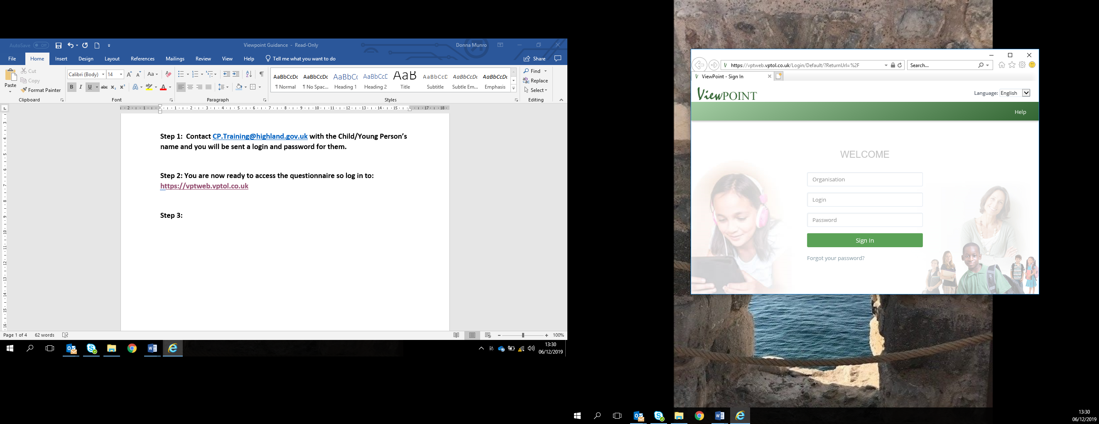

**NB: The login is for each child/young person to compete the questionnaire but the information is for use by the Social Worker and it is important the child/young person knows the Social Worker will access it. The password cannot be changed.**

**Step 4: Ready to start the questionnaire – once you log in, the questionnaire should appear – press Start**



**Step 5: Child/Young person decides on questionnaire style – with graphics or without (questions are the same)**



**Step 6: The Questionnaire – the questions will appear at the top of the screen with a number of options for answers – these can also be spoken by clicking on the yellow button with speaker.**

**The Social Worker can discuss the answers as the questionnaire is being completed or at the end. Notes can be added at any time by clicking on the arrow on the right hand side of the screen and typing in the note pad.**





**Step 7: The Report – once the young person has completed the questionnaire the results can be viewed at any time by logging in with the login details for that young person.**

**You will see this screen….**

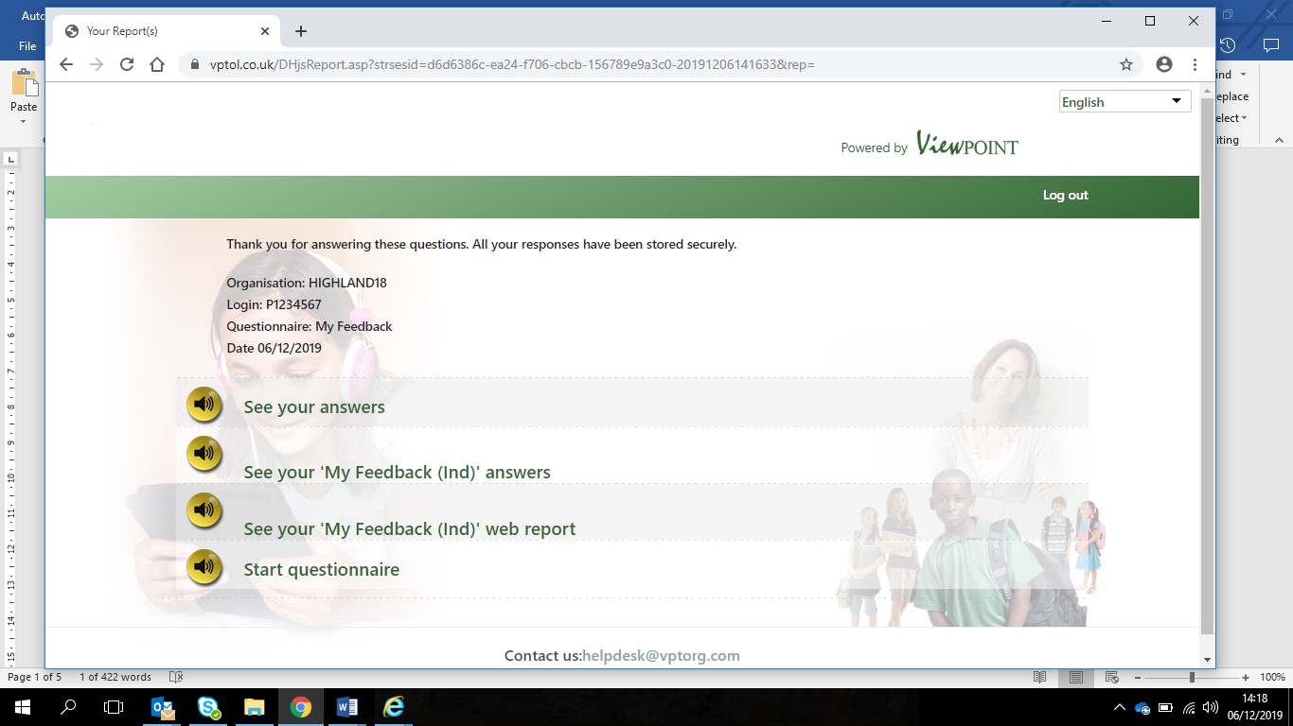

**There are different types of report available from a simple list of answers to a more visual web version which can be used to measure strengths/pressures over time.**

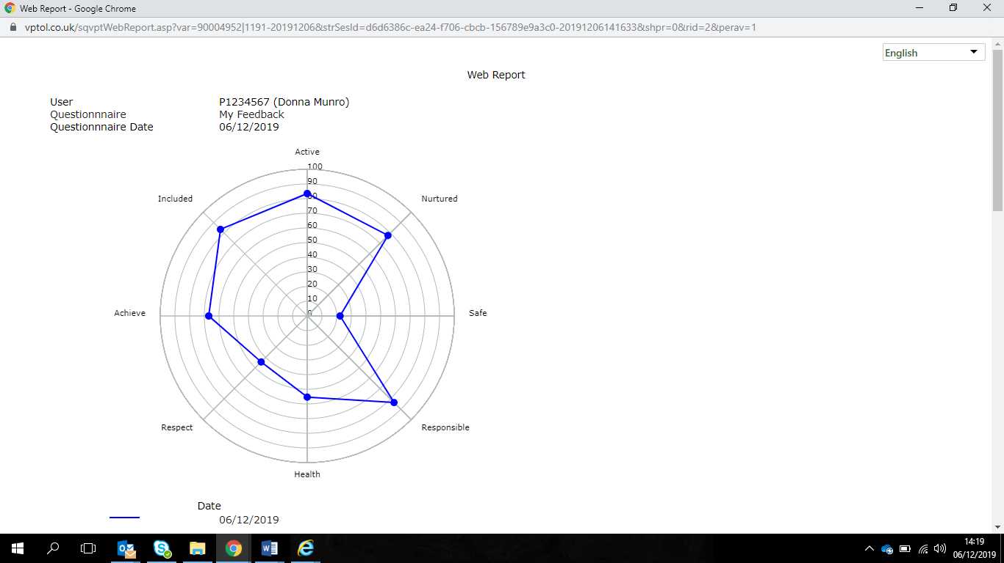

**Step 8 – Incorporate Report into Child’s Plan using the information provided by the child/young person.**

**NB: This should be a summary of the views given pulling out any key strengths and pressures, and including any specific comments provided by the child/young person. The web can also provide a very visual representation of strengths/pressures when comparing with previous questionnaire responses.**