Child Protection Guidance and Toolkit for Community Groups in Highland

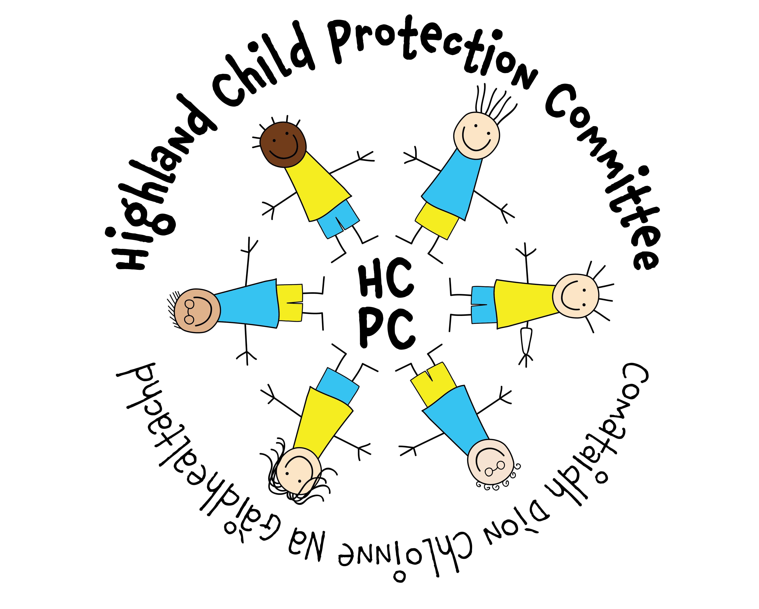

This Guidance has been developed by the Highland Child Protection Committee for Community Groups providing activities for children, young people and families in Highland. This may include sports groups, arts and crafts clubs, religious groups or any organised groups/activities which involve regular contact with children and young people. This document provides guidance only and cannot cover every situation. Groups should act proportionately and appropriately, and seek advice through the Child Protection Committee or local professionals where clarity is required.

NB: Larger Third Sector Organisations and those with a number of paid staff should have robust child protection policies and procedures in place and may wish to visit the Third Sector sections of the Highland Child Protection Committee Guidelines. This provides further tools to help support recruitment of staff and volunteers, as well as more detailed guidance on child protection issues.

Please note that whilst this guidance refers to work with children and young people, many of the issues covered are also applicable to working with vulnerable adults. Further advice and information on Adult Support and Protection can be found online.

Highland Child Protection Committee would like to thank the Keeping Children Safe Reference Group for their support in developing this guidance.
Introduction

In Scotland, children are defined within law as under the age of 16 years. However, the Children and Young People (Scotland) 2014 Act and UN Convention on the Rights of the Child recognise our responsibility to provide services and support to all children and young people under the age of 18 years.

Children and young people usually trust and respect the adults involved in providing activities for them. On occasion, staff or volunteers may become concerned about a child or young person, or the child may disclose something has happened to them. It is crucial that community groups feel able to respond appropriately to concerns about children and young people.

This Guidance aims to provide the information you need to help you make sure your Community Group has the right procedures and guidelines in place, along with access to ongoing training and support to help ensure you are competent and confident in dealing with child protection issues.

Further information and guidance is available on the Highland Child Protection Committee Website – www.hcpc.scot

Creating a safe environment

It is good practice for all Community Groups to have a nominated Child Protection Lead who is selected by the Group and vetted appropriately. The Child Protection Lead is responsible for ensuring that:

- Child protection policies and procedures are up to date
- Policy is clearly displayed (if possible) and all volunteers/staff are aware of the policy and have read and understood it
- Group knows how to access specialist child protection advice
- Any child protection concerns are shared and recorded appropriately
- Disclosure/PVG checks for staff and volunteers are carried out and recorded/stored effectively
- Records are kept and referrals are made to Disclosure Scotland in cases where staff or volunteers are suspected or known to have harmed a child, and that these individuals are removed from unsupervised contact with children/adults ‘at risk’ until such time as a decision is made whether their names should be added to the Disqualified from Working with Children list

Volunteers should always know who their nominated child protection lead is and how to contact them

Groups should have a Child Protection Policy in place which is proportionate and appropriate (see Tool 1 for sample policy). Where groups receive funding or use premises from High Life Highland and/or Highland Council this is mandatory. Groups should make a note in their minutes to show that they have agreed a policy and this has been made known to all members and volunteers. In addition, they are required to make sure that any groups applying to use their facilities for activities involving children have a policy in place. Groups should also have a Policy Statement which is displayed or available to view by all those using the Group and/or volunteering with the Group. A Sample Statement is provided in Tool 2.

Recruitment Staff and Volunteers

It is good practice to use similar standards when recruiting volunteers as for paid staff. They should:
- know what is expected of them. Tasks to be carried out should be clearly defined, so that everyone is clear about who is responsible for what.
- have clear lines of support and supervision
- be valued
- have safe working conditions
- be insured
- know their rights and responsibilities, how to make a complaint and how things will be dealt with if they do something wrong
- be paid agreed expenses where appropriate
- be provided with an introduction to their role in the community group, and given appropriate levels of supervision to assess progress and to sort out any problems
- receive appropriate and relevant training
- be free from any sort of discrimination or harassment which breaks the law on equality

Tool 3 highlights good practice for recruitment and induction of volunteers.

Protection of Vulnerable Groups (Scotland) Act 2007

The Protection of Vulnerable Groups (PVG) (Scotland) Act defines regulated work by reference to: the activities that a person does; the establishments in which a person works; the position that they hold; or the people for whom they have day to day supervision or management responsibility.

There are two types of regulated work:
- regulated work with children;
- regulated work with adults.
The reason for having two types of regulated work, and two corresponding lists of individuals who are unsuitable to do such work, is to allow for the fact that unsuitability to work with one group does not always go hand in hand with unsuitability to work with the other.
You need to undertake disclosure checks for anyone, paid or unpaid, whose normal duties fit the definitions for regulated work with children or adults.

Where an organisation is also a Scottish charity then trustees concerned with its management or control may also be required to be disclosure checked.

For further information about the Protection of Vulnerable Groups Scheme visit: https://www.mygov.scot/disclosure-types/?via=http://www.disclosurescotland.co.uk/guidance/infoforindivid/chap1_intro/1_0_introducing.html

Tools 4 and 5 of this tool kit provide forms for collecting information about staff/volunteers and for reference requests where appropriate.

Please note, these checks allow us to screen those who apply for paid posts or volunteer and check any recorded information about them. However, it is not a guarantee of suitability to work with children and you should use your professional judgement and the knowledge you and your staff may have about potential volunteers and their suitability.

Recruitment of Volunteers with Criminal Convictions

Having a criminal conviction does not necessarily preclude someone from being employed by, or involved with Organisations, and it may be discriminatory to reject them on this basis. However, it is important to consider any risks involved for children, young people and other volunteers so the offences do need to be considered. The type(s) of work to be undertaken, nature and number of offences, length of time and specific issues affecting the person at the time and since may all be considered. Further information and advice about the Rehabilitation of Offenders Act including amendments made in February 2018 can be found here. Tool 6 provides further guidance for Organisations where a volunteer or staff member may have previous convictions.

Practice Issues

Transporting children and young people:

Where possible, ensure transport arrangements are in place prior to activities taking place. Consider any risks involved and ensure information is available for other members and parents/carers. If it is necessary to transport children other than by use of hired transport e.g. bus company, minibus then the following good practice should be implemented:
- Drivers should be vetted appropriately in accordance with these guidelines
- Vehicles should be roadworthy and appropriately taxed and insured
- Consent should be obtained from the child’s parent/carer
- A collection point and drop off point should be identified and parents/carers notified of these points.
- Ensure an adequate adult-child ratio and, where possible, both male and female staff should accompany mixed groups of children. Ensure the accommodation and sleeping arrangements are suitable
- Always have a list of emergency contacts and medical information available

Photographing, videoing and filming:

Publications and websites are a great way to promote the achievements of children and community groups. However, it is important to consider any risks that may arise from posting photos/videos online. For example, some children may be subject to statutory measures or may be living with parents or carers who have had to flee domestic abuse or other threatening situations. To reveal their whereabouts may place them at risk.

The following measures are recommended as good practice and will contribute to safe participation in your organisation:
- Consent should always be obtained from the parent/carer and child whose picture may be taken or used.
- The organisation reserves the right at all times to prohibit the use of photography, film or video at any event or activity with which it is associated.
- People are made aware where they can report concerns about the use of photographs and films, i.e. the Designated Child Protection Officer for the organisation and/or the Police. Further information on Sexting can be found on the Highland Child Protection Committee website www.hcpc.scot

Publications and Websites:

- Always obtain consent before displaying pictures or information.
- Never include personal information that could identify a child or place them at risk e.g. full name, home address, e-mail address, telephone number, dates, place and times activities take place. Instead give the contact details of a group leader who can deal with requests for information about the organisation.
- Never depict children in a provocative, demeaning or tasteless manner.

Tool 7 contains 10 top tips for effective Child Protection in Community Groups

Dealing with a Child Protection Situation:

Being alert to signs and symptoms:

People who abuse others often do so in a manner that makes it difficult for children or young people to tell someone else if they are being abused. However there may be signs which make you concerned and may be an indication of abuse or neglect.

The child/young person may:
- have unexplained bruising or bruising in an unusual place
- appear afraid, quiet or withdrawn
- appear afraid to go home
- be left unattended or unsupervised
- have inappropriate levels of responsibility for their age
- be acting out in a sexually inappropriate way
- be misusing drugs or alcohol
- be being bullied

The parent/carer (or another adult) may be:
- verbally abusive towards a child or young person
- acting in a violent or sexual manner towards a child, young person or adult who is less able to protect him/herself
- misusing drink or drugs whilst caring for a child or young person

What should I do if I have a concern?

Speak to your nominated Child Protection person as soon as possible. If you are unable to contact them, or it is not appropriate to do so, you should contact your local Family Team (hyperlink).

If your concern is urgent, don’t delay and call the Police immediately on 999

Responding to children who disclose abuse

It is important to know that if you suspect a child is being abused, or they disclose abuse or neglect to you, you have a responsibility to respond appropriately.

Whether you are a volunteer or a paid member of staff you must, at all times:
- Allow the child/young person to speak without interruptions. Reassure them they are right to tell but don’t make suggestions to them which could imply making an investigation.
- Do not investigate or question other than to clarify your understanding. If the matter is to be investigated further this will be done by trained professionals.
- Be clear about what will happen next, who you will tell and when.
- Remain calm, no matter how difficult it is to hear what the child/young person is telling you.
- As soon as practical, write down everything the child/young person told you, but remember that this is a confidential matter between you and that individual.
- Contact your nominated child protection officer as soon as possible.

Remember it is not your job to decide if abuse has taken place – it is your responsibility to report concerns.

What happens next?

All child protection concerns are treated in confidence and seriously. You may be asked for further information and/or the child/young person may be interviewed.

Tool 8 provides a flowchart of actions for reporting and recording concerns about children.

Storage and Handling of Information

Tool 9 discusses storage of information in relation to Disclosure Scotland. However, your group should also consider how information about children or young people will be recorded and stored. This should include:
- Any personal information about children
- Any records of concerns about children
- Copies of any child concern forms
- Volunteer/staff records
- Training records

NB: This list is not exhaustive. All information should be treated in confidence and stored securely. This includes both paper and electronic information.
Every organisation should have clear procedures for information handling and storage that comply with the General Data Protection Regulation (GDPR). This should include:
- Tell people what you are doing with their data
People should know what you are doing with their information and who it will be shared with. This is a legal requirement (as well as established best practice) so it is important you are open and honest with people about how their data will be used.

- Make sure your staff/volunteers are adequately trained
New employees/volunteers must receive data protection training to explain how they should store and handle personal information. Refresher training should be provided at regular intervals for existing staff.

- Use strong passwords when storing information electronically
There is no point protecting the personal information you hold with a password if that password is easy to guess. All passwords should contain upper and lower case letters, a number and ideally a symbol. This will help to keep your information secure from would-be thieves.

- Encrypt all portable devices
Make sure all portable devices – such as memory sticks and laptops – used to store personal information are encrypted.

- Only keep people’s information for as long as necessary
Make sure your organisation has established retention periods in place and set up a process for deleting personal information once it is no longer required.
https://ico.org.uk/for-organisations/charity/

Groups should also ensure they have the relevant consent from service users to store and share information. This includes consent from children and young people.

Further information and advice, along with a range of tools and checklists is available from the Information Commissioner’s Office - https://ico.org.uk/

Training and Further Information

We would recommend that everyone who has contact with children has some child protection training. In Highland this is available online or face-to-face and further information can be found in the Training section of www.hcpc.scot

Child Protection Leads should ensure they are confident and competent in responding to child protection concerns and we would recommend attendance at the Recognition and Response training as a minimum requirement.

Full details of all child protection training is available at www.hcpc.scot
Tool 1

Sample Child Protection Policy

Child Protection Policy for….(name of group)

We believe that every child regardless of age has, at all times and in all situations, a right to feel safe and protected from any situation or practice that results in a child being physically or psychologically damaged. In our group, if we have suspicions about a child’s physical, sexual or emotional well-being, we will take action.

We recognise that child protection should not be treated in isolation - we will take on board guidance given by Highland Child Protection Committee and will address recruitment and selection of volunteers and paid employees by doing the following:

- We accept that it is our responsibility as a group to check that all adults in positions requiring disclosure checks are members of the appropriate Protection of Vulnerable Groups Scheme and have been appropriately vetted

- We will ensure we have a record of personal details for each member of staff/volunteer

- We will ensure we have carried out necessary checks in relation to anyone working with children and young people, including requesting references where appropriate

- We will interview prospective volunteers and staff

- We will notify Disclosure Scotland if anyone on the Disqualified from Working with Children List applies to work for or volunteer with our group

- We will ensure that all staff are given Codes of Practice to work to

- We will remove any member of staff or volunteer whom we know or suspect to have caused harm to a child or to have placed a child at risk of harm and we will notify Disclosure Scotland of our actions and the reasons for them, even if that person has left our group

All volunteers or staff are encouraged to share concerns with the group’s Child Protection Lead. If the situation urgent, the child is too frightened to go home or we have very serious doubts about the child’s safety, we will contact Social Work or Police immediately.

Child Protection Is Everyone’s Responsibility

We believe that every child regardless of age has, at all times and in all situations, a right to feel safe and protected from any situation or practice which results in a child being physically or psychologically damaged. In our group, if we have suspicions about a child’s physical, sexual or emotional well-being, we will take action.

All volunteers or staff will share concerns with the group’s Child Protection Lead/Designated Person. If the situation is clearly an urgent case, the child is too frightened to go home or we have very serious doubts about the child’s safety, we will contact Social Work Services or Police immediately.

If our concerns are more general about a child’s welfare, then we will discuss these with our group’s Child Protection Lead/Designated Person, who would then make a referral to an appropriate professional for assessment of the child’s needs. It is important that all volunteers and staff communicate concerns accurately.

To this end, volunteers and staff will follow the procedures below;

- Upon the receipt of any information from a child or suspicions, it is necessary to make an accurate and detailed written record of what they have seen, heard or know, at the time the event occurs;

- Share their concerns with the Child Protection Lead for the group and agree what action to take;

- Avoid asking any more questions than are necessary to clarify whether there is a concern. Always REFER to statutory services to undertake in depth INVESTIGATION of any suspicions or allegations about abuse.

If we have concerns we must act - it may be the final piece of the jigsaw that is needed to protect that child - or we may prevent, further children from being hurt.

Contact numbers for Local Family Teams and the Police are available at www.hcpc.scot

For ease of reference note them below:

Local Family Team (Care and Protection)

Police 101 (non-urgent)
999 (urgent)

Out of hours Social Work Emergency Service: 08457 697284

Tool 2

Policy Statement for ….. (Name of Group)

We will:

- Hold a register of every child/protected adult involved with the group including relevant medical details and have a contact name and number close to hand in case of emergencies;

- Treat everyone with respect;

- Remember that some issues are confidential;

- Provide an example we would wish others to follow;

- Where possible consider activities which involve more than one adult being present or at least within sight and hearing of others;

- Be aware that someone else might misinterpret our actions even if they are well-intentioned;

- Respect a child’s right to personal privacy;

- Provide time for children to talk to us;

- Encourage children and adults to respect and care for others;

- Take action to stop any inappropriate verbal or physical behaviour;

- Remember to REPORT not INVESTIGATE any suspicions or allegations about abuse;

- Only share concerns and seek support from those identified in the group’s child policy;

Contact numbers for Local Family Teams and the Police are available at www.hcpc.scot.

Designated Child Protection Officer for [name of group]:

Name:

Contact Details:

Tool 3

Recruitment of Staff/Volunteers

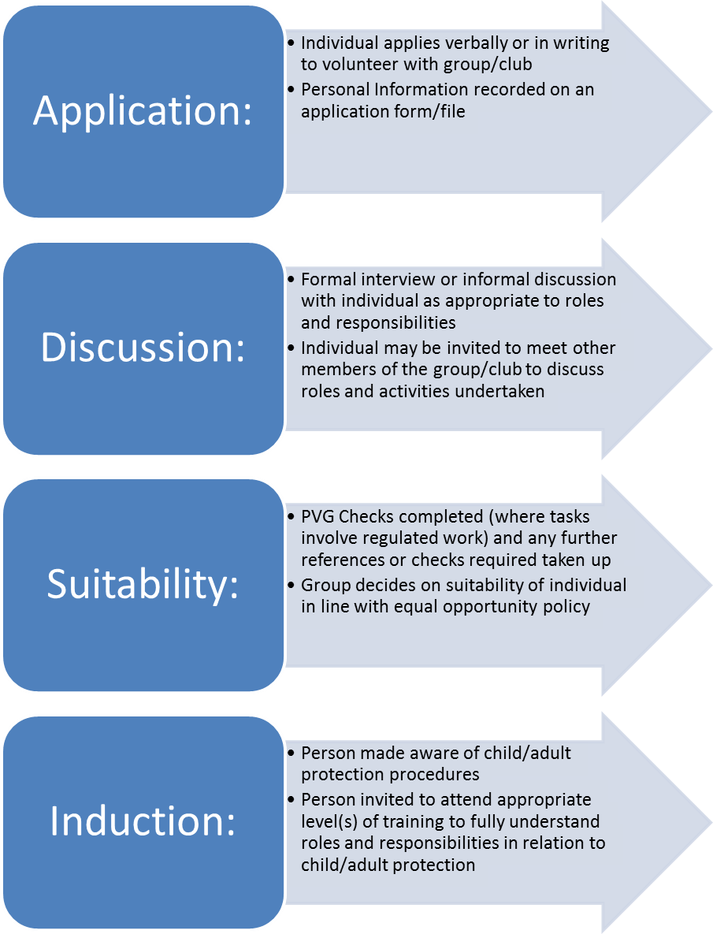
Tool 4
Personal Profile Form

To be completed by all new volunteers/employees at [AGENCY NAME]

- Personal Details

Title
Forename
Surname
Date of Birth
Address
Telephone No:
E-mail:

Occupation
Currently employed? | YES | NO

- Qualifications/Training

Please enter details of any qualifications or training courses you have attended which are relevant to caring for young children. Date(s) Title of Qualification/Training Subjects Studied Length of Course Name of Organisation

- Experience

Please give details of experience of working with children/young people
In what capacity? Between which dates? Other comments:

- Referees

Please provide the names and addresses of TWO responsible persons for reference purposes. Referees should not be related to you and, where possible, should have a knowledge of your ability to care for or be in the proximity of children/protected adults. All references will be taken up. You should secure prior agreement of referees before providing their names.
Referee 1  Name:  Address:  Telephone Number:  E-mail:  How do you know this person? | Referee 2  Name:  Address:  Telephone Number:  E-mail:  How do you know this person?

- Rehabilitation of Offenders Act

We are committed to selecting people on the basis of their individual skills, and experience, and will not, therefore, automatically refuse a particular individual on the basis of a previous criminal conviction. We will assess the relevance of any offence to the particular activity in question in order to ensure our duty of care to our service users.

Do you have any criminal convications which are not ‘spent’ in terms of the Rehabilitation of Offenders Act 1974

Yes No

If you tick Yes to this question, we will contact you for further information and discussion (alternatively you can submit this information in writing).

- Declaration

I have read and understood the organisation’s Child Protection Policy and agree to the appropriate vetting procedures. I do not know of any reason I cannot work with children and young people in a paid or voluntary capacity. I agree to inform the organisation of any change in circumstances.

Signed: ________________________________ Date: ______________

Tool 5
REFERENCE QUESTIONNAIRE

POSITION:

The post involves access to children. As an organisation committed to the welfare and protection of children, we are anxious to know if there is any reason at all to be concerned about this applicant being in contact with children or young people.

The information given in this reference will be held in confidence.
Name and Address of Employee/Volunteer:

- How long have you known this person?

- In what capacity have you known this person?

- If you are aware of any reason why our Group should not use this person in our activities with young people please give details:

Signed _______________________ Date _________________________

Name (Print):
Address:

Position:

Tool 6
Policy on Recruitment of Ex-Offenders

Policy Statement for:
……………………

We will treat any applicant for any position (paid or voluntary) within our organisation fairly and not discriminate unfairly against the subject of a disclosure on the basis of conviction or other information revealed.

Where appropriate we will require membership of the Protection of Vulnerable Groups Scheme and request a Standard or Enhanced disclosure as necessary and relevant to the position sought.

Where a position requires a disclosure we will make this clear on the application form, job advert and any other information provided about the post.

At interview we will make sure that open and measured discussions can take place on the subject of offences.

Failure to reveal information at interview, that is directly relevant to the position sought, could lead to withdrawal of an offer of employment.

At interview or when receiving a disclosure which shows a conviction or which contains intelligence of significance to working with children and families or protected adults, we will use our professional judgement and take into consideration –

- Whether the applicant is banned from working with our client group
- Whether the conviction/intelligence is relevant to the position being offered.
- The seriousness of the offence revealed.
- The length of time since the offence took place.
- Whether the applicant has a pattern of offending behaviour.
- Whether the applicant’s circumstances have changed since offending took place.

We will ensure that all our members (staff or volunteers) involved in the recruitment process are aware of this policy and have received relevant training and support.

Any applicant for any post that requires a disclosure may receive a copy of this policy.

Tool 7
10 Tips for Child Protection

Remember - the protection of children and young people is the responsibility of everyone in your group, not just the people who run or manage the group. Policies and procedures will only be effective when they operate in a culture where children and young people are respected and given every opportunity to thrive and flourish. The following actions can help to create a safer environment for everyone.

- Have a Child Protection policy and make sure that it is clearly displayed and communicated. Make sure copies are available for all staff/volunteers, children and parents/carers

- Draw up a Child Protection policy statement with the name and contact details for your Nominated Child Protection Officer, local area Family Team and Police. Ensure that this is clearly displayed, known and understood and copies made available to children/staff/volunteers/parents/carers as appropriate
- Appoint a Child Protection Lead/Nominated Person for your group, and provide them with access to appropriate training
- Agree and provide a code of conduct for staff and volunteers, this should include expectations of conduct and procedures for outings and taking of photos/use of media
- Implement safe recruitment and vetting procedures for staff and volunteers and provide access to Child Protection training
- Involve members in monitoring and regularly reviewing policy and protocol
- Treat everyone equally and with respect; encourage children to feel comfortable and confident that they are valued and listened to
- Encourage an open and inclusive ethos for all children, staff, volunteers, parents and carers
- Where it is necessary for a staff member/volunteer to be alone with a child or young person, ensure that the door is open and another adult is within earshot
- Respect children and young people’s personal space
Any concerns about child/adult abuse or the conduct of a member towards children, young people and adults who may be less able to protect themselves should be reported to the Child Protection Lead in the first instance. Where it is not possible or appropriate to speak to the Child Protection Lead, contact your local Family Team or the Police.

Tool 8

Policy on the Secure Handling, Use, Storage and Retention of Disclosure Information.

In accordance with the Disclosure Scotland Code of Practice, for registered persons and other recipients of Disclosure Information, we will ensure the following practice.

- Checks will only be requested when necessary and relevant to a particular post and the information provided on a disclosure certificate will only be used for recruitment purposes.
- We will ensure that an individual’s consent is given before seeking a disclosure, and will seek their consent before using disclosure information for any purpose other than recruitment.
- Information will only be shared with those authorised to see it in the course of their duties.
- Where additional information is provided to our designated signatory and not to the applicant, our designated signatory will not disclose this information to the applicant, but will inform them of the fact that additional information has been provided, should this information affect the recruitment decision.
- Information will be stored in a locked non-portable container, for a maximum of 6 months. Only those authorised to see this information in the course of their duties will have access to this container.
- Information will be destroyed by shredding.
- No image or photocopy of the disclosure information will be made, however the following details may be retained:
  - Date of issue of PVG check
  - Name of subject
  - Disclosure type
  - Position for which disclosure was requested
  - Unique reference number of disclosure
  - Recruitment decision taken
- If the subject of the Disclosure check is found to be on the ‘Disqualified from Working with (Children/Adults) List’ we will notify the Police that an attempt has been made to acquire work with children/adults.
- We will ensure that all staff with access to information are aware of this policy and have received relevant training and support.
- We will make a copy of this policy available to any applicant for a post (paid or voluntary) with us that requires a PVG check.

Further advice and information can be found here: https://www.mygov.scot/pvg-scheme/?via=https://www.disclosurescotland.co.uk/disclosureinformation/pvgscheme.htm

Tool 9
Responding to Child Protection Concerns
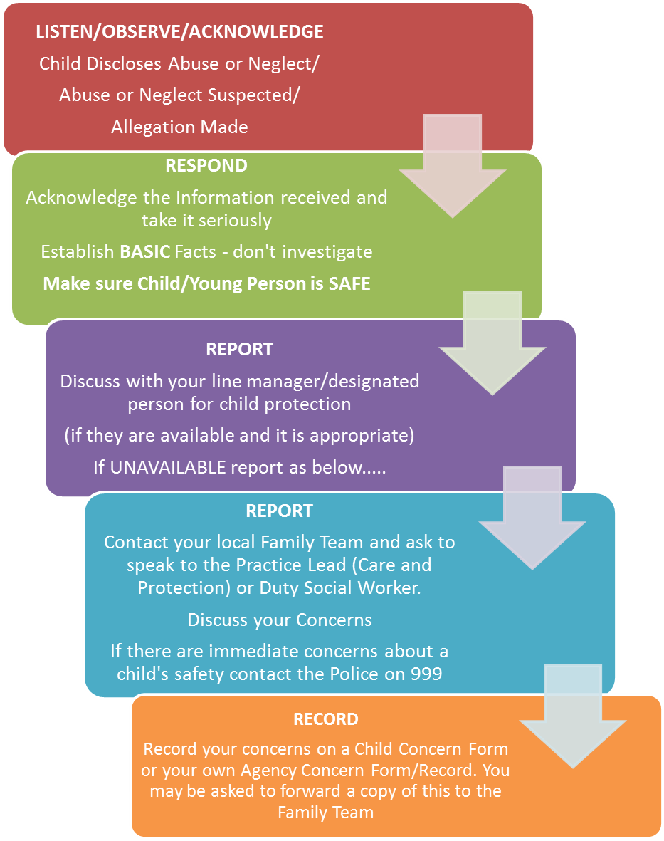
Tool 10
Good Practice for Staff and Volunteers

General Points:
- Treat everyone with respect.
- Always respect a child/protected adult’s right to personal privacy.
- Never make salacious, suggestive or demeaning remarks/gestures towards a child/protected adult.
- Avoid any physical horseplay with a child/protected adult or any actions another adult may misinterpret, no matter how innocent and well intentioned your actions may be.
- Always encourage children/protected adult to feel comfortable and confident to point out to you attitudes or behaviours they do not like (including your own).
- If you suspect that a child, young person or protected adult is becoming inappropriately attracted to you (or another volunteer), you must share your concerns with a member of senior management.

One-to-One Situations:
- It may be important for you to be alone with a child. In these circumstances try to ensure that others are within earshot and preferably within vision.
- If you are on your own with a child NEVER have the door locked.
- Do not isolate yourself from the rest of the group.
- Try to find a room with a window in the door, or use a ground floor room with windows.
- If possible consider leaving the door open or ajar.

Behaviour to Avoid
- General behaviour, avoid the following:
- Losing your temper
- Raising your voice unnecessarily
- Inappropriate language or behaviour
- Befriending children on social media sites unless the official site of the group/organisation
- Sending inappropriate messages/images to children

NEVER:
- Raise your hand
- Threaten a child
- Hit a child
- Strike or use an implement on a child
- Grab or pull at a child’s clothing
- Have inappropriate touching or contact with a child whether ‘invited’ or not.

Where an allegation is made against a member of staff/volunteer in your project, you should have procedures in place to respond to these. However, child protection concerns should still be reported as above.

