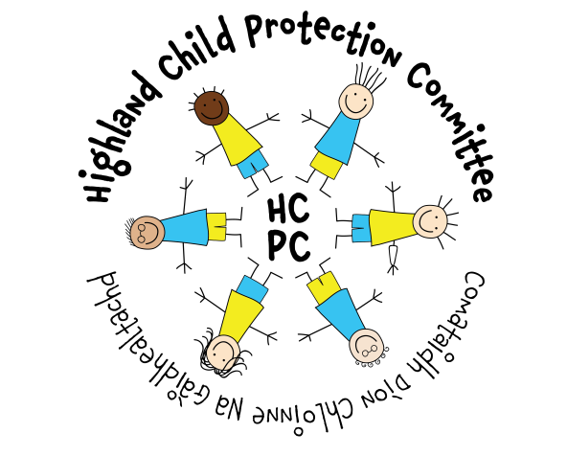

HIGHLAND CHILD PROTECTION COMMITTEE
IMPROVEMENT PLAN
2019 – 2022

Contents | Page
- Introduction  - Preface by Chief Officers  - Foreword by Chair, Highland Child Protection Committee | 3  4
- Child Protection Planning in Highland  - Reporting Structure  - Strategic Planning  - Constituent Members of Highland CPC | 5  6  7
- CPC Priorities 2019-2022  - Key Priorities  - Principles of Protection  - For Highlands Children Priorities | 8  9  10
- Improvement Plan 2019-2022 | 11
- Additional Information  - Abbreviations  - Glossary of Terms  - CPC Membership 2019 | 23  24  26

Preface by Chief Officers

The Highland Chief Officer Group is pleased to endorse Highland Child Protection Committee’s Improvement Plan and priorities for 2019 – 2022. This reflects our direction to the CPC and our views based on the available various briefings and formal reports made available to us.

As Chief Officers we give a continued commitment and support to the work of the Committee, but acknowledge the particular challenges facing us all within the context of an ever changing child protection landscape, increasing demands and expectations of agencies alongside current financial restraint and uncertainties.

The Chief Officer’s would also like to extend our thanks to staff and managers who deliver frontline services for children and families, and commend their professionalism, sensitivity and diligence in meeting the demands and responsibilities facing them within the restraints highlighted.

Foreword on behalf of the Highland Child Protection Committee

As Chair of Highland Child Protection Committee I am pleased on behalf of the Committee to present our Improvement Plan 2019–2022. The plan is based on desired outcomes from our 6 priority themes. We seek to achieve better preventative and protective measures for vulnerable children and better outcomes for those we aim to protect in the future. In support of its successful delivery we aim to continue to capture increasing levels of information on the outcomes being achieved for our most vulnerable children.
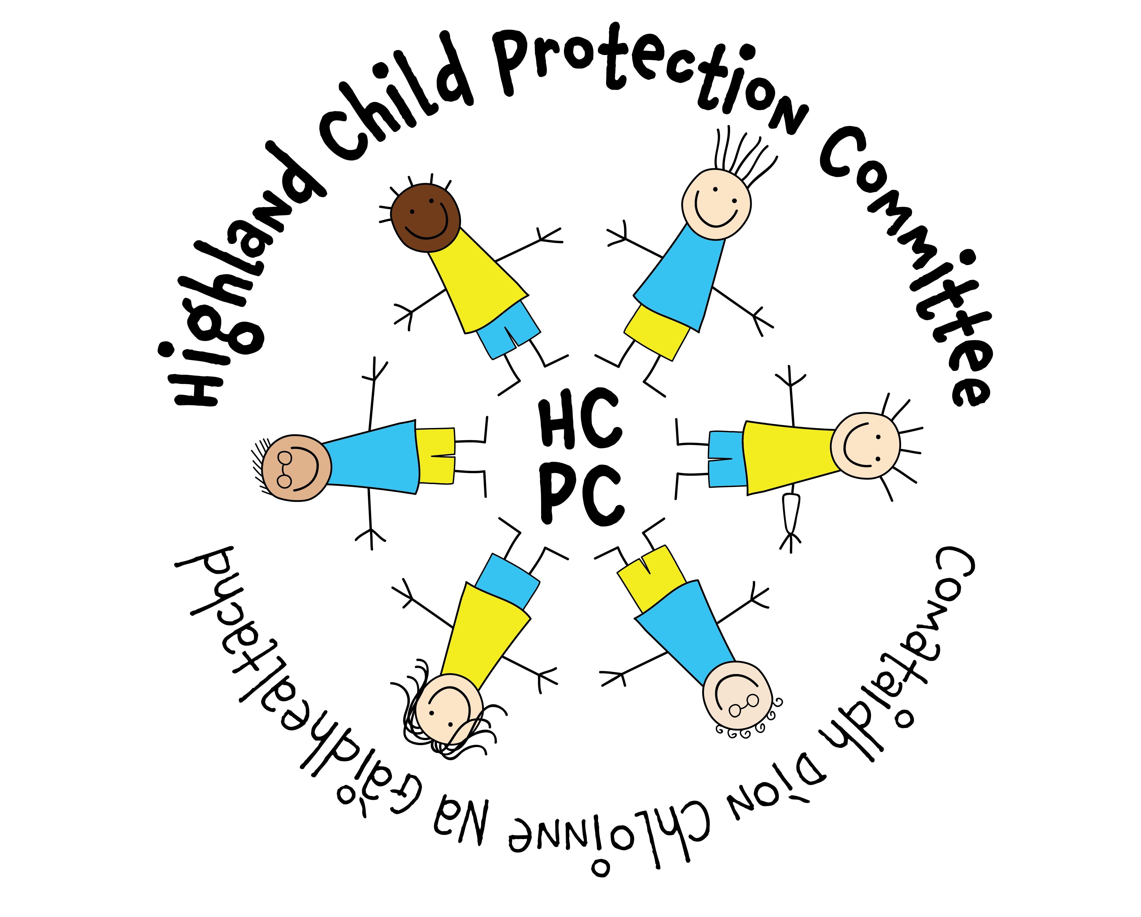
The proposed measurement of these outcomes has been carefully considered and demonstrates the application of SMART criteria:
- Specific – target a specific area for improvement
- Measurable – quantify or at least suggest an indicator of progress.
- Achievable – be able to specify who will do it.
- Realistic – state what results can realistically be achieved, with available resources
- Time-limited — specify when the result(s) can be achieved.

The Highland Child Protection Committee’s Improvement Plan 2016 to 2018 has been positively evaluated and the results show that we have delivered to expectation. A period of review and reflection has enabled the CPC to move forward to a position where we can now be more proactive and ambitious, developing and providing a range of tools and training to assist services in delivering effective support and interventions for children and families. With a robust Quality Assurance plan in place we can also identify and measure improvement across Highland.

Reporting Structure – Highland Child Protection Committee

Child Protection Committee Membership 2019

Strategic Planning – Child Protection Committee

Summary of Key Priorities for 2019-2022
Priorities 2019-2022

PRINCIPLES OF PROTECTION – CPC THEMES FOR GOOD PRACTICE IN CHILD PROTECTION

STRONG LEADERSHIP
TIMELY INTERVENTIONS
BUILDING EFFECTIVE RELATIONSHIPS 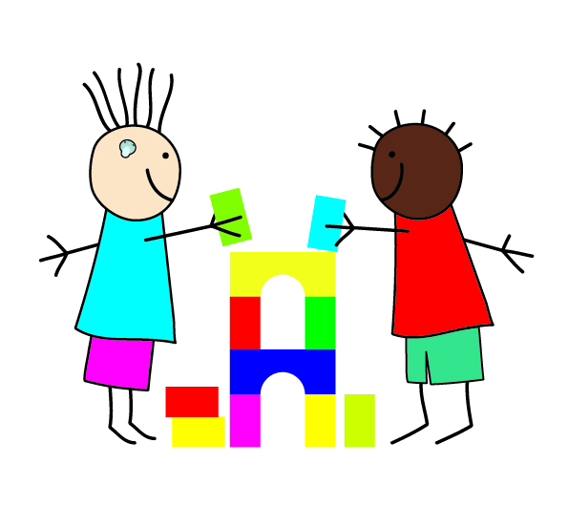
KEEPING CHILDREN & YOUNG PEOPLE AT THE CENTRE
INFORMATION SHARING
EFFECTIVE ASSESSMENT AND PLANNING
7

For Highlands Children
Key Outcomes
The achievement of better outcomes for Highlands’s children, their families and the communities in which they live is the overarching objective for children’s services. The outcomes are designed to consider the ways in which;
- Children and young people receive the help and support they need to optimise their well-being at every stage.
- Children and young people get the best start in life and enjoy positive, rewarding experiences growing up.
- Children and young people benefit from clear protocols, procedures and effective systems for recording observations and concerns which take account of best practice in information-sharing.
The outcomes relate to the impact of services on the well-being of children and young people using the SHANARRI indicators. It focuses on their experiences and the extent to which their lives and life opportunities will be enhanced to ensure they are;
- Safe
- Healthy
- Achieving
- Nurtured
- Active
- Respected and Responsible
- Included

The Highland Child Protection Committee is committed to supporting these outcomes in the following ways:
Safe
1. Children are protected from abuse, neglect or harm at home, at school and in the community.
2. Children are well-equipped with the knowledge and skills they need to keep themselves safe.
3. Young people and families live in increasingly safer communities where anti-social and harmful behaviour is reducing.

FHC Outcome: Children are protected from abuse, neglect or harm at home, at school and in the community
Highland CPC Improvement Plan 2019-2022
Improvement Priority: Children and young people are at the centre of child protection practice, policy development, prevention and intervention initiatives across Highland
CPC Theme(s): The needs of children are at the centre of all practice (QI 4.1)
Needs assessment
UNCRC Article 3 (best interests of the child) requires we work to ensure the best interests of the child must be a top priority in all decisions and actions that affect them. The 2018 Analysis of Case Reviews report identified a tendency for child’s plans to focus on parental issues rather than child’s needs particularly in cases where there are factors such as domestic abuse, parental substance misuse and/or mental ill-health. The views of children and young people should also be clearly evidenced within child’s plans and staff should be supported to establish these views regardless of age and stage of development. The Child Protection Committee (CPC) has invested in Viewpoint to help practitioners capture the views of children in planning and review processes.
UNCRC Article 12 (respect for the views of the child) determines that every child has the right to express their views, feelings and wishes in all matters affecting them, and to have their views considered and taken seriously. The Care Inspectorate’s ‘Review of Findings Joint Inspection services for children and young people 2012-17’ also discusses the need to include children and young people in the design and delivery of child protection initiatives. Highland CPC is committed to taking forward this work and is currently pursuing opportunities to engage with children and young people and their families effectively.
Actions | Lead | Timescale | Measures/Evaluation | BRAG
All children of school age (with capacity to do so) due for child protection plan review will be offered the opportunity to complete Viewpoint questionnaire (or other suitable method) to ensure their views are sought and recorded | Katrina Beaton, Principal Officer (Social Care) | April 2019 | % of viewpoint questionnaires completed  Feedback collated
Deliver master class in relation to child protection and children with disabilities for practitioners to highlight potential vulnerabilities and risks for children and families | Learning & Development Sub-Committee | June 2020 | Master class delivered  No. of participants  Participant feedback
Develop a Young People’s Sub-Committee to co-ordinate the participation of young people in the work of the CPC | James Martin  Gillian Pincock  Donna Munro | July 2020 | Young People’s Sub-Committee established and meeting regularly  Young People’s Sub-Committee Improvement Plan
Work with CALA and Safe, Strong and Free to create test resource for seeking the views of very young children/children with limited communication | Keeping Children Safe Sub-Committee | Oct 2019 | Resources developed and tested  Feedback from children and families
Work with UHI Visual Communication and Design Degree students to develop awareness/ educational resources relating to relationships/CSE | Lead Officer with SLWG | May 2020 | Resources developed and available through www.hcpc.scot  Feedback from young people and parents/carers

FHC Outcome: Children are protected from abuse, neglect or harm at home, at school and in the community
Improvement Priority: Practitioners are encouraged and supported to build effective relationships with parents/carers in child protection practice
CPC Theme(s): Relationships with parents/carers are effective, constructive and central to improving wellbeing and minimising risk of harm (QI 1.1, 2.1, 2.2, 5.4)
UNCRC Article 5 requires that Governments must respect the rights and responsibilities of parents and carers to provide guidance and direction to their child as they grow up, so that they fully enjoy their rights. This must be done in a way that recognises the child’s increasing capacity to make their own choices. In Child Protection practice it can be challenging to maintain effective relationships with parents/carers under stressful circumstances. However, UNCRC Article 18 (parental responsibilities and state assistance) also states that ‘Governments must support parents by creating support services for children and giving parents the help they need to raise their children’. Significant Case Reviews have also highlighted the importance of developing effective relationships with parents/carers with the ability to support and/or challenge parents/carers particularly in cases where parental behaviour contributes to the risk of harm.
Article 19 (protection from violence, abuse and neglect) states that Governments must do all they can to ensure that children are protected from all forms of violence, abuse, neglect and bad treatment by their parents or anyone else who looks after them. The Analysis of Case Reviews report 2018 found that practitioners need to be able to identify and respond to signs of non/disguised compliance and practice with respectful uncertainty. This can be achieved and acted upon effectively where constructive relationships with parents/carers are developed. Practitioners also need to take cognisance of the age, ethnicity and history of parents/carers in order to develop plans which are realistic, achievable and effective. The 7 minute briefing model has been successfully used in Fife to provide short inputs to staff groups. In 2018/19 Highland CPC tested the model using two Significant Case Reviews and this has been received positively by staff and managers within key statutory and third sector organisations.
Actions | Lead | Timescale | Measures/Evaluation | BRAG
Develop prompt cards for staff based on principles of protection themes – aide memoires | Lead Officer | Sept 2019 | No. of cards disseminated  Staff feedback re: effectiveness
Develop and disseminate 7 minute briefing paper on respectful uncertainty to help staff challenge presenting behaviour and identify over optimism in practice | Quality Assurance Sub-Committee | April 2019 | No. of briefing session delivered  Feedback forms received
Deliver training and refresher sessions on Graded Care Profile to highlight strengths based approach and help parents make sense of levels of risk and need | Learning & Development Sub-Committee | Aug 2019 | No. of participants attending training
Identify methods for consulting with parents and carers about their experiences of child protection processes | Quality Assurance Sub-Committee | Nov 2019 | Report for CPC
Include disguised/non-compliance in child protection training | Learning & Development Sub-Committee | June 2019 | Disguised/Non-Compliance included in training materials
Audit child’s plans and supervision records to evidence parent/carer views are sought and recorded effectively | Quality Assurance Sub-Committee | Nov 2020 | QA Improvement Plan/Audit Reports
Include parents/carers in Community engagement strategy to encourage early sharing of child protection concerns and awareness of child protection issues | James Martin, High Life Highland with SLWG | December 2019 | Strategy and Plan developed with SMART targets

FHC Outcome: Children are protected from abuse, neglect or harm at home, at school and in the community
Improvement Priority: Practitioners, managers and communities are supported to identify, share and respond to concerns about children promptly and effectively
CPC Theme(s): Effective and timely intervention minimises the risks to children and young people (QI 5.1, 5.2, 5.3)
Needs assessment
UNCRC Article 9 (separation from parents) states that Children must not be separated from their parents against their will unless it is in their best interests (for example, if a parent is hurting or neglecting a child). Children whose parents have separated have the right to stay in contact with both parents, unless this could cause them harm. UNCRC Article 20 (children unable to live with their family) also states that if a child cannot be looked after by their immediate family, the government must give them special protection and assistance. This includes making sure the child is provided with alternative care that is continuous and respects the child’s culture, language and religion. Child Protection work is often complex with practitioners and managers having to make decisions with limited time and information available.
The 2018 Analysis of Case Reviews report highlighted the necessity for effective and timely intervention to minimise risks to children. Significant Case Reviews have demonstrated that ‘drift’ particularly in cases of neglect and parental substance misuse can have severe consequences for children and young people. Likewise, in Reviews people within the local community have been aware of the risks posed to the child but were unwilling and/or unable to report these. Work undertaken with High Life Highland to increase staff knowledge and confidence in relation to child protection issues has resulted in better working relationships with Police Scotland and local Social Work teams with more appropriate sharing of concerns about children using High Life facilities and services. The CPC would want to use this model to engage with Community Partnerships and local communities to encourage and support people who may have concerns about children and young people.
Actions | Lead | Timescale | Measures/Evaluation | BRAG
Community Engagement Strategy and Plan to be developed to raise awareness of child protection in local communities and encourage communities to report concerns | James Martin, High Life Highland with SLWG | December 2019 | Strategy and Plan developed with SMART targets
Updated Initial Referral Discussion (IRD) process to be disseminated to Family Teams and reviewed after 1 year | Quality Assurance Sub-Committee | June 2020 | Audit of IRDs undertaken in 2019/20
Develop a suite of recommended resources for use with young people in relation to Child Sexual Exploitation | Child Sexual Exploitation Sub-Committee | Nov 2019 | List of resources produced and made available through www.hcpc.scot
Develop and deliver training on Child Sexual Exploitation for residential staff, front line practitioners and community groups (including night time economy) | Child Sexual Exploitation Sub-Committee | June 2020 | CSE Improvement Plan  No. of people receiving training  Feedback from participants
Launch updated Highland Underage Sex Protocol to include information regarding online behaviours | Jennifer Baughan/Dan Jenkins | July 2019 | Website data – no. of pages viewed  Practitioner feedback
CPC will develop a dataset based on the national minimum dataset to keep Chief Officers, Managers and Practitioners informed of patterns and trends relating to child protection in Highland | Quality Assurance Sub-Committee | Oct 2019 | Dataset established with system for collection and collation established  Quarterly reports considered at QA Sub-Committee  Formal reporting and consideration of dataset at CPC

FHC Outcome: Children are protected from abuse, neglect or harm at home, at school and in the community
Improvement Priority: CPC will promote effective information sharing with children, young people and families, within agencies and across the partnership
CPC Theme(s): Relevant information is shared appropriately, clear lines of responsibility for action are understood across partners and communication is effective in minimising potential risks (QI 1.1, 5.1, 5.2, 6.1)
Needs assessment
The majority of case reviews highlight flaws or gaps in information sharing within and between agencies. In Highland’s Analysis of Case Reviews 2018, Dr Vincent acknowledged strengths in relation to appropriate information sharing across Highland, particularly in relation to child protection concerns. However, the length of time taken to share information was highlighted, along with a reluctance to retain some ownership of the concerns once shared, and a lack of feedback and further discussion between agencies. The need for integrated chronologies which clearly identify significant life events is also highlighted within the ‘Analysis of Case Reviews’ report and the Care Inspectorate’s ‘Review of Findings Joint Inspection services for children and young people 2012-17’
Actions | Lead | Timescale | Measures/Evaluation | BRAG
Disseminate information about chronologies e-module and monitor feedback | Learning and Development Sub-Committee | March 2020 | No. of participants undertaking e-module  Quality of chronologies
CPC Website to be further developed to include a practitioner log-in area containing policy and guidance documents, research papers, training materials and resources | Lead Officer/Chairs of Sub-Committees | Sept 2019 | Website updated with practitioner area available  No. of subscribers  Website data – pages visited, number of views
Deliver training in relation to Trafficking and the National Referral Mechanism to ensure timely sharing of concerns | Learning & Development Sub-Committee | Dec 2019 | Learning and development Improvement Plan/No. of staff attending training
Update local trafficking protocol to ensure practitioners and managers are clear how to share information in relation to trafficking concerns | CSE Sub-Committee | Sept 2019 | Protocol updated and available on www.hcpc.scot
Develop local guidance in relation to missing children | Multi Agency Missing Children review group | Oct 2019 | Guidance document provides detail of governance, reporting and quality assurance of missing incidents – available on www.hcpc.scot  Children Missing from Education guidance developed and disseminated
Provide support to CAPSM Co-ordinator to shape work plan and consider recommendations | CAPSM Sub-Committee | March 2020 | CAPSM Co-ordinator appointed and reporting to CAPSM Sub-Committee  CAPSM Improvement Plan

FHC Outcome: Children are protected from abuse, neglect or harm at home, at school and in the community
Improvement Priority: Practitioners are supported to develop effective child protection plans
CPC Theme(s): Child protection plans are effective in achieving outcomes to meet needs and minimise risk of harm, and all available resources, techniques and tools are used to best effect (QI 1.1, 2.1, 5.1)
Needs assessment
UNCRC Article 6 (life, survival and development) states that every child has the right to life and Governments must do all they can to ensure that children survive and develop to their full potential. UNCRC Article 27 (adequate standard of living) also states that every child has the right to a standard of living that is good enough to meet their physical and social needs and support their development. In keeping with the ethos of the Highland Practice Model agencies and practitioners must work together with families to ensure that children receive the right help at the right time in order to promote the best possible outcomes.
Care Inspectorate’s ‘Review of Findings Joint Inspection services for children and young people 2012-17’ discusses the need for improvements in early intervention and in particular, recognising early signs of neglect. The review also discusses the complexity of issues involving the behaviours of adults such as parental substance misuse and domestic abuse, along with cases of neglect where risks are cumulative. The CPC Dataset evidences that Neglect, Domestic Abuse and Substance Misuse remain the three highest risk indicators in child protection registrations across Highland. Child protection plans are required to have clear goals, outcomes and actions in order to reduce or minimise risk of harm and practitioners require support to develop effective plans which can lead to improved outcomes for children. In order to assist with assessment and planning processes, Highland CPC have developed a number of tools and invested in the Graded Care Profile to help practitioners measure care given to children and young people. These now need to be embedded in practice across Highland, underpinned by a trauma informed approach and with clear mechanisms for reviewing the effectiveness of practice.
Actions | Lead | Timescale | Measures/Evaluation | BRAG
Quality Assurance Sub-Committee will review a proportion of Child’s Plans to determine if they are evidenced based and provide a clear analysis of areas of strengths, risk, need and concern, including cumulative concerns and the potential impact they may have on the child. | Quality Assurance Sub-Committee | March 2020 | Multi‐agency file audit and single agency file audits evidence good or improving practice
Advanced training on Assessment and Analysis/Direct Work with Families to be developed | Learning & Development Sub-Committee | March 2020 | Training materials developed  No. of staff attending training
Set up quarterly monitoring system to measure use of Graded Care Profile across Highland for reporting to CPC | Katrina Beaton, Principal Officer (Social Care) | Aug 2019 | No. of staff receiving training  No. of GCP2 assessments completed
Substance Misuse Practitioner Toolkit to be rolled out to teams across Highland | CAPSM Sub-Committee | Dec 2020 | Feedback from practitioners
Develop advanced e-module on Child’s Plans | Highland Practice Model Improvement Group | Dec 2019 | No. of completed modules  Participant feedback  QA Audits of child’s plans – is quality improving?
Develop resources and training for practitioners in relation to domestic abuse based on the Safe and Together model | Quality Assurance Sub-Committee with Violence Against Women Partnership | Dec 2019 | No. of staff trained  Resources available  Feedback from practitioners
Undertake literature review of Recovery services (sexual abuse and exploitation) and develop report with recommendations for effective Recovery services in Highland | CSE Sub-Committee | Nov 2019 | CSE Improvement Plan/Report presented to CPC
FHC Outcome: Children are protected from abuse, neglect or harm at home, at school and in the community
Improvement Priority: CPC should evidence clear leadership, delivery of high quality learning and development opportunities and scrutiny of child protection practice across Highland
CPC Theme(s): A culture of effective leadership, management, support and supervision is embedded in child protection work across Highland and in the principles of Highland Child Protection Committee (QI 3.1, 7.2, 9.1)
Needs assessment
UNCRC Article 17 states that every child has the right to reliable information from a variety of sources, and governments should encourage the media to provide information that children can understand. Governments must help protect children from materials that could harm them. CPC have a role to play in ensuring information available for children and families in statutory, third sector and community settings is appropriately monitored and challenged where concerns arise.
The Care Inspectorate Review of Inspections 2012-2017 identified leadership as a key measure of child protection practice within local areas. The Public Protection Chief Officer Group was established in 2018 to consider child protection alongside public protection themes within Violence Against Women, Criminal Justice, MAPPA and Adult Support and Protection. The CPC is responsible for the scrutiny of child protection practice in Highland and required to consider child protection data, quality of practice across the partnership and the provision of effective learning and development opportunities for practitioners and managers working with children, young people and families. CPC is required to report to Chief Officers on a quarterly basis as well as keeping them informed of findings from Significant or Initial Case Reviews in regards to individual children.
Actions | Lead | Timescale | Measures/Evaluation | BRAG
Staff and managers will receive updated information regarding core and additional child protection training available and recommended for staff groups across Highland | Donna Munro | Sept 2019 | Training Leaflet for Staff and Managers updated and re-issued through all member agencies  Training statistics – attendance
Chief Officers will receive regular written feedback about key child protection issues affecting children & young people, staff, agencies and communities in Highland | Chair | June 2019 | Reports to Public Protection Chief Officer Group
CPC will review ICR/SCR action plan quarterly to ensure agencies are accountable for actions arising from local case reviews | Chair/Lead Officer | March 2020 | ICR/SCR Action Plan updates and reporting
In 2019/20, 3 newsletters will be produced to keep practitioners and communities informed about child protection practice in Highland and nationally | Lead Officer | March 2020 | CPC Newsletter
Staff will have access to core child protection training across Highland appropriate to their roles and responsibilities | Learning and Development Sub-Committee | June 2019 | Training Calendar available on www.hcpc.scot  No. of Training Places offered  Training Figures reported to CPC/Annual Report  4 x Master Class sessions delivered  Places taken up  Evaluation reports
A minimum of 4 x 7 minute briefings will be developed to support team meetings and reflective discussions on a range of child protection issues | Quality Assurance Sub-Committee | March 2020 | 7 minute briefings developed  Feedback from staff groups  Summary reports
CPC Training Team will deliver a minimum of 4 master class sessions in 2019/20 | Learning and Development Sub-Committee | May 2020 | Master class sessions delivered  Feedback from attendees
Updated Child Protection Guidance to be disseminated to staff and made available on CPC website | Lead Officer/Nominated CPC Leads | July 2019 | No. of staff receiving link to Guidance  No. of views on www.hcpc.scot  Feedback from practitioners

Abbreviations
CALA Care and Learning Alliance
CAPSM Children affected by Parental Substance Misuse
CPC Child Protection Committee
CSE Child Sexual Exploitation
FHC For Highland’s Children
GCP2 Graded Care Profile 2
ICR Initial Case Review
MAPPA Multi Agency Public Protection Arrangements
QA Quality Assurance
SCR Significant Case Review
SMART Specific Measurable Achievable Realistic Timescales
SLWG Short Life Working Group to take forward a specific piece of work
UHI University of Highlands and Islands
UNCRC United Nations Convention on the Rights of the Child

Glossary of Terms
Sub-Committee Group directed by the Committee to implement actions on behalf of the Child Protection Committee. Sub-Committees are required to report progress to Child Protection Committee on a quarterly basis
Graded Care Profile 2 Graded Care Profile 2 (GCP2) helps professionals measure the quality of care being given to a child. It's an assessment tool that helps them to spot anything that's putting that child at risk of harm from neglect
7 Minute Briefing A method of delivering messages in a short period of time
Chronology A list of significant events in a child’s life in order of their occurrence
Chief Officers Group The Public Protection Chief Officer Group comprises of the chief officers and senior managers for each of the key partner agencies in Child Protection and Public Protection. This includes representatives from Highland Council, NHS Highland and Police Scotland
Child Protection Committee Every Local Authority must have a Child Protection Committee. Child Protection Committees are locally based, inter-agency strategic partnerships responsible for the design, development, publication, distribution, dissemination, implementation and evaluation of child protection policy and practice across the public, private and wider third sectors in their local area
Keeping Children Safe Keeping Children Safe is a collective group of Third Sector providers with an interest in Child Protection. Chaired by the Care and Learning Alliance the group supports practitioners and managers working in the third sector and community groups
Safe and Together A programme for working with families where there are concerns about domestic abuse. It is a strengths bases approach working in partnership with the victim of abuse to reduce risk to themselves and any children. It also promotes work with perpetrators of domestic abuse.
Safe, Strong & Free The Safe Strong and Free Project (Ssf) is a Primary Abuse Prevention Programme. It is a Highland charity which aims to reduce the vulnerability of young children to abuse and assault
Viewpoint An interactive tool for gathering and collating the views of children and young people

Highland Child Protection Committee Membership -2019/2020
 | Name | Organisation
Current Chair: | DCI Vince McLaughlin | Police Scotland
Current Vice Chair: | Karen Ralston | Interim Head of Children’s Services, Highland Council
Elected Member Rep: | Linda Munro | Councillor
Lead Officer: | Donna Munro | Highland Child Protection Committee

Members
Hugo van Woerden | Lead Director Children’s Services | NHS Highland
Dr Stephanie Govenden | Lead Doctor Child Protection | NHS Highland
Sally Amor | Children’s Service Commissioner | NHS Highland
DI Diane Smith | Chair of CSE Sub-Committee | Police Scotland
Karen Erskine | Authority Reporter | SCRA
Suzann Barr | Chair of Children’s Panel | Children’s Panel
Fiona Shearer | Care and Learning Manager | Highland Council
Debbie Milton | Chair of CAPSM Sub-Committee | Highland Council
David Goldie | Head of Housing | Highland Council
James Martin | Head of Development | High Life Highland
Norma Reuttimann | Training and Development Co-ordinator | Keeping Children Safe/Care and Learning Alliance
Tracie McDermott | Welfare Officer | Army Welfare Service
Fiona Malcolm | Legal Manager – Litigation and Advice | Highland Council
Gillian Pincock | Lead Child Protection Advisor (Health) | Highland Council
Mark Holloway | Head of Operations | Scottish Prison Service

