Protocol for Children and Families Missing
Including Unborns for whom there are Concerns

Warning – Document uncontrolled when printed

Policy Reference: SH/CP/MFA.ROA/31/10/12 | Date of Issue: 31/10/12  Date of First Review 30/6/14
Prepared by: Principal Child Protection Advisor | Date of Review: 10.09.15
Lead Reviewer: Principal Child Protection Advisor | Version: 3.0
Authorised by: Child Protection Committee | Date: 31/10/12

Distribution:  Director of Care and Learning  Head of Childrens Services  Director of Public Health  Board Director of Nursing  Head of Health  Head of Education  CI Police Scotland - Highland |  |  | Head of Midwifery  Area and Childrens Services Managers  Principal Officers - Care and Learning  Child Protection Advisors  Children’s Services Managers  Army Welfare Services Inverness
Method
CD Rom | E-mail X | Paper X |  | Intranet X

CHILDREN/FAMILIES MISSING FROM KNOWN ADDRESS/
or EDUCATION IN HIGHLAND AUTHORITY AREA

(This form contains sensitive personal data. See Highland Data Sharing Partnership Procedures)

This guide should be followed and this form should be completed when anyone working with children and families, such as a health practitioner, teacher, or play, Early Learning and Childcare Setting worker, becomes aware that a child or pregnant woman & unborn child is missing from a known address, school or an Early Learning and Childcare provider and they have no forwarding information.
This guide is applicable to all agencies in contact with children and young people. Specific appendices are included: form for raising a national MFA page 12, education procedures page 13, school absence policy page 16.
Appendix 1 page 12 should be completed when taking a missing alert forward to stage 3.

This is a 3 Stage Guide

*Stage 1 must be completed by all raising a concern - pages 3 and 4
Stage 2 by Named Person/Lead Professional at time concerns are raised to next level - page 5; Stage 3 by Agency Lead when MFA or CME is to be raised - page 6.

All reasonable and practical effort should be undertaken to locate the family. If at the end of local checks you still have no forwarding information, please discuss the situation with the Child Protection Advisor for health staff, senior teacher or supervisor for your agency or social work team manager, as appropriate.

Concerns regarding vulnerability or child in need/child in need of protection (including unborn babies) may necessitate the raising of a Missing Family Alert (MFA) or Children Missing from Education (CME).

An MFA or CME is only completed at Stage 3 and by The Keeper of the Register, or The Principal Child Protection Advisor - Health, or the Head Teacher, as appropriate.

An MFA for unborn babies is completed by the Principal Child Protection Advisor – Health in collaboration with the senior midwife.

Acronyms glossary:
MFA Missing Family Alert (Health)
CME Child Missing from Education
MKA Missing from Known Address
CHI Community Health Index Number
SCN Scottish Candidate Number
CPA Child Protection Advisor (Health)
LAC Looked After Child

*Details: Complete as far as possible and as appropriate with information you have:

COMPLETE THIS FORM WITH AS MUCH DETAIL AS YOU CAN

Child’s Name: Child’s DOB:

CHI: Sex:

Also Known As:

Parent’s/Guardian’s Name:

Address:

Contact Tel.Nos:

Child’s Previous Known Address:

Present School/: Early Learning and Childcare settings School Stage:

SCN:

Last date of Attendance:

Previous Schools:

Any additional support needs

Details:

Emergency Contacts / Relations Contact
Details:

Previous Social Work Involvement
Details:

CareFirst ID:

Other Relevant Information:

Is this child on The Child Protection Register?

Is this a Looked After child?
STAGE 1 LOCAL CHECKS *Note: this is the critical stage for gathering information and locating family early. This should be completed by any agency identifying concerns for a missing child/family/pregnant woman and forwarded to Named Person and Lead Professional (where there is one) within 24 hours. A telephone call with explanation of circumstances to agency advisor/supervisor may assist/ advise on completion.

YES NO DON’T
COMPLETE THIS FORM WITH AS MUCH DETAIL AS YOU CAN KNOW/
THIS IS NOT IN ORDER ALL POINTS HAVE EQUAL STATUS NA

Is the child on the Child Protection Register or a Looked
After Child? If yes contact Lead Professional immediately

- Speak to/inform Named Person and Lead Professional,
(where there is one)

- Speak to any known extended family

- Speak to neighbours/significant members of the community

- Speak to friends/acquaintances

- Speak to Interrupted Learning and Development worker
as appropriate particularly in relation to travelling families
(usually following contact with housing)
Contact details: 01349 868208

- Speak to other agencies as appropriate e.g. Homestart & give details.
For Army Welfare Service (as appropriate)
Contact details:
01463 233132

Additional comments/details:
Please give as much detail as known

This stage 1 completed form must now be passed to Named Person and Lead Professional
STAGE 2
DATABASE SEARCHES & PARTNER AGENCY CHECKS
This section to be completed by Named Person: HEALTH VISITOR or Midwife or Head Teacher, and/ or Lead Professional
*Note: All reasonable and practical checks should continue to be made to locate the family

YES NO N/A

- Discuss with Child Protection Advisor-Health/senior teacher/
supervisor for your locality/school/centre

- Request checks from own agency databases i.e. Community
Child Health Department / Education checks in SEEMIS
Contact details: (01463 702077) childmis@highland.gsx.gov.uk

- Contact partner services as appropriate and request relevant
Information i.e. Early Learning and Childcare provider/School
attended

- Check Health Visitor/School Nurse/GP Practice with
whom registered

- Check with Housing as appropriate

- Check with Social Work as appropriate

- Check with Check with Family Protection Unit at Police HQ,
Inverness (who can check the vulnerable persons database)
ask for information as appropriate following discussion with CPA –
Health/senior teacher/supervisor. Consider the possibility of safe
housing under the witness protection scheme.

Additional Comments/details:
Please give as much detail as known

Name of CPA-Health/ senior teacher /supervisor discussion took place with
Name: Date:

For Health professionals: If after discussion it is agreed that no MFA is to be raised, please send this completed form to the Named Person and Lead Professional (where there is one) and copy this form with the casenotes to the Child Health Department, Room 8, Morven House, Raigmore Hospital for further action. Reassess circumstances and continue to be alert to further information regarding whereabouts.

For Education: If after discussion it is agreed no CME is to be raised please send this completed form to the Named Person and Lead Professional/senior teacher/head teacher as appropriate for filing in child’s records. Reassess circumstances and continue to be alert to further information regarding whereabouts.
Signed: ………………………………………….. Date: ……….............................
For progress to Stage 3 forward Stage 1 and 2 forms to your Agency Lead
STAGE 3
RAISING A MISSING FAMILY ALERT (MFA) or CHILDREN MISSING FROM EDUCATION (CME)

Note this stage can only be completed by Agency Lead and or Keeper of the Child Protection Register (or depute). They will assess and progress any MFAs and CMEs on receipt of Stage 1 and Stage 2 forms.

When child/family are not located and there are concerns of child wellbeing/vulnerability for a child in need or in need of protection (including unborn babies) this must be progressed to stage 3 without delay

Agency Leads Care and Learning

Social Work & Keeper of the Child Protection Register (or depute)
Details: 01463 703408
07919206868
cpadmin@highland.gcsx.gov.uk

Health: Principal Child Protection Advisor-Health
Details: 01463 703427
07990776805
cpadmin@highland.gcsx.gov.uk

Education: Head Teacher
AND Keeper of The Child Protection Register

When Police have been notified give details
Details:
Name of contact………………………Rank……..……….time…………date……………………....

When Keeper of the Register has been notified give details:

Details:
Name of contact………………………….time………………………date…………………….............

When a Missing Family Alert has been raised give details:

Details
Name of person raising alert: Date:
CHILDREN MISSING FROM A KNOWN ADDRESS/or EDUCATION INFORMATION SHEET

Background
The death of Danielle Reid in Inverness in 2002, prompted Highland Education Department to develop a protocol to pro-actively locate children missing from education. National Guidance for Child Protection includes Children Missing guidance.

This information sheet will also form the basis for audit.

Definition of Missing Family
This is a family or pregnant woman who has disappeared from a known location. This includes unborn children.

Urgent concerns may need to be referred immediately to social work and police colleagues.

It is the responsibility of the Keeper of the Register to trace “missing” children whose names are on the Child Protection Register or Looked After. However if information about such children comes to the attention of professionals in the first instance, contact with other agencies, such as social work or police should be made promptly.
Definition of a child ‘missing from education’
Children ‘missing from education’ are children and young people of compulsory school age who are registered on a school roll and not in attendance and have not given a valid reason. They are expected to appear at a school or an early learning and childcare setting but do not arrive, and there has been no immediate explanation or advance warning provided by parents or carers. They are not knowingly being educated otherwise at home, privately or in an alternative provision. They have usually not attended school for a substantial period of time (usually agreed as at 4 weeks, or considerably less for vulnerable children).

Concerns that a Family May Be Missing
All reasonable and practical efforts should be undertaken to locate the family and this should include discussion with other professionals; interrogation of IT systems such as Community Health Index (CHI), Child Health Surveillance, Standard Immunisation Recall Systems (SIRS) and Patient Administrative System (PAS); SEEMiS, and CareFirst.

Contacts in partner statutory agencies may also be able to assist, e.g. housing, social work, police, health and education.

Concerns that a Family is Missing
If a family remain missing a) the Child Protection Advisor-Health should advise the Principal Child Protection Advisor - Health; b) Education personnel should notify The Head Teacher. Where there are concerns regarding vulnerability or child in need/child in need of protection a) an NHS Scotland Missing Family Alert Template (MFA) and/or b) Education (CME) will be completed and circulated within Scotland and other countries as appropriate

Pregnant Woman at Risk of Absconding
There may be occasions when serious concerns arise regarding the safety and welfare for a pregnant woman and her unborn child who are not located at their home address, for example cases of serious domestic violence. An MKA followed by an MFA form should be completed, as required, and procedures followed for these.

Where the welfare of the mother or unborn is at risk of serious harm, for example unstable substance misuse accompanied by other high risk factors such as homelessness, serious mental health issues, or sexual offence concerns of a parent, and where the mother has been evading maternity and health services, and there is a fear the woman may abscond prior to delivery, this MFA process should be followed.

On these rare occasions there may be a need to alert other health services should the woman require medical attention and attend where she may not be known.

Missing Family Alerts received into Highland
Alerts are regularly received into Highland from other areas in Scotland and the UK. These are posted on a database and may be accessed by practitioners needing to inquire about a family moved into their area where concerns are evident.
To inquire if a family who have arrived in your area may be missing from another area contact
CP admin 01463 703477

Reference
“If there is concern that a child may be at risk of significant harm this will always override a professional or agency requirement to keep information confidential….This includes sharing information prior to the birth of a child to ensure protective plans are in place from the moment of birth.”
Sharing Information about Children at Risk: A Brief Guide to Good Practice. Scottish Executive (2004) http://www.scotland.gov.uk/Publications/2004/04/18512/28931

‘Where a practitioner believes, in their professional opinion, that there is risk to a child or young person that may lead to harm, proportionate sharing of information is unlikely to constitute a breach of the Act in such circumstance’ Information Commissioner March 2013

References
Information Sharing Procedures Highland
http://forhighlandschildren.org/4-icspublication/
Highland Child Protection Guidance
http://forhighlandschildren.org/2-childprotection/publications.htm
NHS Scotland Guidance for Health Professionals Responding to Missing Families & Unborn Babies For Whom There Are Concerns October 2014

Appendices

- Education

Information to consider when a child/family may be missing

- Flowchart re Children Missing from Known Address and Missing Family Alerts

- Missing Family Alert form

- Children Missing from Education Guidelines for Schools

Appendix 1

INFORMATION TO CONSIDER WHEN A CHILD/FAMILY MAY BE MISSING

1 in 4 children who run away are put at risk of serious harm*¹. From what you know of the child’s background and circumstances, is there any reason to be concerned about the possibility of any of the following:

- The child is vulnerable because of learning disability, mental ill-health, physical/sensory impairment or a past history of having been abused.
- The child is a young carer in a situation where one or more parents have mental health and/or drug/alcohol misuse problems.
- The child has significant drug/alcohol misuse and/or behavioural problems and/or is associating with known/suspected criminals or other people who may pose a threat (consider child sexual exploitation).
- Loss of family home due to eviction or avoidance of payment of rent arrears (Poverty or Substance Misuse often contributes)
- Fleeing from home to escape violence (This can include domestic violence or harassment from others, e.g. drug dealers/loan sharks.)
- Running away from bullying or abuse.
- Running towards a preferred/idealised situation. (Are parents separated? Is there an older boyfriend or girlfriend? Has the child established a relationship with a stranger over the internet, etc.)
- Abduction by an estranged parent (Tug of Love situation)
- Removal to family’s country of origin for the purpose of engaging in harmful cultural practices, e.g. Forced Marriage or Female Genital Mutilation (The former applies to boys as well as girls)
- The family’s cultural background promotes the concept of family or community honour and is likely to punish behaviour that is perceived to bring dishonour.
- Trafficking between countries or UK locations for the purposes of sexual exploitation, domestic slavery or involvement in cultivation of drugs, etc.
- Radicalisation.
- The child has not been seen by anyone for a period in excess of 10 days and the family is not one that is normally mobile, i.e. migrant, gypsy/traveller or Forces.

*1 Still Running 3 – Early findings from our third national survey of young runaways, 2011 – The Children’s Society.

Appendix 2
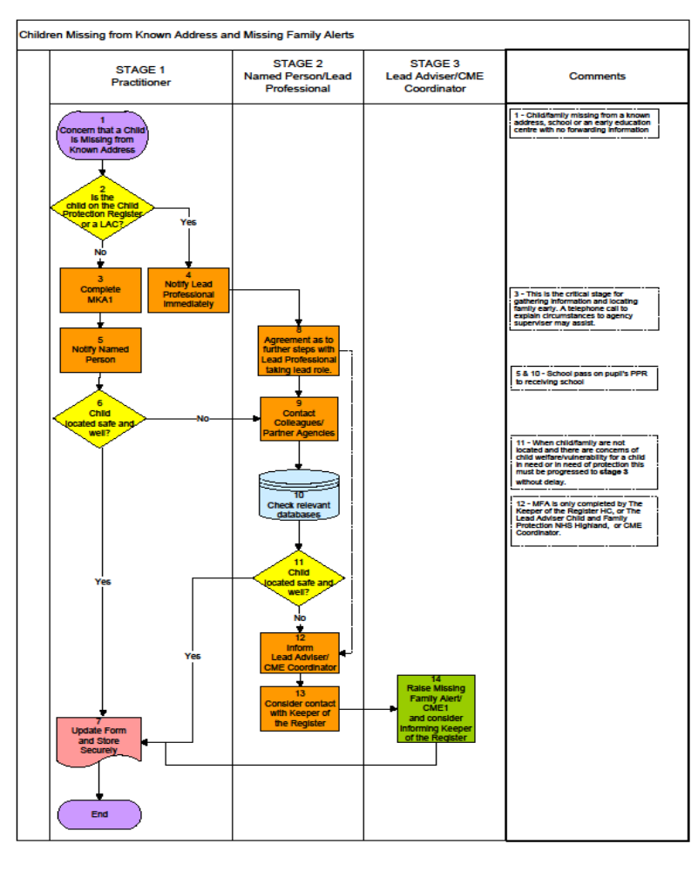

DATE OF ISSUE: DATE OF RE-ISSUE (If applicable):

Appendix 3 CONFIDENTIAL – MISSING FAMILY ALERT FORM (MFA)
FAMILY NAME: |  | FAMILY AKA:
MOTHER |  | D.O.B. |  | CHI:
FATHER |  | D.O.B. |  | CHI:
PARTNER |  | D.O.B. |  | CHI:

CHILDREN’S NAMES
1ST CHILD |  | D.O.B. |  | CHI:
2ND CHILD |  | D.O.B. |  | CHI:
3RD CHILD |  | D.O.B. |  | CHI:
4TH CHILD |  | D.O.B. |  | CHI:

ADDRESS (LAST KNOWN):

Risk Factors (Identify all known risks)
On Child Protection Register |  | Parenting Concerns |  | Vulnerability
Child Protection Order Pending |  | Unborn |  | Prostitution
Adult Substance Misuse |  | Previous LAC |  | Travelling family
Domestic Abuse |  | Refugee |  | Paediatric Health
Adult Learning Disability |  | Homeless |  | Child Psychiatry
Adult Mental Health Issues |  | Learning Disability |  | Physical Disability

Further details AND clinical infoRMATION HELD ON FILE FROM: | NAME:  ADDRESS:  TEL:  HEALTH BOARD:
Should you locate this family, please contact the Senior nurse for Child Protection IN YOUR AREA WHO WILL INFORM THE NURSE equivalent In the health board area raising the alert

Staff Risks:
(detail any relevant factual information)

REFERRED TO POLICE AS MISSINg PERSON YES NO | DATE REFERRED:
- NHS staff in areas of identified risk will receive this MFA1
- Staff in receipt of this MFA 1 should make it available in a confidential area for colleagues to read.
- NHS staff, on receipt of the MFA1, should check the family details against case files held.
- If the family are located contact the Senior Nurse for Child Protection or equivalent in your Health Board
Area and the named person on the MFA1 for further details and health records.
- Destroy the MFA1 after 3 months or EDD plus 3 months for unborns or on receipt of ‘Family
Found’ information.
family FOUND: yes no  DATE FOUND: | FOUND BY (Please indicate)  Police Social Work Health Education SAS NHS 24  Practitioner Services Other
NATIONAL AUDIT/ADMINISTRATION

Appendix 4 CHILDREN MISSING FROM EDUCATION –
GUIDELINES FOR SCHOOLS
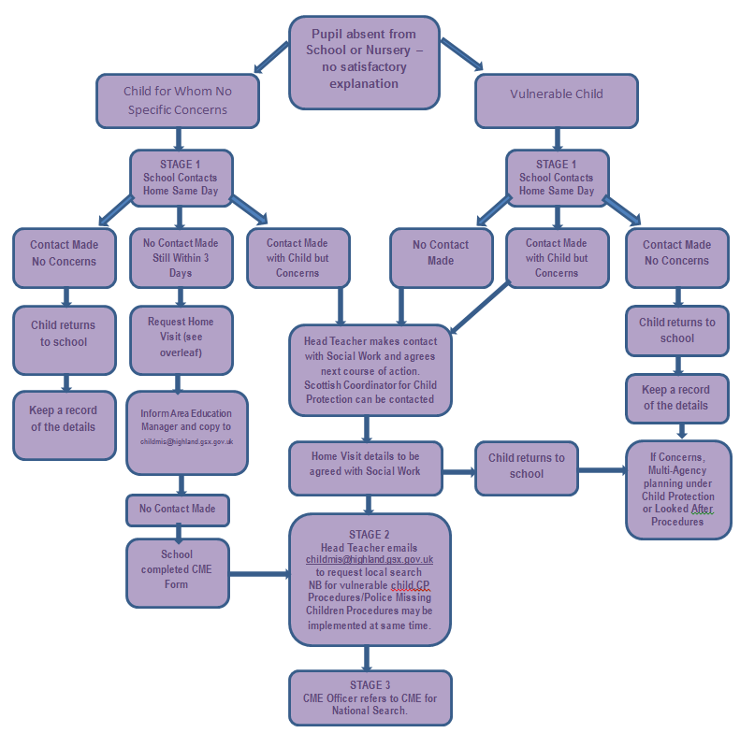
Vulnerable Child:
is on the child protection register (Notify Keeper of the Register immediately)
is the subject of a child protection investigation
is a Looked After Child or Accommodated Child (Notify Keeper of the Register immediately)
has or is in the process of being referred to the Children’s Panel
has significant additional and or learning support needs
has medical issues including mental health issues /or within family
has a history of substance misuse personally and/or within the family
has cultural/identity issues
is at the centre of a custody dispute.

Footnotes:
If at any time during the process the school or any agency believes the child may be at risk, follow Highland Child Protection Guidance
If the child is on the CP Register the Lead Professionalk or Team Manager should be notified immediately.
Records should be kept of all actions taken, who spoken to, decisions reached and outcomes.

Assess the risks and vulnerability of the child involved. Use this as a guide to judge the appropriateness of steps suggested below.
Stage 1 – Steps the school should take after third day of no contact

☐ | Ask other children in the class/school (consider also confidentiality and sensitivity).
☐ | Check what other staff know.
☐ | Contact all emergency contact numbers as listed on e¹ (including parent mobiles, other family members)
☐ | Check with siblings in other schools.
☐ | Home visit to conclude if child/family is there. For small schools, police may be contacted to carry this out.
☐ | If police are contacted, the relevant Area Care & Learning Manager should be notified.

Stage 1 – Steps the school should take where there is an unexplained absence and a risk to the wellbeing of the child has been assessed.

☐ | All reasonable and practical effort should be undertaken to locate the child/family, including speaking to: any known extended family, neighbours or community members, friends/acquaintances, Named Person/Lead Professional , other agencies as appropriate
☐ | Relevant agencies involved with the child should be contacted.
☐ | The CME form should be completed and forwarded to Named Person and Lead Professional within 24 hours. This form can be located at  http://www.forhighlandschildren.org/2-childprotection/publications_61_2242241664.doc

Stage 2 – DATABASE SEARCHES & PARTNER AGENCY CHECKS – Named Person (Head Teacher) should coordinate further searches and checks at Highland level.

☐ | All reasonable and practical checks should continue to be made to locate the child/family. The Head Teacher must complete Stage 2 of the CME form
☐ | Request checks from Phoenix e1 using childmis@highland.gsx.gov.uk
☐ | Contact partner services as appropriate and request relevant Information
☐ | Check Health Visitor/School Nurse/GP Practice with whom registered
☐ | Check with Housing as appropriate
☐ | Check with Social Work as appropriate
☐ | Check with Police ask for information as appropriate

Stage 3 – (Children Missing Education national referral) - This stage can only be completed by Agency Lead and or Keeper of the Child Protection Register.

☐ | When Stage 1 and Stage 2 parts of the Missing from Known Address CME form have been sent to childmis@highland.gsx.gov.uk a national CME referral can be made.

Appendix 5

Care and Learning

Children Missing From Education – School Absence Policy

This guidance provides absence management procedures which are mandatory for all schools to have in place.

All schools are required to;
- Issue the standard letter to all parents/carers annually
- Ensure parents/carers of newly enrolled pupils receive copies of the procedures/letter.
- Include a clear statement of procedure in the school handbook
- Ensure the necessary procedures are in place within your establishment.
- Advise staff of these procedures.
- Advise Parent Councils of these procedures.

1.0 Highland Practice Model

- All professionals, including those in education authorities and schools, take timely and effective action to protect children.
- All agencies and professionals, including education authorities and schools and their staff, share information about children when it is necessary to protect them.
- All agencies and professionals, including education authorities and schools and their staff, work together to assess needs and risks and develop effective Child’s Plans.
- All staff in school education should take action when a child does not arrive at school as expected.

Whilst education early learning in a early learning and childcare settings is non-statutory and parents may elect to choose part-time attendance, staff should take action when a child does not arrive at early learning and childcare settings as expected.

If at any time during the process the school or any agency believes the child may be at risk they must follow Highland Child Protection Inter-agency Guidelines.
http://forhighlandschildren.org/2-childprotection/publications.htm

All parents/carers have a duty to provide appropriate education for their child. Where parents/carers choose to provide education for their child by ensuring the attendance of their child at a school run by the Council, they have a duty to ensure regular attendance, unless there is a good reason for non-attendance.

The Council will monitor attendance for the purposes of ensuring the provision of an appropriate education and maximise child safety. The steps to be taken by the Council in the event of any failure to attend school without good reason are set out below.

2.0 Attendance and Absence Management
Attendance at school by children and young people is essential in order that they receive the education to which they are entitled. The health, safety and well-being of children and young people at school, and before and after school must be protected and promoted to enable them to benefit from the educational opportunities available.

Parents/carers, schools and the Council all have a part to play in maximising attendance and health, safety and well-being.

Highland Council’s School Absence Policy is based on the following principles which schools and the authority must follow.

3.0 Parent/Carer responsibilities and actions
Parents will be expected to sign an agreement with the school (Appendix 1). This agreement will include the following:

- Parents will be responsible for the safety and well-being of their children whilst they are not in school.
- Parents will be responsible for providing the school with suitable emergency contact numbers and ensure that these numbers are kept up to date (at least termly).

In discharging these responsibilities, parents and carers need to commit to the following actions:

- To inform the establishment of any prearranged absence, e.g. attendance at a hospital appointment or other unavoidable event, prior to the absence taking place.
- To inform the establishment of their child’s absence by 9.15am on the morning of the first day of absence. For afternoon sessions, parents/carers must inform the establishment no later than half an hour into the session.
- To respond promptly to contacts from the school.
- To provide written confirmation/email of absence as soon as possible.

Parents/carers will note that where contact cannot be established in relation to an unexplained absence, schools may inform other relevant service, e.g. social work and /or police.

4.0 School/ Early Learning and Childcare establishments responsibilities
Every establishment is required to have procedures in place which are clear and communicated to all staff, parents and pupils. Establishments require to have a clear statement in their handbook of parents’ responsibility to inform the school if their child is absent and a statement of the procedures the school/ early learning and childcare settings will have in place to contact them. The absence procedures deal with the following groups of children:

4.1 Children who are reported to have moved school but have not been registered at a new school.
“Children Missing” are children who have enrolled or who are expected to appear at a school or early learning and childcare establishment but do not arrive, and there has been no immediate explanation or advance warning provided by parents or carers.
The Children Missing from Education (CME) procedures should be followed.

http://www.highland.gov.uk/downloads/file/160/child_missing_from_education_guidelines

4.2 Children whose absence is unexplained.
All establishments should identify a person who will collate a list of children who are absent immediately after registration, giving the name of the child/young person and reason if known. An adequate number of staff for the size of the establishment should be identified as substitutes in case of absence through illness or other work commitments. These individuals will have responsibility to make contact with parents, carers or emergency contacts in case of unexplained absence on the first day of absence. (See Appendix 2 - Timeline.) A record must be kept of these actions.
- If a letter or note from the parent/carer has been sent to the school, this should be recorded on the SEEMiS database.
- Where a verbal explanation has been given by another responsible adult then this should be noted.
- If any anecdotal information is passed to a member of staff by an adult or a child then this should be noted on the SEEMiS database.

It is vital that a log of action outcomes is kept on such absences in each establishment.

THREE DAY RULE (see Appendix 2)

DAY 1: First day of unexplained absence of pupil
The school will endeavour to make contact by telephone, text or e-mail to parents, carers or emergency contacts informing them that the child is absent and requesting a reason for the absence. If no contact can be made with the parent/carers or emergency contacts on the first day of absence, this will be noted by the school. If the family is known to other agencies because of possible concerns about his/her wellbeing, then contact will be made with these agencies.

DAY 2 and DAY 3: Second and third day of unexplained absence of pupil
The school will make vigorous attempts to contact a carer or family member by telephone, text or e-mail. Local enquiries may be made as appropriate. If no contact can be made on the second day of absence, this will be noted by the school.

After the third day of unexplained absence of pupil
The school should follow the Guidelines as set out

http://www.highland.gov.uk/downloads/file/160/child_missing_from_education_guidelines

If no contact is established, schools with support staff, will arrange a home visit to check the situation. If the child is not found and no satisfactory explanation is given for absence, the police will be notified of the child’s non-attendance. The police will treat this as a missing persons alert. For small schools, the police may be involved to conduct visits where it is not possible for the school to do so.
If a decision has been made to contact the police, the relevant Area Education Manager should be notified and a copy of the Child Missing from Education (CME) be emailed to childmis@highland.gsx.gov.uk

For pupils who may be at risk
Where Social Work Services are involved with the family, they should be informed of any unexplained absence. (See Appendix 2.) In the case of significant concern, the police should be notified on the first day. This must be based on a risk assessment using professional judgement and on the school’s knowledge of family and other circumstances.
A young person may be at risk if he/she:
- is on the child protection register – Notify the Keeper of the Register immediately.
- is the subject of a child protection investigation
- is a Looked After Child or Accommodated Child
- has or is in the process of being referred to the Children’s Panel
- has significant additional and or learning support needs
- has medical issues including mental health issues and/or within the family
- has a history of substance misuse personally and/or within the family
- has cultural identity issues
- is at the centre of a custody dispute.

Feedback should be given to the Named Person and Lead Professional (where there is one) on the outcome of any contacts with parents/carers by services out-with the school.

4.3 Persistent non-arrivers and truants.
Where children are regularly absent, whether because of truancy or other reasons, schools should assess and seek to address the issues involved. A Child’s Plan should be implemented.

Where these issues involve aspects relating to the family or community, it may be appropriate to utilise support staff from other agencies, through the Child’s Plan meeting. Immediate concerns about the safety of a child these should always be raised promptly with the Social Work Service and Police Scotland.

Appendix 1
HOME & EMERGENCY CONTACT ADDRESSES & TELEPHONE NUMBERS

Pupil Name:_________________________ Stage: (eg P1, S1) _____

Date of Birth ____/______/______

Home Address: ___________________________________________________

___________________________________ Post Code: ___________________

EMERGENCY CONTACT DETAILS

Parents/Carers Name: _____________________________________________

Address: ________________________________________________________

Home Tel No:______________ Mobile No(s) _________________

Work Tel No:______________ e-mail address: _________________________

Parents/Carers Name:______________________________________________

Address: ________________________________________________________

Home Tel No: Mobile No(s)

Work Tel No:_____________ e-mail address: ________________________

Alternative Emergency Contact 1:

Name: ___________________ Relationship: (eg Friend, Aunt) _____________

Address: ________________________________________________________

Home Tel No:________________ Mobile No(s) ______________________

e-mail address: ___________________________________________________

Alternative Emergency Contact 2:

Name:____________________ Relationship:(eg Friend, Aunt)

Address: ________________________________________________________

Home Tel No:________________ Mobile No(s) ______________________

e-mail address: ___________________________________________________

Appendix 1
 School Heading

To all parents/Carers

Dear Parent/Carer

Children in Highland, within school and on the way to school, are well looked after by school staff, transport contractors and parents. However, we cannot be complacent regarding pupil safety.

Within Highland to improve the protection for children the “Three day rule”
has been in operation for a number of years:

THREE DAY RULE FOR UNEXPLAINED ABSENCE OF PUPILS

DAY 1: First day of unexplained absence of pupil
The school will endeavour to make contact by telephone or e-mail to parents, carers or emergency contacts informing them that the child is absent and requesting a reason for the absence. If no contact can be made with the parent/carers or emergency contacts on the first day of absence, this will be noted by the school. If the family is known to other agencies, because of possible concerns about the wellbeing of the missing child or his/her siblings, then contact will be made with these agencies. The Named Person/Lead Professional will be informed.

DAY 2: Second day of unexplained absence of pupil
The school will make vigorous attempts to contact a carer or family member by telephone, text or e-mail. If no contact can be made on the second day of absence, this will be noted by the school.

DAY 3: Third day of unexplained absence of pupil

If no contact is established by the end of the third day, the school will arrange a home visit to check the situation. If the child is not found and no satisfactory explanation is given for absence, the police will be notified of the child’s non-attendance. The police will treat this as a missing persons alert. For small schools, the police may be involved to conduct visits where it is not possible for the school to do so.

For these arrangements to work effectively it is essential for us to have your help with the following:

Steps for Parents

- Keep the school up to date with your telephone number, including mobile phone if you have one, and other details for emergency contacts.
- Be responsible for the safety and well-being of your child/children whilst they are not in school.
- Inform the school or Early Learning and Childcare setting of any prearranged absence, e.g. attendance at an hospital appointment or other unavoidable event, prior to the absence taking place.
- Inform the school or Early Learning and Childcare setting of your child’s absence by 9.15am on the morning of the first day of absence. For afternoon sessions, inform the school no later than half an hour into the afternoon session.
- Respond promptly to contacts from the school.
- Provide written confirmation of absence as soon as possible.

You will note that where contact cannot be established in relation to an unexplained absence, schools may inform other relevant services, e.g. social work and/or police.

Whilst cases of children going missing on the way to school are very infrequent, it is essential that we take all necessary precautions to ensure the safety of pupils.

Could you please complete and return to school the attached slip.

Thank you for your assistance in helping ensure the protection of Highland’s children.

Yours sincerely

--------------------------------------------------------------------------------------

I/We agree to implement the Steps for Parents outlined in the Child Protection – Attendance at School Letter and enclose up to date contact telephone numbers and email addresses

Name: ……………………………………………………………………………………………………………….

Name of Pupil(s) ………………………………………………………………………………………………

Address …………………………………………………………………………………………………………….

Date ……………………… Signature ………………………………………….

